**Alexandria University Faculty of Computers and Data Science** **Computing and Data Science Department**

**B.Sc. Graduation Project**

**Hospital Management System**

|  |  |
| --- | --- |
| 1. **Bassem Ahmed Anwar** | **20191479102** |
| 1. **Badieh Nader Naeem** | **20191477703** |
| 1. **Bishoy Shehata Moris** | **20191616066** |
| 1. **John Lamei Shahin** | **20191615928** |
| 1. **Michael Emad Ramzy** | **20191473803** |
| 1. **Mohamed Ahmed Awd** | **20191565860** |

**By**

**Supervised By**

**Prof. Dr.** **Gamal M. Behery**

**2023**

**Acknowledgment**

It has been a great opportunity to gain lots of experience in real-time projects, followed by the knowledge of how to design and analyze real projects.

The success and outcome of this project required a lot of guidance and assistance from many people and our team was extremely privileged to have this all along the journey of our project.

For that, we want to thank all the people who made it possible for students like us.

First and foremost, I have to thank my parents for their love and support throughout my life. Thank you both for giving me strength to reach for the stars and chase my dreams.

We would like to express our deepest gratitude to our graduation project supervisor Prof. Dr Gamal Behery for his patience and guidance throughout the semester.

We also would like to thank the medical staff, especially Dr. Ahmed Mansour, who helped us collect the necessary data and answered our questions.

Thanks for the Continuous Support and Kind Communication, which had a Significant Effect on us from all the teaching staff of our college,

Moreover, it is our duty to thank all the testing committee members for their generous discussions and encouragement.

At last, we would like to thank all the people who helped, supported, and encouraged us to accomplish the graduation project Phase 2 whether they were in the university or in the industry.

**Figures**

Figure 1 Admission and Discharge Record 16

Figure 2 Patient Ticket 17

Figure 3 Doctors Emergency Calls 17

Figure 4 Doctors Emergency Schedule 18

Figure 5 Treatment Sheet 19

Figure 6 Medication Sheet 20

Figure 7 Diagnose Summary 21

Figure 8 Discharge Summary 22

Figure 9 Clinical Progress Notes 23

Figure 10 Doctor Visits and Follow up Sheet 24

Figure 11 Patient Visits 25

Figure 12 Blood Transfusion Request Form 25

Figure 13 Blood Transfusion Observation Form 26

Figure 14 Patient Consents 27

Figure 15 Blood and Blood Products Transfusion Sheet 28

Figure 16 Death Medical Report 29

Figure 17 ICU Treatment Plan Sheet 30

Figure 18 ICU Admission Sheet 31

Figure 19 Pain Managment Plan Sheet 32

Figure 20 The Morse Fall Risk Scale 33

Figure 21 PANAS Scales 34

Figure 22 Operations Schedule 35

Figure 23 Theatre Operation Register 36

Figure 24 Operation Report 37

Figure 25 Lab Tests Schedule 38

Figure 26 Radiology Tests Schedule 38

Figure 27 Lab Investigation Form 39

Figure 28 Lab Request Form 40

Figure 29 Complete Blood Picture Analysis 41

Figure 30 Blood Coagulation Analysis 42

Figure 31 Blood Chemistry Analysis 42

Figure 32 CT Scan Report on Neck 43

Figure 33 Lab Sample Receipt 43

Figure 34 Lab Review Report 44

Figure 35 Arterial blood Gas Analysis 44

Figure 36 Schema 53

Figure 37 ERD 54

Figure 38 Usecase 1 74

Figure 39 UseCase 2 75

Figure 40 User Login Sequence Diagram 76

Figure 41 User Logout Sequence Diagram 77

Figure 42 User Data Access 78

Figure 43 Diagnose Sequence Diagram 79

Figure 44 Treatment Sequence Diagram 80

Figure 45 ICU Sequence Diagram 81

Figure 46 Patient Entering Emergency 82

Figure 47 Context Diagram 83

Figure 48 Patient DataFlow Diagram 84

Figure 49 Doctor DataFlow Diagram 85

Figure 50 Doctors Activity diagram 87

Figure 51 Patient Activity Diagram 88

**Tables**

Table 1 Patient 59

Table 2 patient related data 59

Table 3 Admission_and_Discharge 60

Table 4 Admission and Discharge related data 61

Table 5 Case_diagnose 61

Table 6 Case diagnoses related data 62

Table 7 Laboratory_Test 62

Table 8 Radiology_test 63

Table 9 Operation 64

Table 10 ICU_Admission_Discharge 65

Table 11 ICU Admission related data 65

Table 12 ICU_Follow_up_sheet 66

Table 13 ICU Follow-up related data 67

Table 14 Treatment_Medication 67

Table 15 ICU_Doctors_Visits 68

Table 16 Relative_Visits 68

Table 17 Old_history 69

Table 18 Old history related data 69

Table 19 Patient_Appointment 69

Table 20 Clinics_Schedule 70

Table 21 Doctors 70

Table 22 Doctors related data 71

Table 23 Emergency_Schedule 71

Table 24 Doctors_Callings 72

Table 25 Er_S_C 72

Table 26 Operation_Data 73

**Summary**

Nowadays, the field of medicine and treatment for the patient has become more difficult because of the large number of branches of medicine and their differences, and the increase in the number of specializations and specialists in them, and it has become somewhat difficult for the patient to find a solution to his problem.

so he goes to many doctors in different specialties to solve his problem, and therefore the new doctor does not know his medical history, genetic diseases and previous medical tests and x-rays.

This leads to harm for this patient sometimes, so the patient resorts to hospitals sometimes, in hospitals some of the patient's data is recorded and saved, but from the hospital side only, and the patient or doctors outside the hospital haven't control to see the patient's history, so the aim is to solve every problem individually and then combine them to have the solutions.

In chapter 1 will discuss our problem statement and objective in more details and what we admire to achieve. In chapter 2 we review the project background and the material collected. Chapter 3 discusses the system functional and non-functional requirements and the proposed schema. At last in chapter 4 we summarize The Implementation methodology.

Table of Contents

**Acknowledgment** 2

Chapter 1: Introduction 9

1.1. Problem Statement 10

1.2. Objectives 11

1.2.1. General Objective 11

1.2.2. Specific Objective 11

Chapter 2: Background and Source Material 12

2.1. Background 13

2.2. Source Material 16

Chapter 3: Proposed System 45

3.1. System requirements 46

3.1.1. Functional requirements 47

3.1.2. Non- Functional requirements 49

3.2. Proposed Schema 51

3.2.1. ERD 54

3.2.2. Business Rules 55

3.2.3. Entities 58

3.3. Use Case Diagrams 74

3.4. Sequence Diagram 76

3.5. Data Flow Diagrams 83

3.6. Activity Diagram 86

Chapter 4 : Conclusion and Future Work 123

4.1. Conclusion **Error! Bookmark not defined.**

4.2. Future work **Error! Bookmark not defined.**

References 130

# Chapter 1: Introduction

In the era of globalization and computerization which first features are appearing in the middle of the last century, digital information has become a crucial element in almost all areas and aspects of modern life. Many areas are impacted by computerization, which in turn had a great impact on the social and cultural consequences of society and contributes to globalization to the emergence of the so-called information society and the knowledge economy. In the information society, the creation, distribution, use, integration, and manipulation of information is a major activity.

And one of the most important of these fields is the medical field, whose combination with computing is one of the most important things to facilitate the patient.

The goal of our project is to facilitate some steps for the patient, So the patient can book clinics in a hospital with all the specialties variety, including the medical laboratory and the medical rumor center, and he can record his medical history and deal with it and present it to the doctor or the treating organization, and from the doctor side they can To know the patient's medical history and hereditary diseases and direct him to the appropriate treatment method for his condition.

## Problem Statement

The working methods in the medical field today are very complex and require a lot of procedures and time that the patient may not have. There is an enormous gap between hospital systems and the way they work and their speed. Each institution operates on an independent system, which makes sharing data between health institutions very difficult, and they are not free from the paperwork that takes a lot of time. There is no unified place where you can store all your health records throughout your life to share what you want from it with the health institutions that need it with one click. There is also no unified place for booking medical appointments in different specialties and locations, following up with your doctors, following up on medications, and so forth.

And here comes our role. we are going to provide solutions to all the above-mentioned problems by automating the whole hospital management system. Our goal is to create an integrated system for the management of medical institutions.

By providing One Integrated View to Patients for Billing, Collection, Discharge Detail, and Patient Medical History. Easy Query Handling for an instant decision of Bed Allocation for Patients, and request for Bed Transfers and Effective Search facility to search any type of information related to patient history.

Allowing them to record all the information needed in a smooth and organized way and making all this information available to the patient at anytime and anywhere to use as he wishes.

## Objectives

### General Objective

Our project aims at the general level to develop the medical culture among the general public at the level of the region that we are aware of, because of our observation as a work team that the medical life within the region is not well and there are many problems that greatly impede this process, and from here came our idea for this project, which we hope Through it, to improve the medical process inside the country.

### Specific Objective

The project aims to develop and maintain the daily status of patients' entry/exit, doctors' list, reporting, etc., and has been designed to achieve the following objectives:

* Build Hospital System to Automate the Transactions between patients and the hospital.
* Provide easy ways to the patient for their safety and their health care.
* Reduce Administrative expenses.
* Get the Best Co-ordinate among the different departments.
* Provide One Center (System) For All Nodes (users).
* Divide Our System into Main Tasks :
  + Outpatient clinics and their scheduling
  + ICU Department
  + Admission and Discharge
  + Nursing Department
  + Patients Services

# 

# Chapter 2: Background and Source Material

In this chapter we introduce the concepts used to build the database and others to build the diagrams and collected real world material that we based our database on.

## Background

A database is information that is setup for easy access, management and updating. Computer databases typically store aggregations of data records or files that contain information, such as sales transactions, customer data, financials, and product information.

Databases are used for storing, maintaining and accessing any sort of data. They collect information on people, places or things. That information is gathered in one place so that it can be observed and analyzed. Databases can be thought of as an organized collection of information. [1]

**Requirements collection and analysis**

During this step, the database designers interview prospective database users to understand and document their data requirements. The result of this step is a concisely written set of users’ requirements. These requirements should be specified in as detailed and complete a form as possible.

In parallel with specifying the data requirements, it is useful to specify the known functional requirements of the application. These consist of the user defined operations (or transactions) that will be applied to the database, including both retrievals and updates. In software design, it is common to use data flow diagrams, sequence diagrams, scenarios, and other techniques to specify functional requirements. We will not discuss any of these techniques here; they are usually described in detail in software engineering texts. [2]

**Conceptual Design**

Once the requirements have been collected and analyzed, the next step is to create a conceptual schema for the database, using a high-level conceptual data model. This step is called conceptual design. The conceptual schema is a concise description of the data requirements of the users and includes detailed descriptions of the entity types, relationships, and constraints; these are expressed using the concepts provided by the high-level data model. Because these concepts do not include implementation details, they are usually easier to understand and can be used to communicate with nontechnical users. The high-level conceptual schema can also be used as a reference to ensure that all users’ data requirements are met and that the requirements do not conflict. This approach enables database designers to concentrate on specifying the properties of the data, without being concerned with storage and implementation details, which makes it is easier to create a good conceptual database design.

During or after the conceptual schema design, the basic data model operations can be used to specify the high-level user queries and operations identified during functional analysis. This also serves to confirm that the conceptual schema meets all the identified functional requirements. Modifications to the conceptual schema can be introduced if some functional requirements cannot be specified using the initial schema.

The next step in database design is the actual implementation of the database, using a commercial DBMS. Most current commercial DBMSs use an implementation data model—such as the relational (SQL) model—so the conceptual schema is transformed from the high-level data model into the implementation data model. This step is called logical design or data model mapping; its result is a database schema in the implementation data model of the DBMS. Data model mapping is often automated or semiautomated within the database design tools.

The last step is the physical design phase, during which the internal storage structures, file organizations, indexes, access paths, and physical design parameters for the database files are specified. In parallel with these activities, application programs are designed and implemented as database transactions corresponding to the high-level transaction specifications. [2]

**Entity–relationship (ER) model**

which is a popular high-level conceptual data model. This model and its variations are frequently used for the conceptual design of database applications, and many database design tools employ its concepts .

Entities and Attributes

Entities and Their Attributes. The basic concept that the ER model represents is an entity, which is a thing or object in the real world with an independent existence. An entity may be an object with a physical existence (for example, a particular person, car, house, or employee) or it may be an object with a conceptual existence (for instance, a company, a job, or a university course). Each entity has attributes—the particular properties that describe it. For example, an EMPLOYEE entity may be described by the employee’s name, age, address, salary, and job. A particular entity.

Another important category of constraints is data dependencies, which include functional dependencies and multivalued dependencies. They are used mainly for testing the “goodness” of the design of a relational database and are utilized in a process called normalization, The schema-based constraints include domain constraints, key constraints, constraints on NULLs, entity integrity constraints, and referential integrity constraints. [2]

**Normalization**

It is the process of organizing data in a database. This includes creating tables and establishing relationships between those tables according to rules designed both to protect the data and to make the database more flexible by eliminating redundancy and inconsistent dependency. [2]

## Source Material

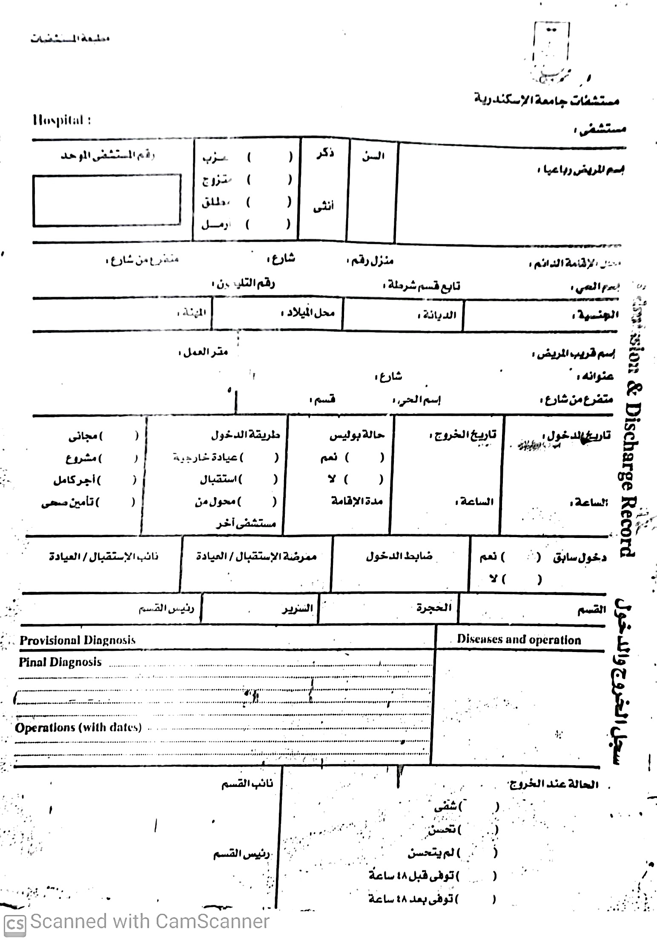we went to some hospitals and met the medical stuff. They helped us configure their work process cycle from the patient entry moment to the hospital in the Emergency department or the Clinics until leaving and provided us with some data forms that they use to store their data as follows :

Figure 1 Admission and Discharge Record

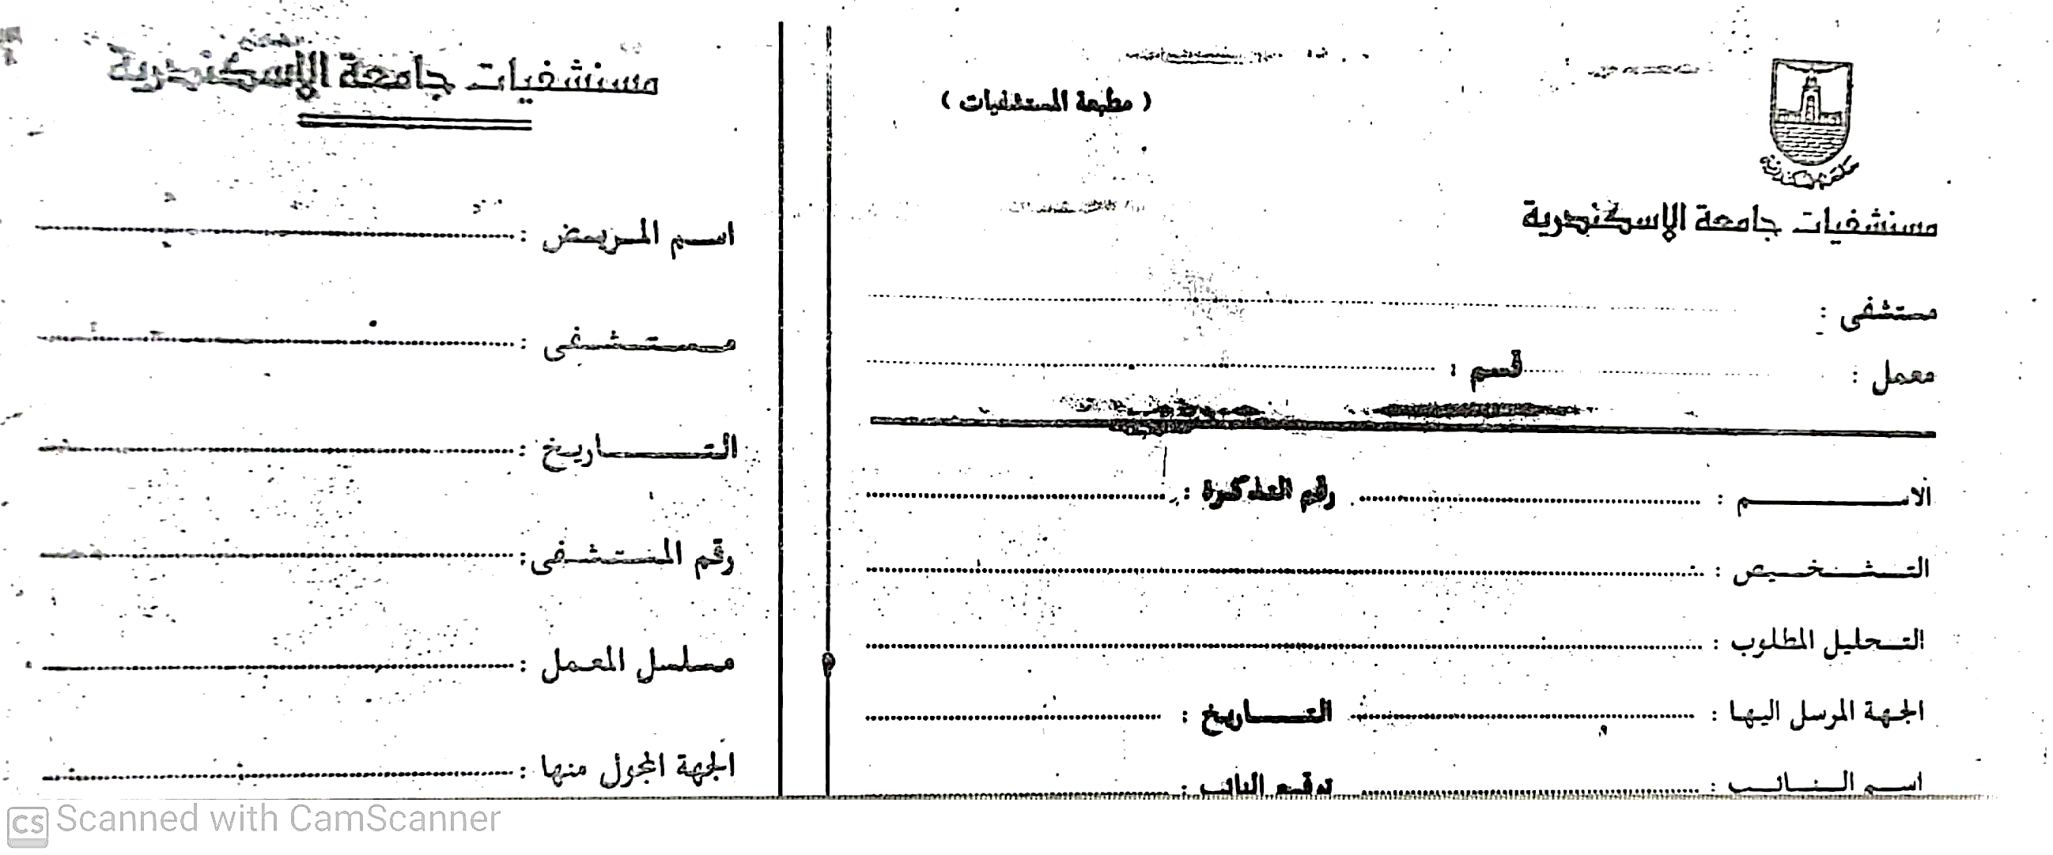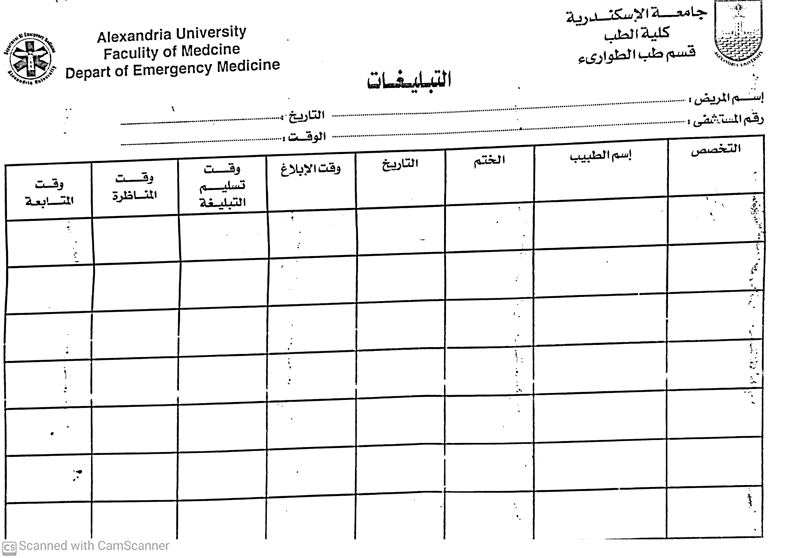

Figure 2 Patient Ticket

Figure 3 Doctors Emergency Calls

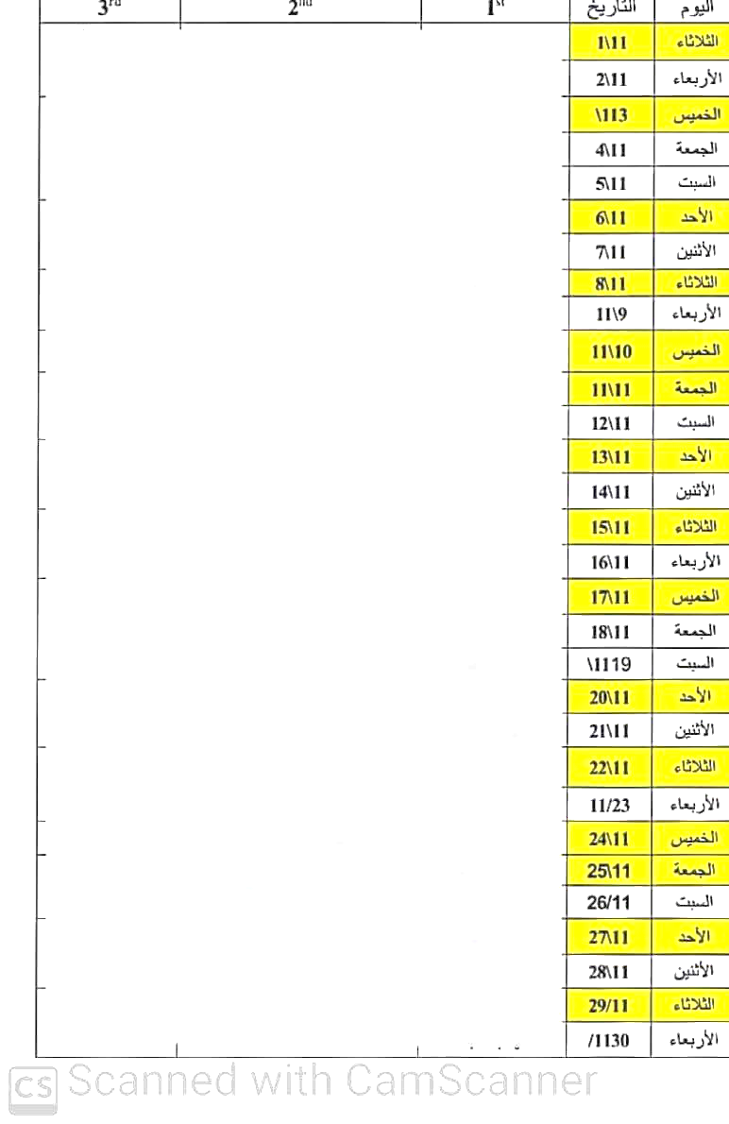

Figure 4 Doctors Emergency Schedule

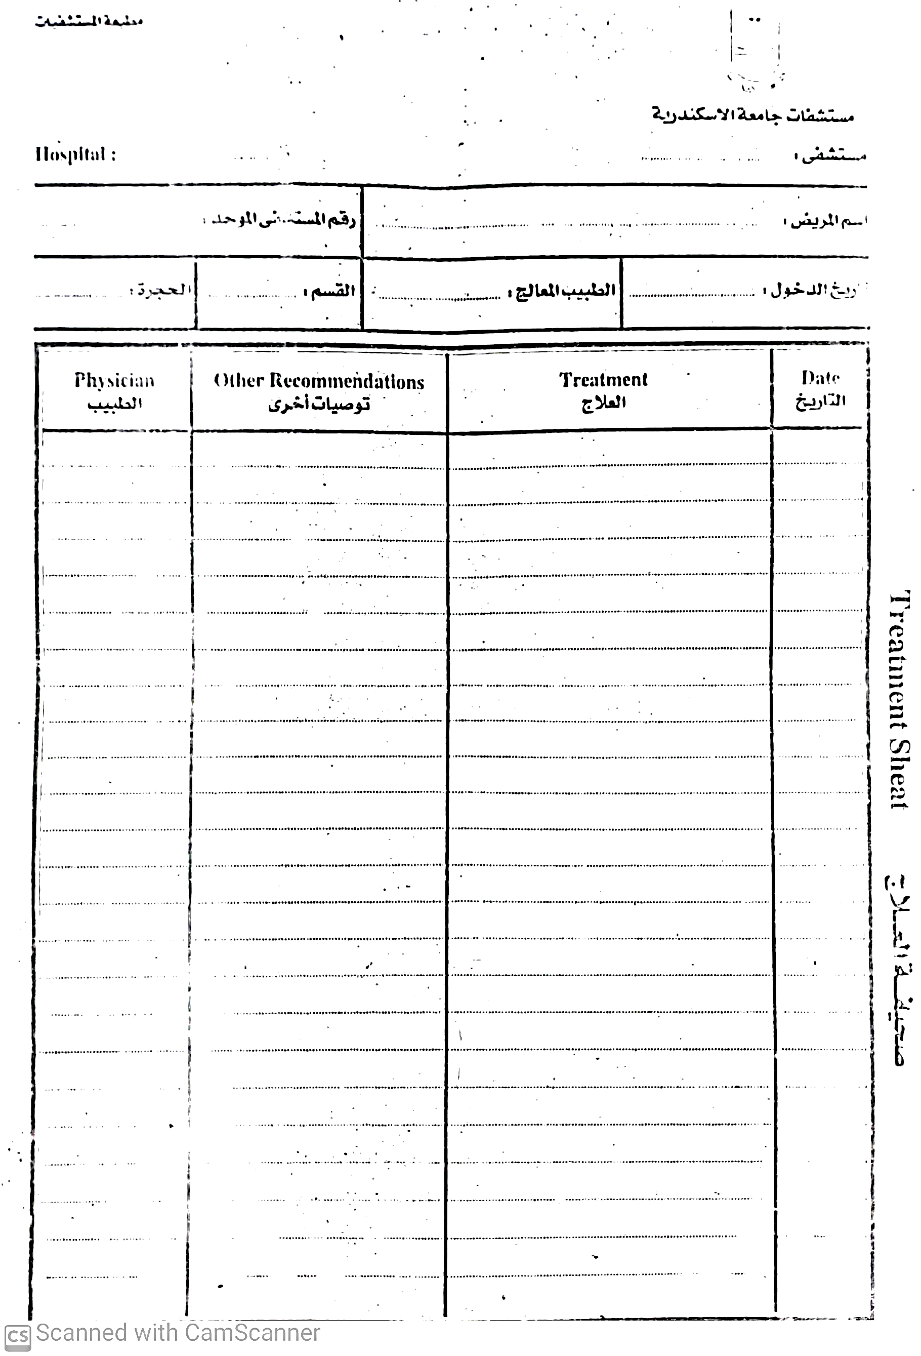

Figure 5 Treatment Sheet

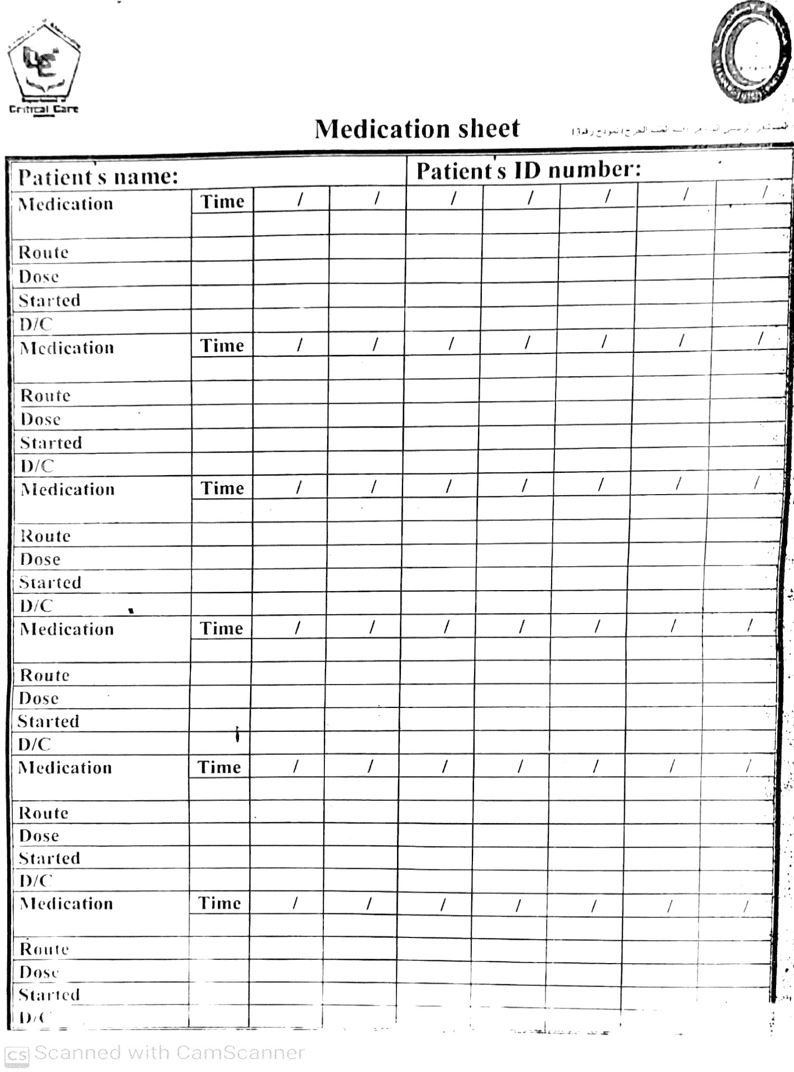

Figure 6 Medication Sheet

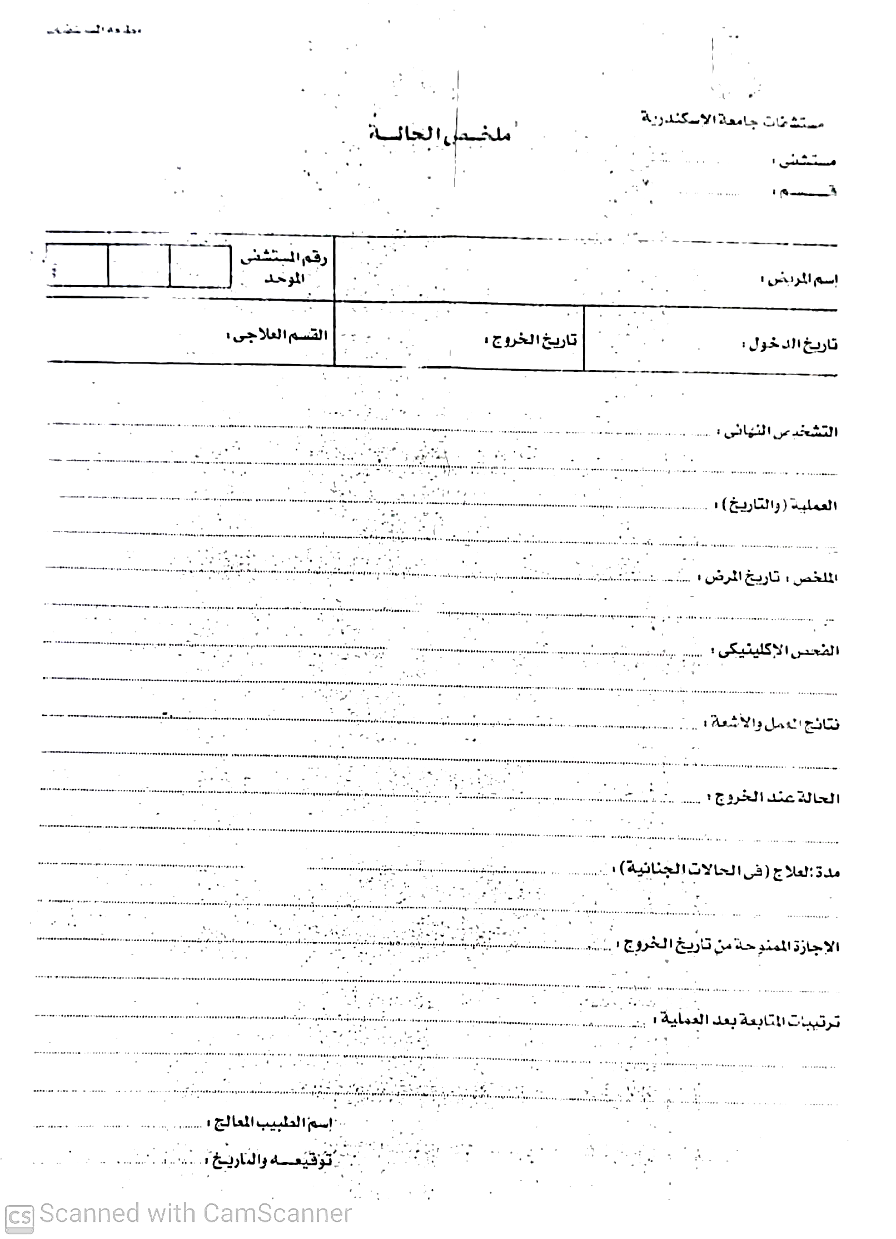

Figure 7 Diagnose Summary

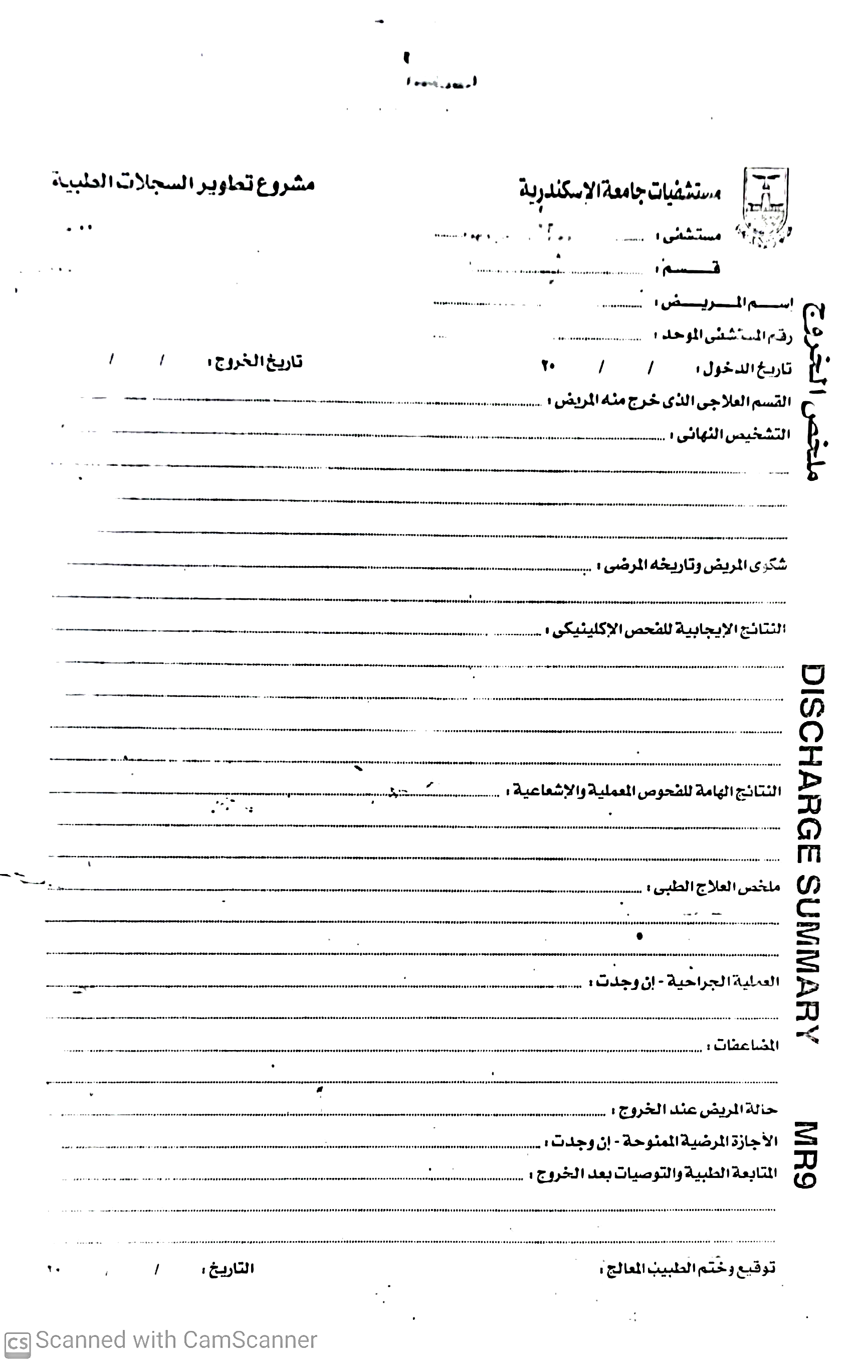

Figure 8 Discharge Summary

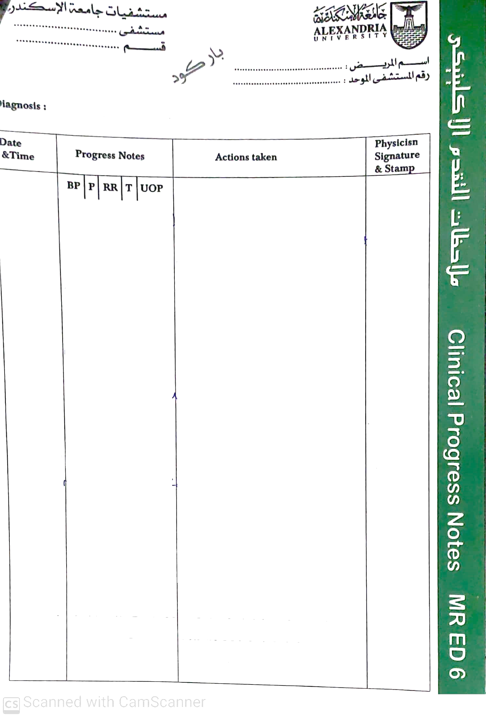

Figure 9 Clinical Progress Notes

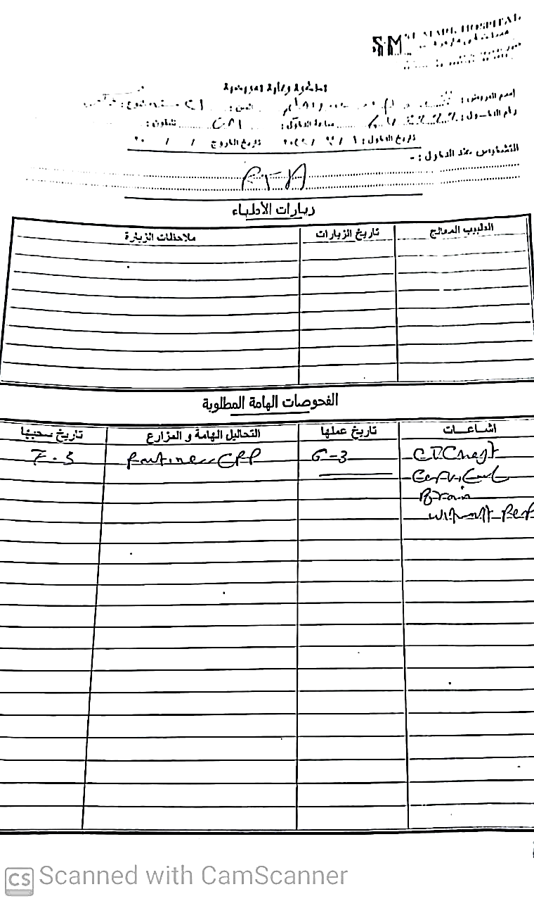

Figure 10 Doctor Visits and Follow up Sheet

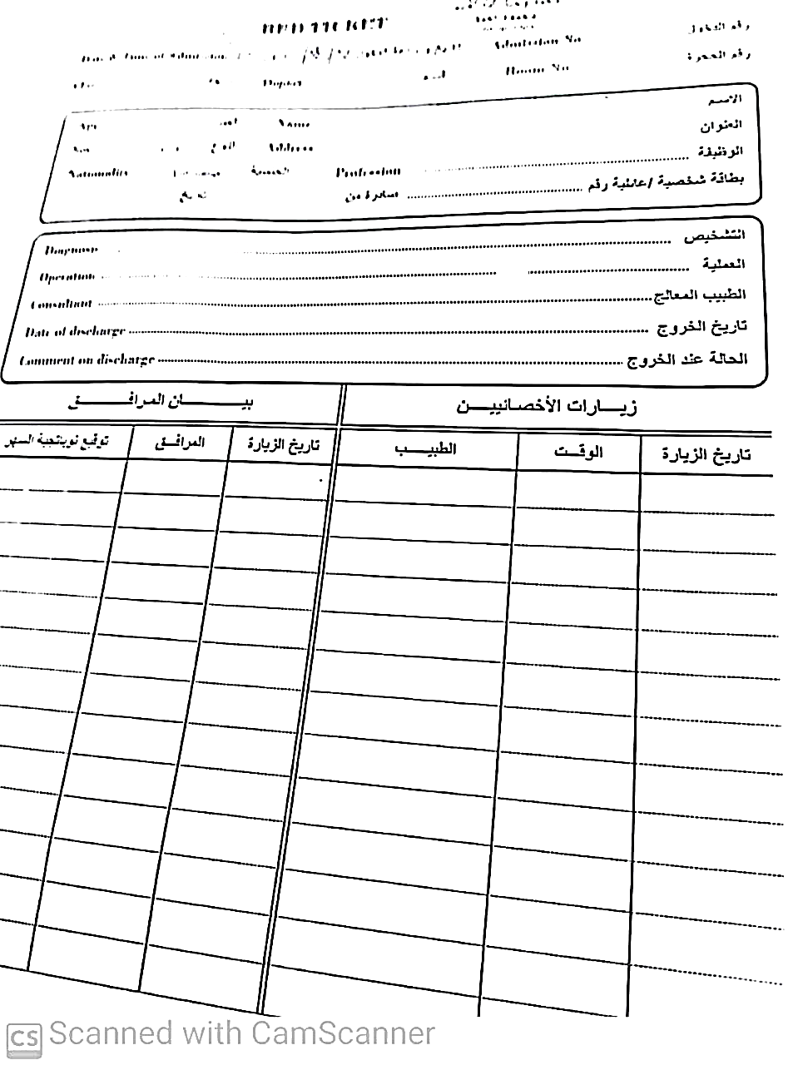

Figure 11 Patient Visits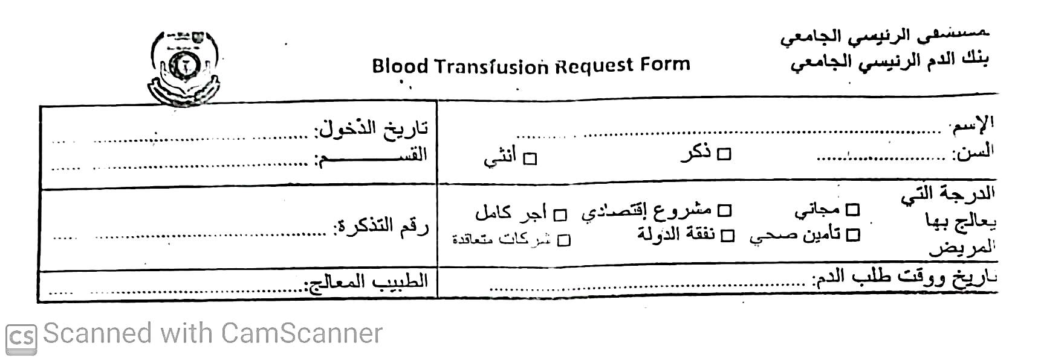

Figure 12 Blood Transfusion Request Form

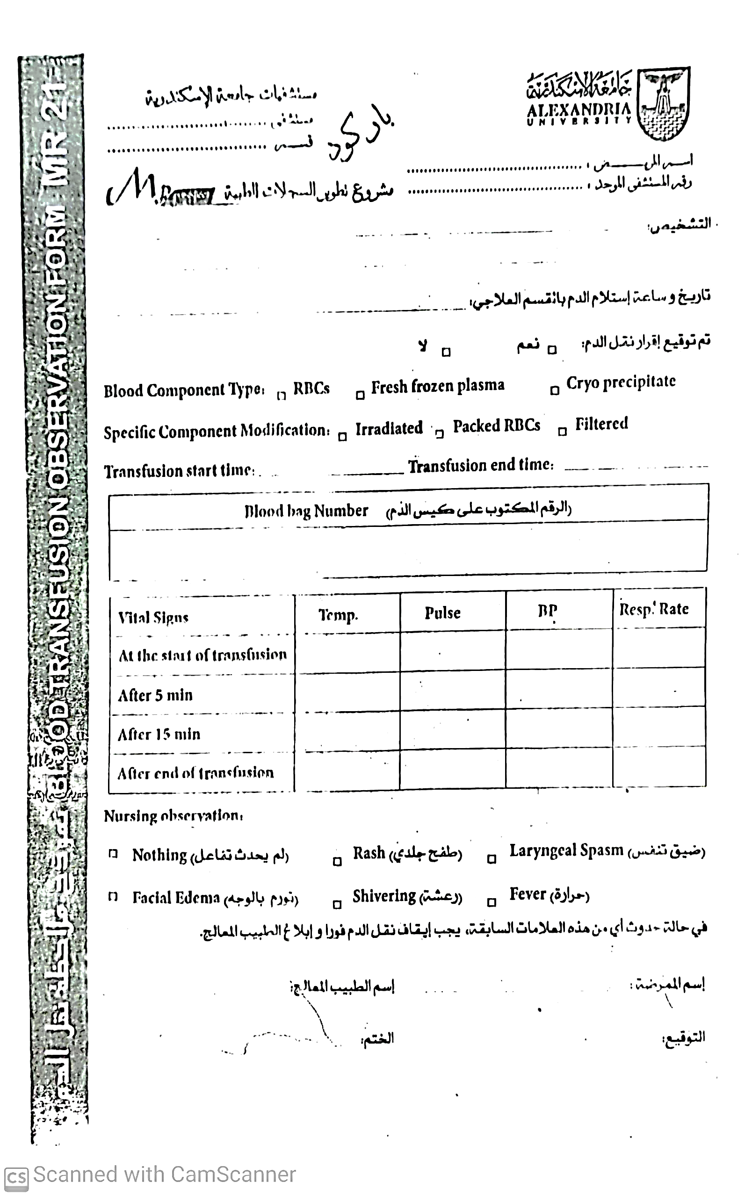

Figure 13 Blood Transfusion Observation Form

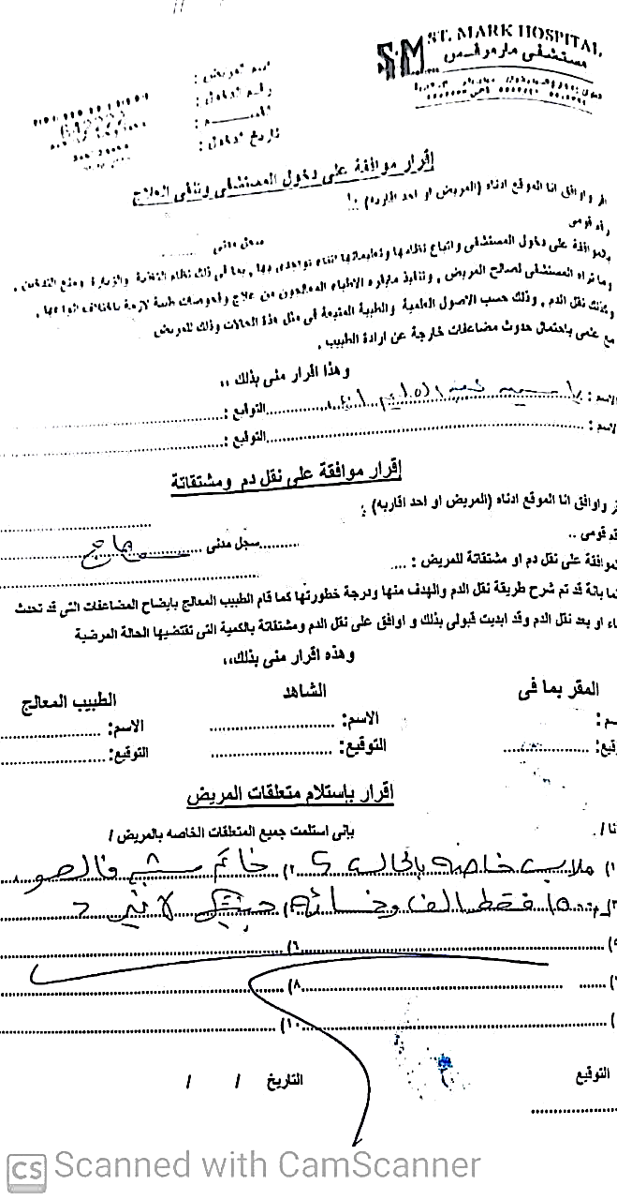

Figure 14 Patient Consents

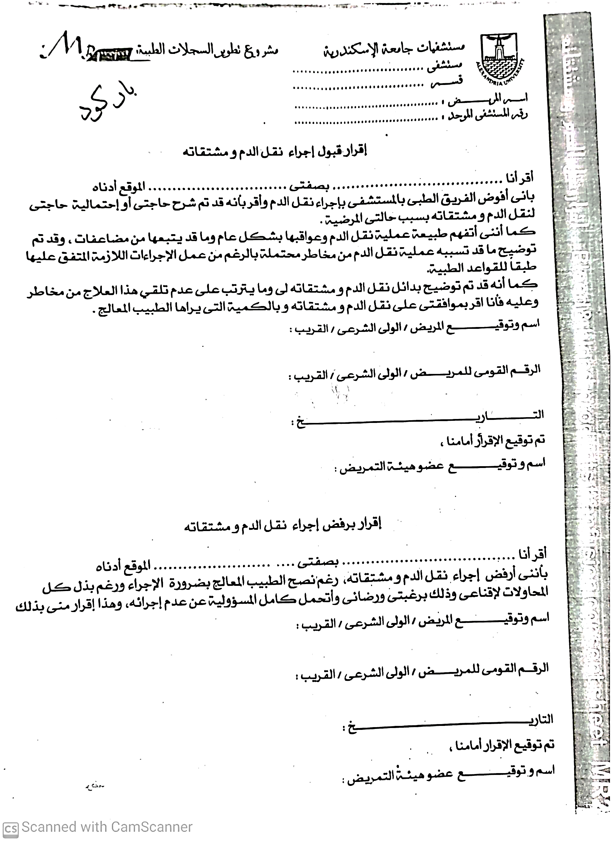

Figure 15 Blood and Blood Products Transfusion Sheet



Figure 16 Death Medical Report

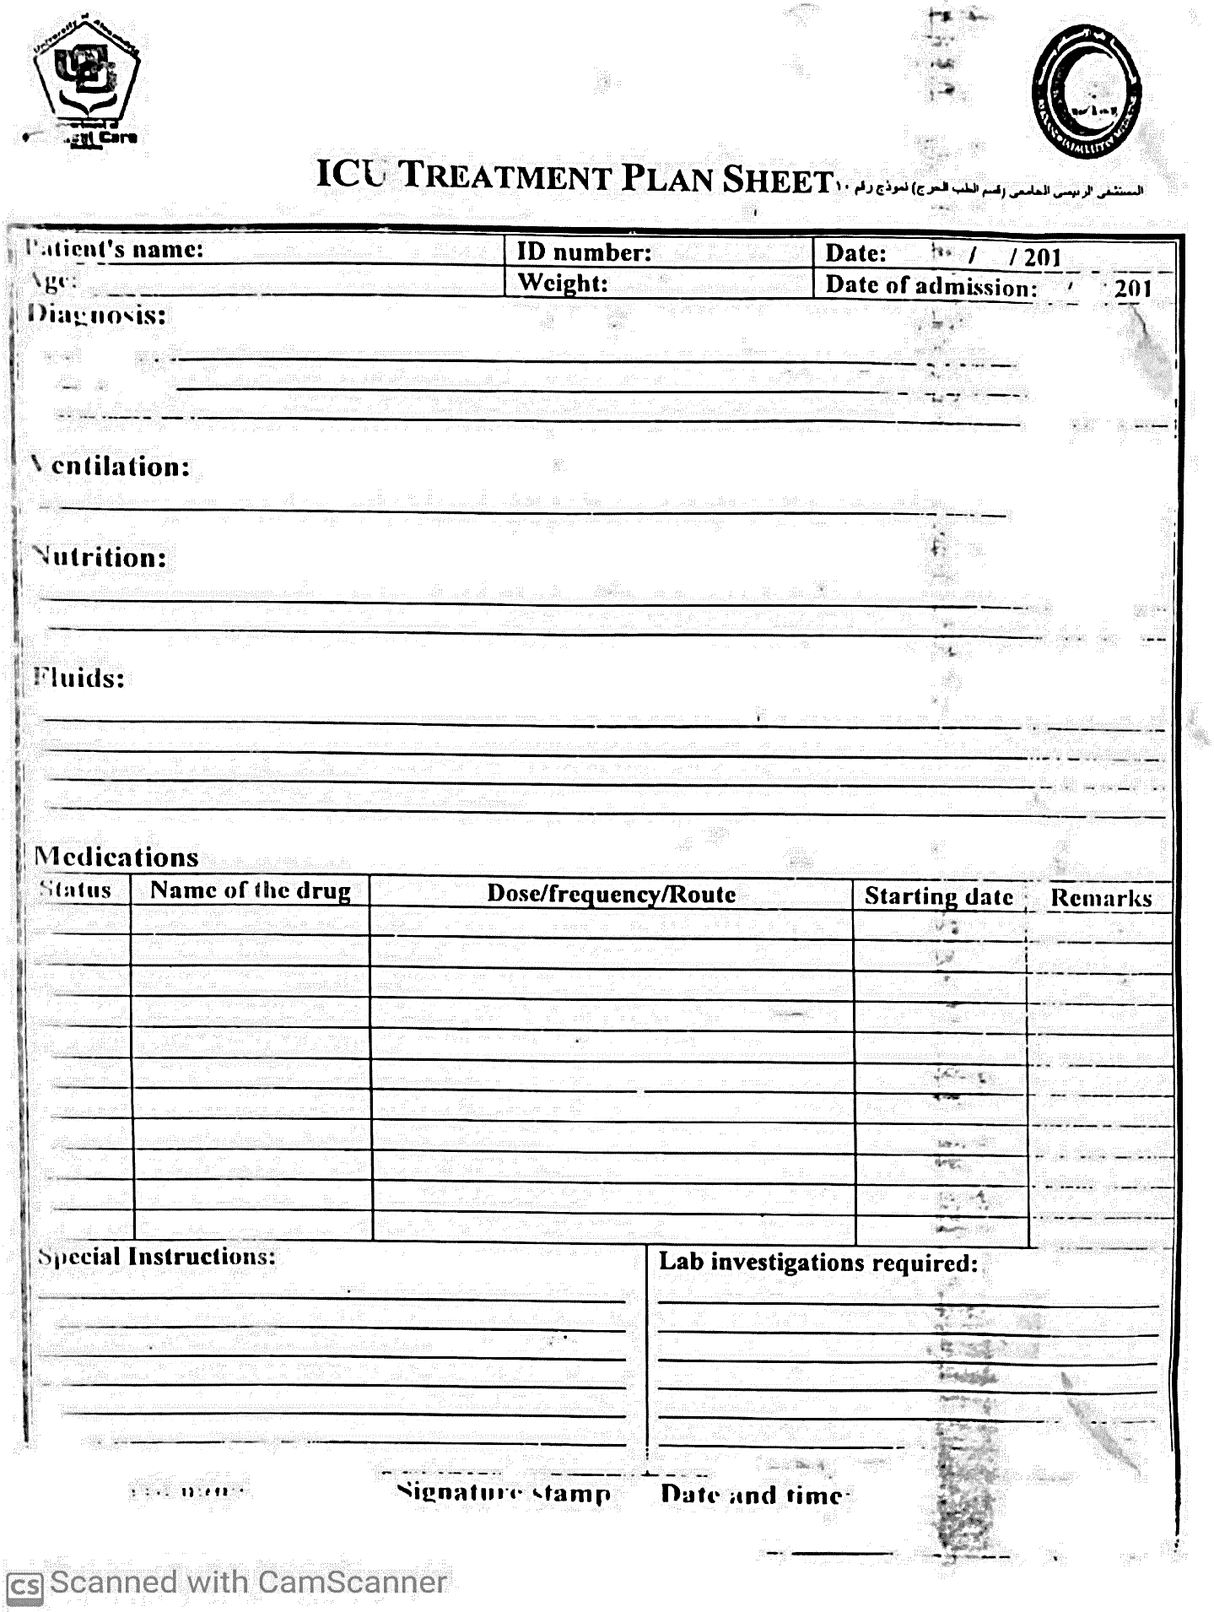

Figure 17 ICU Treatment Plan Sheet

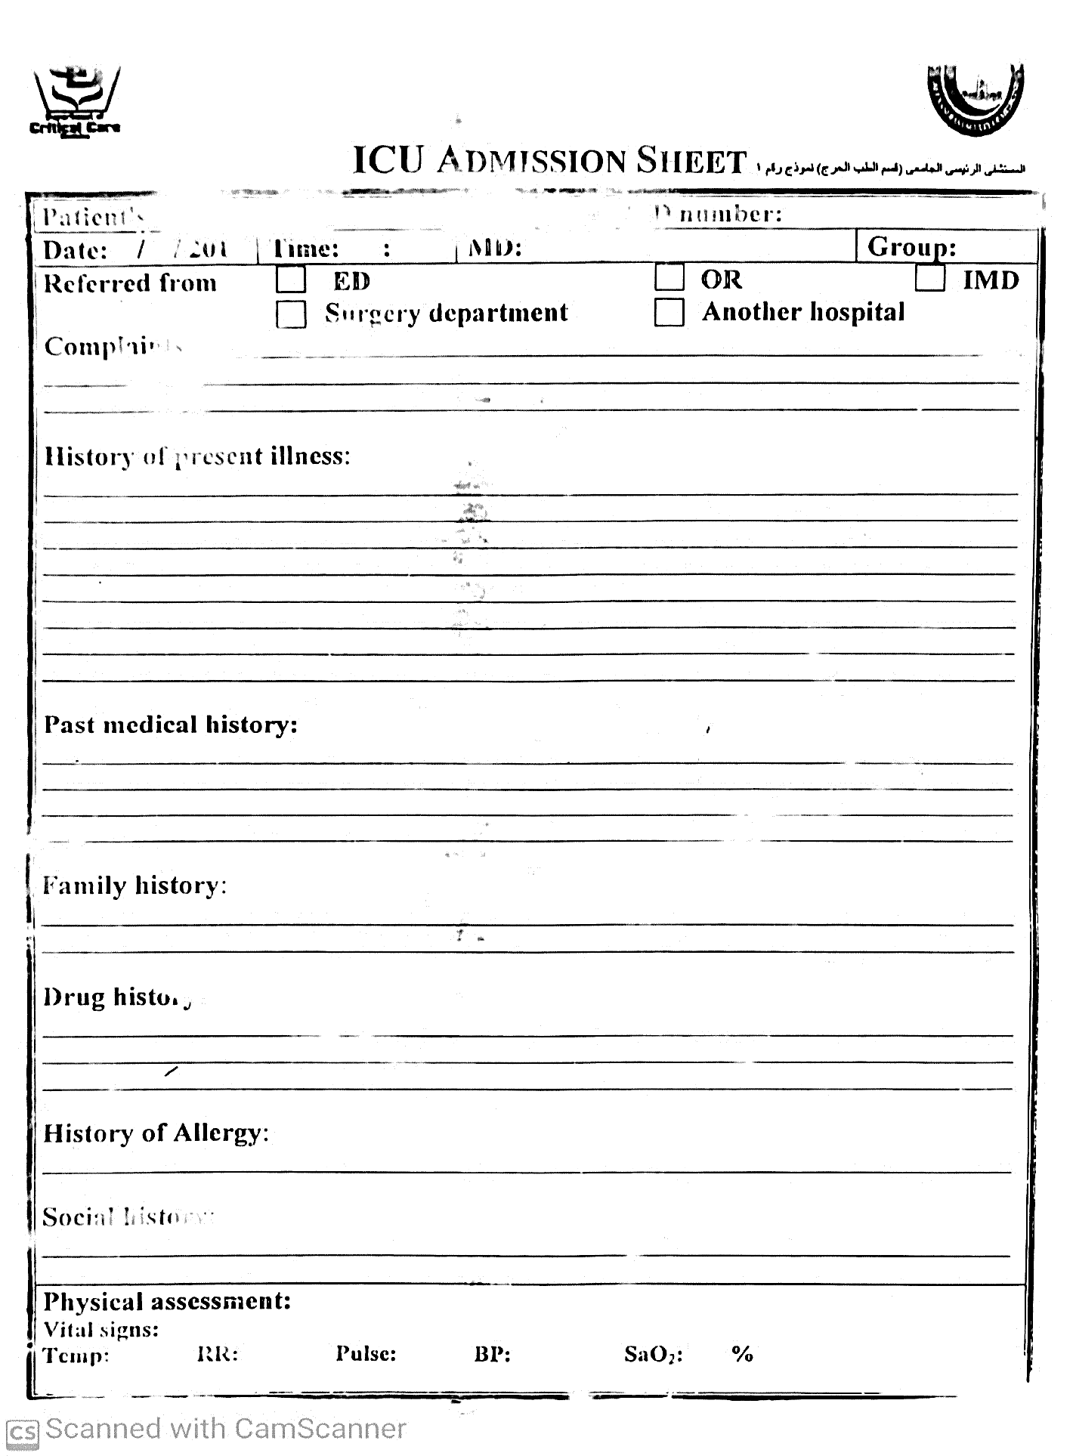

Figure 18 ICU Admission Sheet

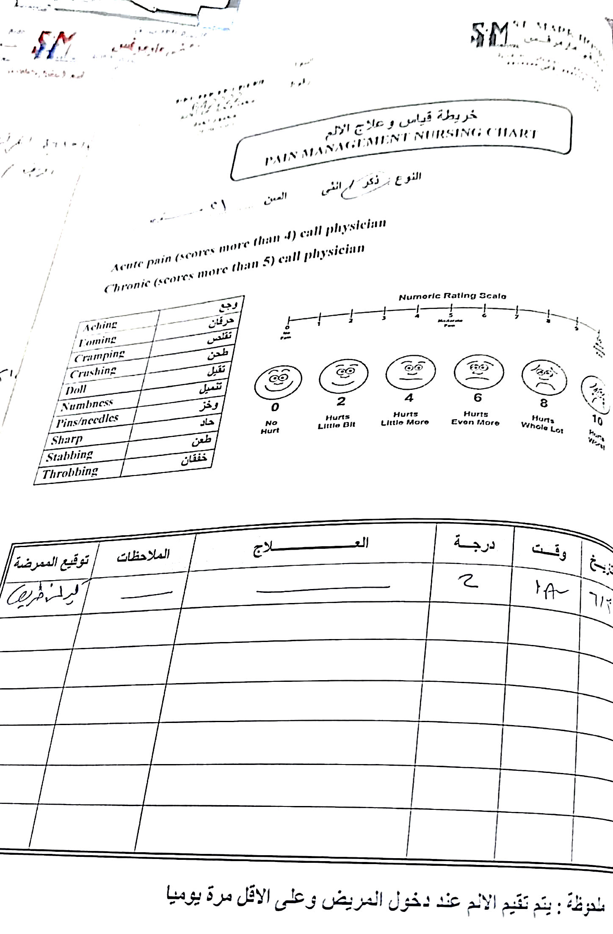

Figure 19 Pain Managment Plan Sheet

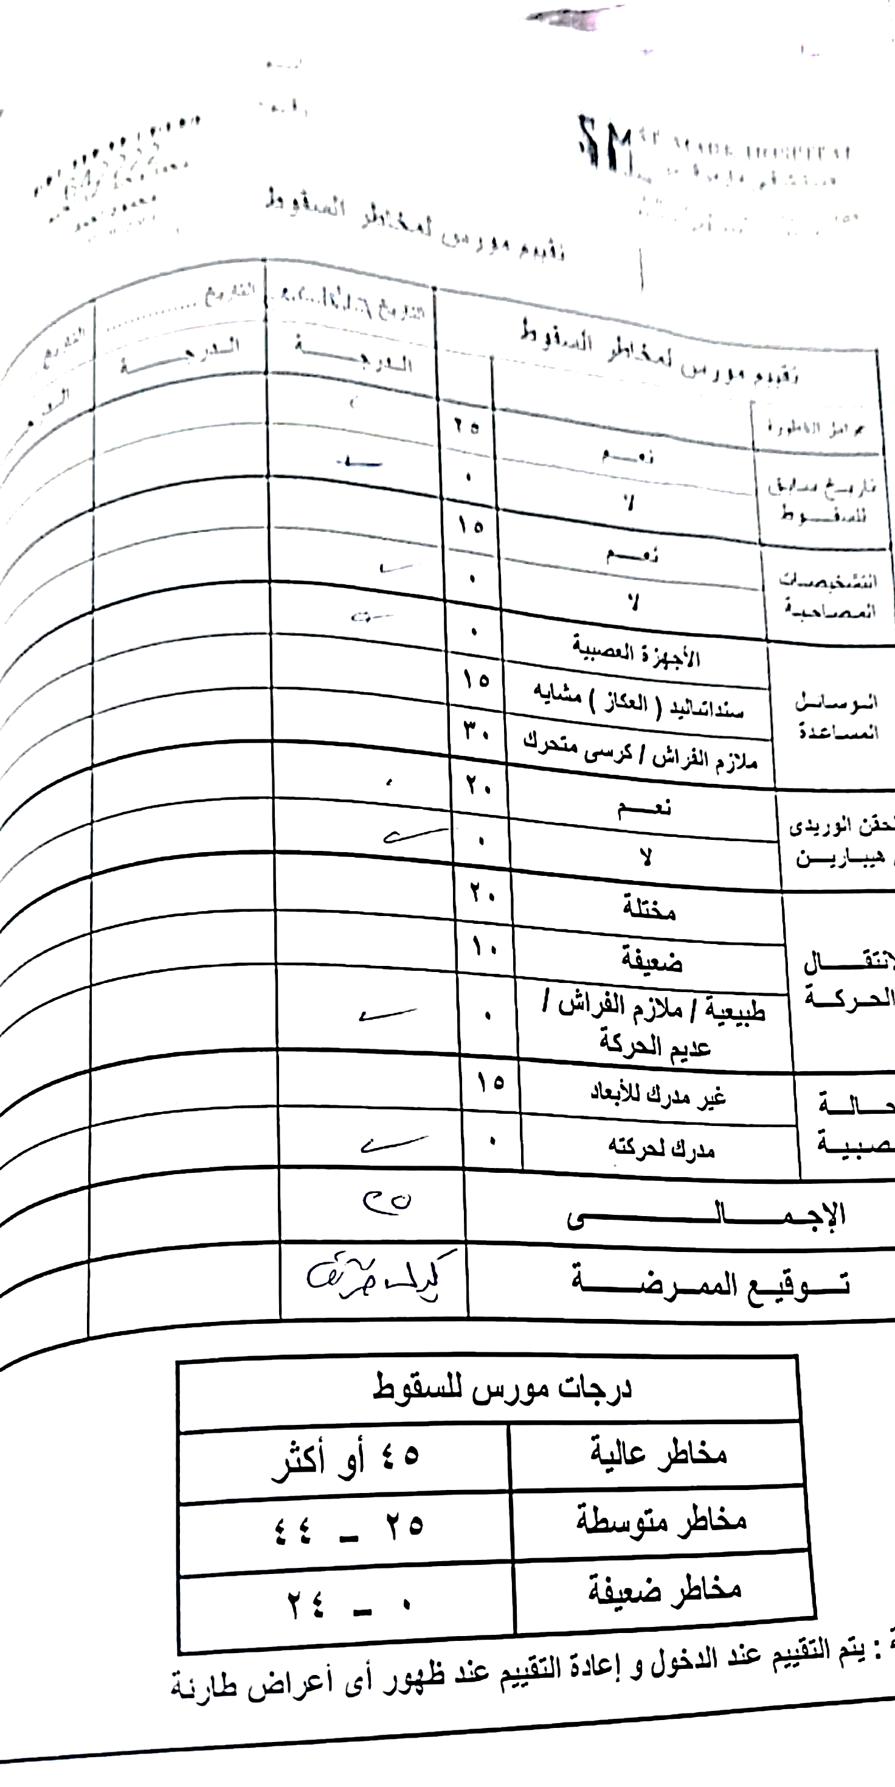

Figure 20 The Morse Fall Risk Scale

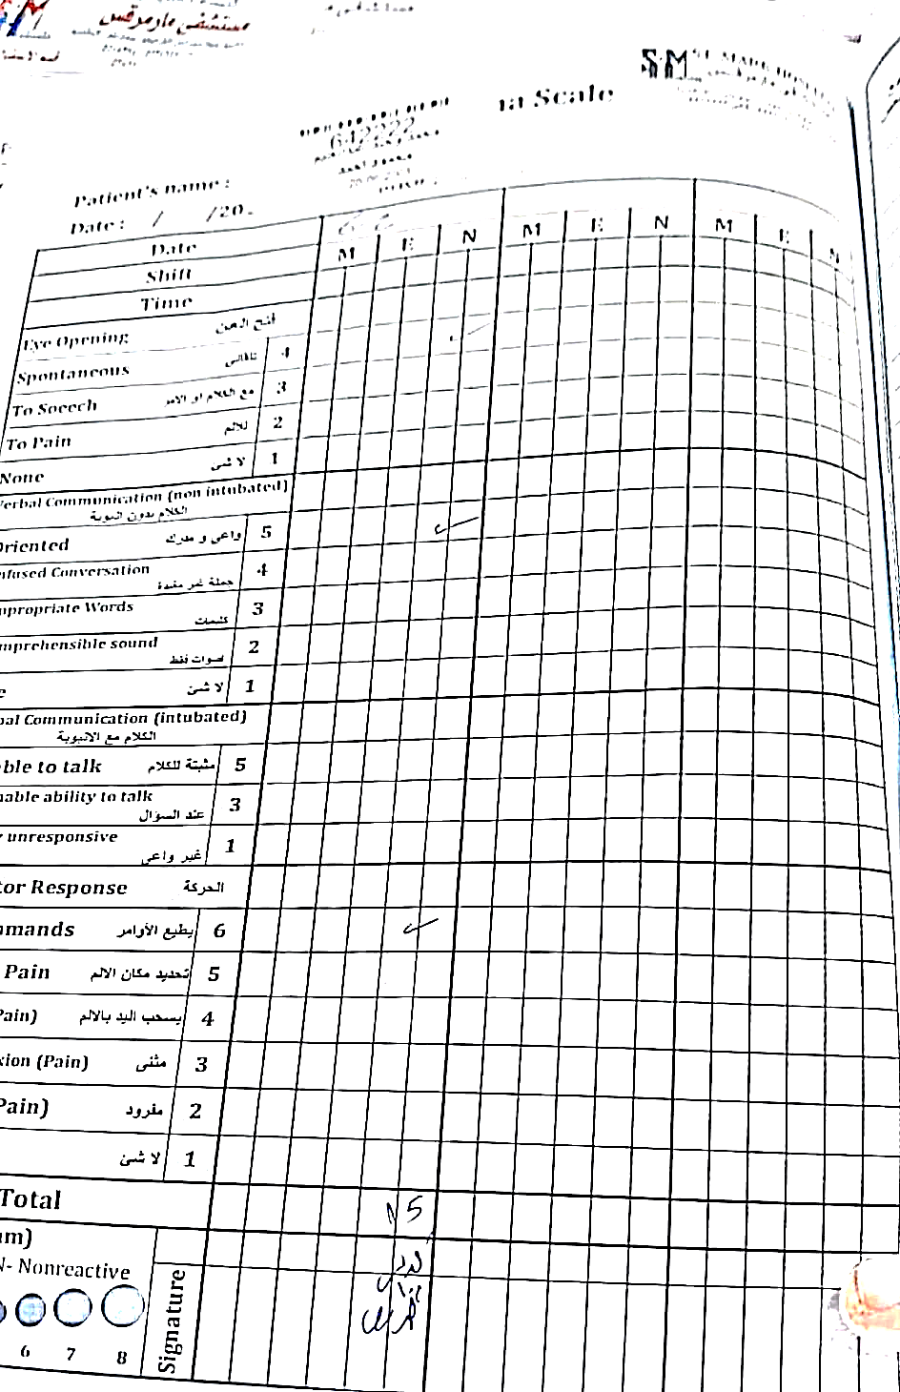

Figure 21 PANAS Scales

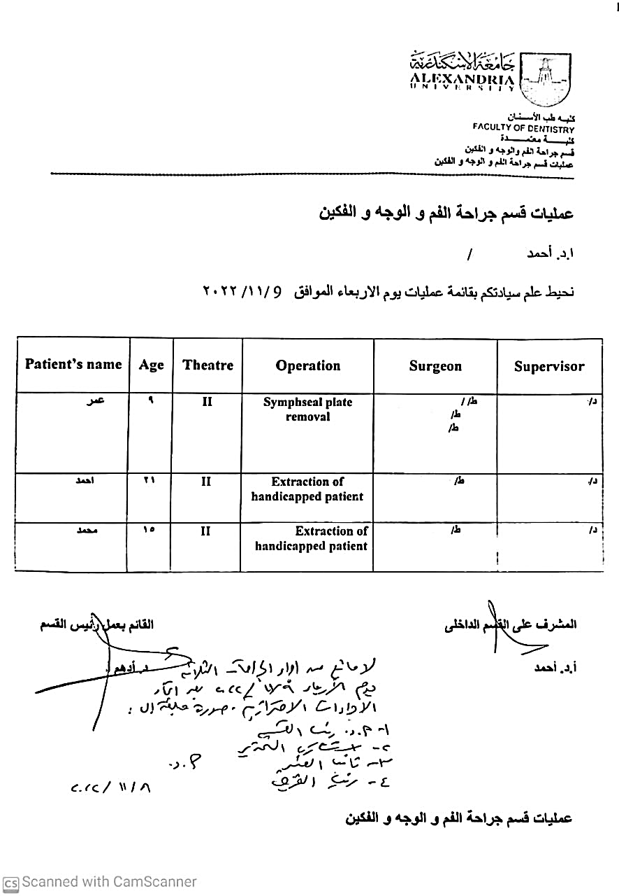

Figure 22 Operations Schedule

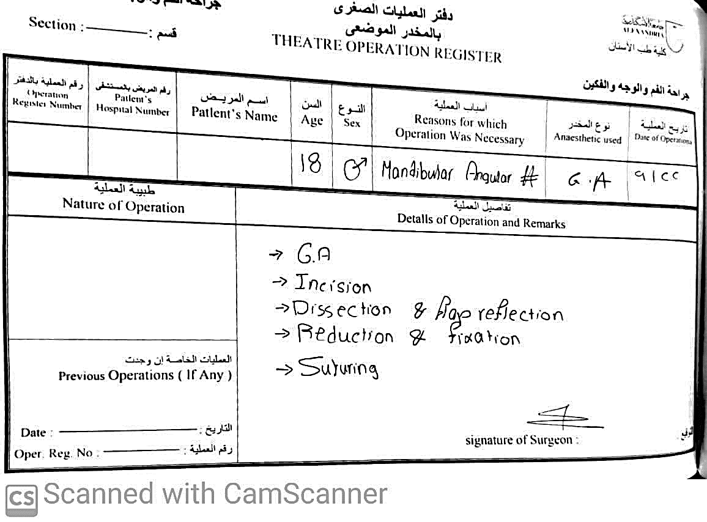

Figure 23 Theatre Operation Register

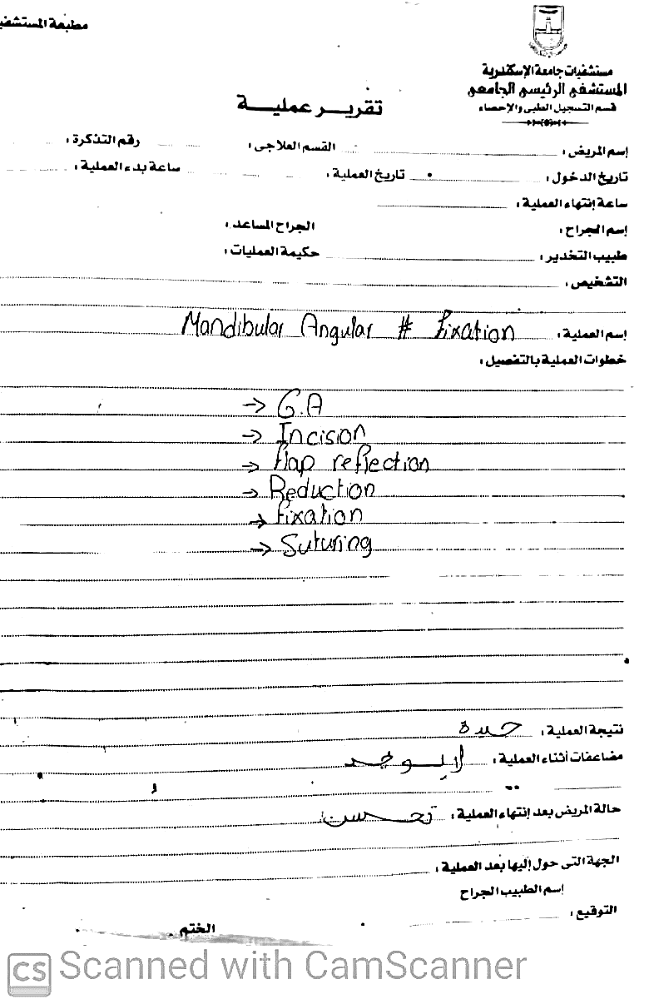

Figure 24 Operation Report

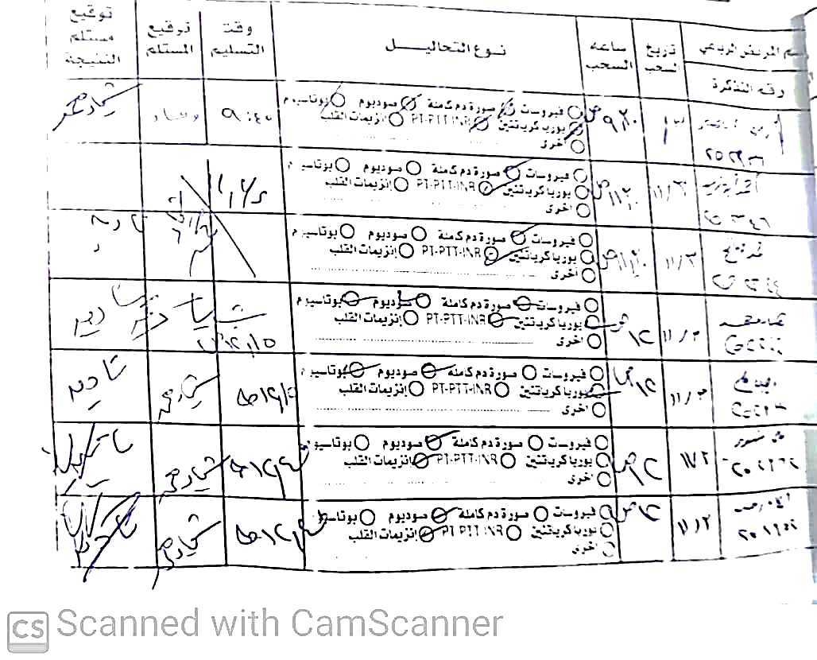

Figure 25 Lab Tests Schedule

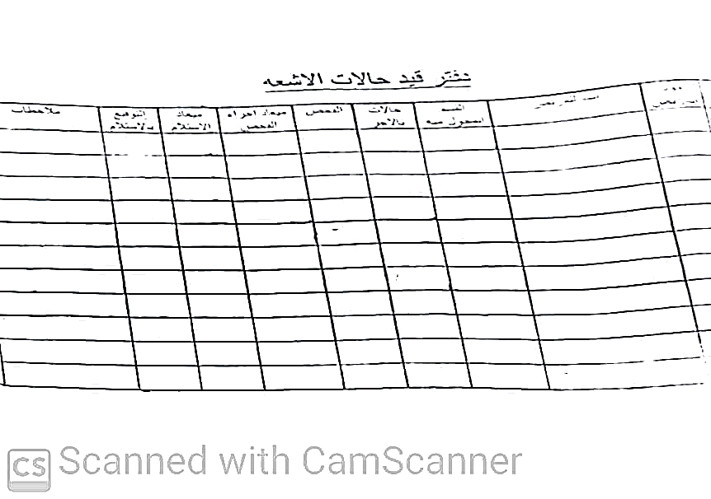

Figure 26 Radiology Tests Schedule

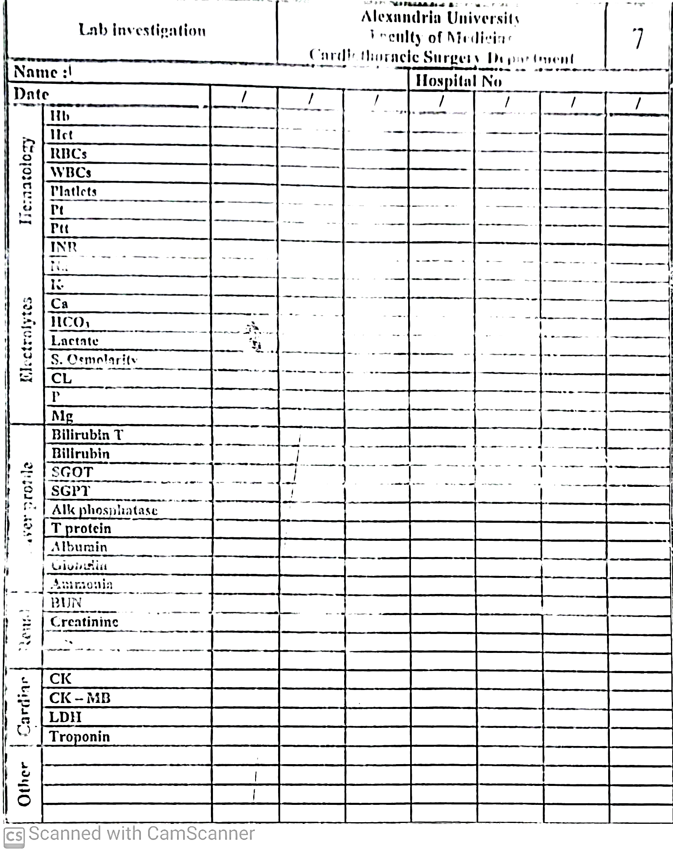

Figure 27 Lab Investigation Form

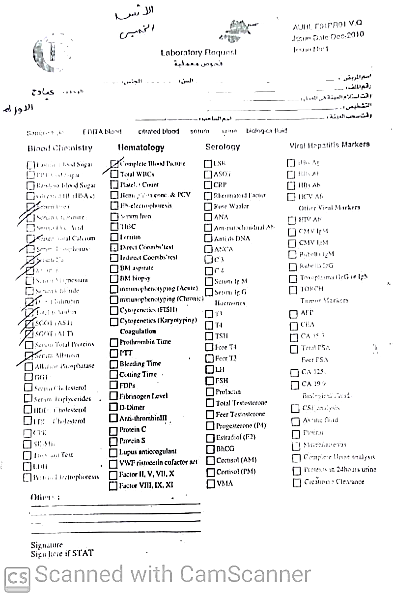

Figure 28 Lab Request Form

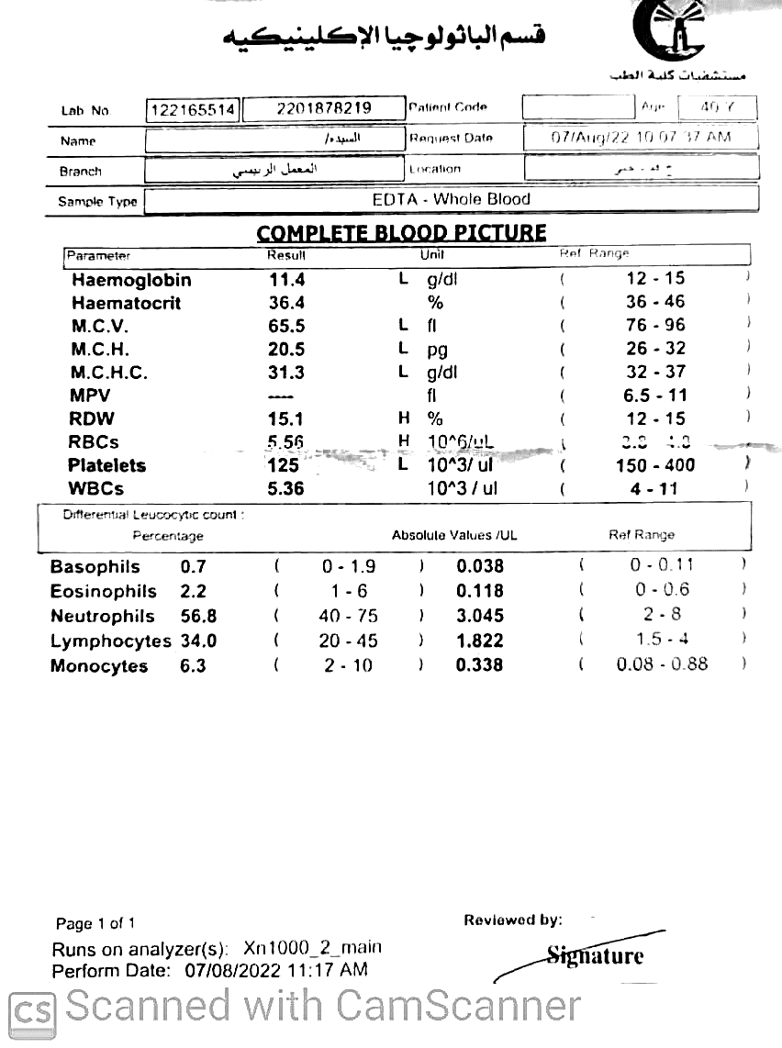

Figure 29 Complete Blood Picture Analysis

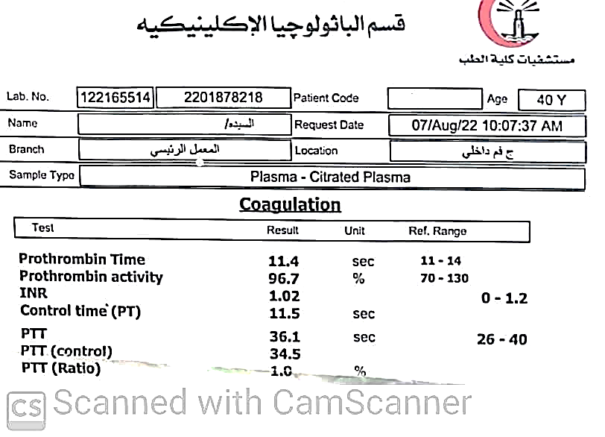

Figure 30 Blood Coagulation Analysis

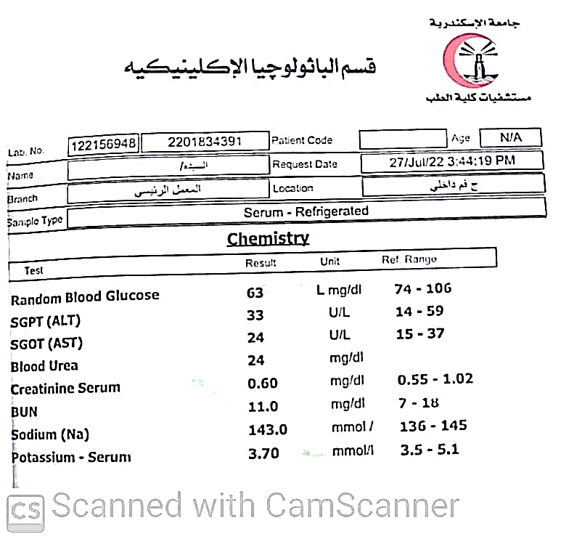

Figure 31 Blood Chemistry Analysis



Figure 32 CT Scan Report on Neck



Figure 33 Lab Sample Receipt



Figure 34 Lab Review Report

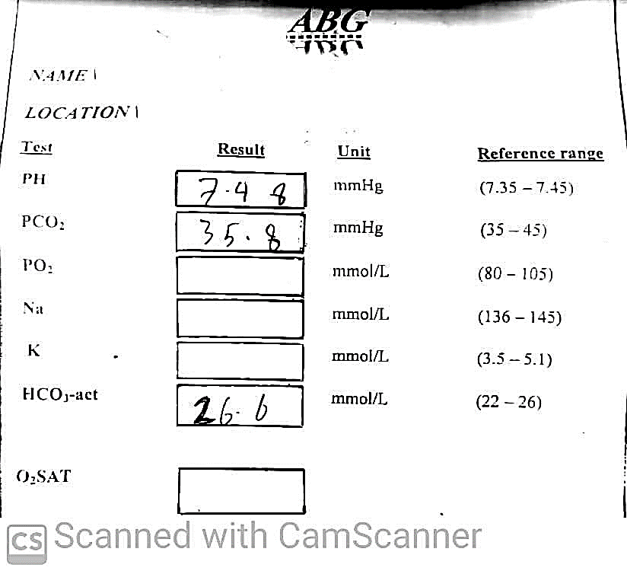

Figure 35 Arterial blood Gas Analysis

# Chapter 3: Proposed System

Throughout this chapter we will discuss the schema for one of Alexandria’s hospitals where we collected their data and their cycle of process That start with the patient entering the hospital till, he leaves. In section 1 we will discuss the System Requirements and in section 2 we will represent the proposed ERD for the system. While representing our system in some diagrams in the rest of the chapter sections.

## System requirements

Requirements engineering is the branch of software engineering concerned with the real-world goals for, functions of, and constraints on software systems. It is also concerned with the relationship of these factors to precise specifications of software behavior, and to their evolution over time and across software families. [3]

System Requirements Analysis gives the system the tools to set up a proper and effective analysis of the resources, schedules and parts needed to successfully undertake and complete any large, complex project. Requirements analysis is the first step in the system design process, where a user's requirements should be clarified and documented to generate the corresponding specifications. While it is a common tendency for designers to be anxious about starting the design and implementation, discussing requirements with the customer is vital in the construction of safety-critical systems. For activities in this first stage has significant impact on the downstream results in the system life cycle. For example, errors developed during the requirements and specifications stage may lead to errors in the design stage. When this error is discovered, the engineers must revisit the requirements and specifications to fix the problem. This leads not only to more time wasted but also the possibility of other requirements and specifications errors.

It gives you a complete picture of your entire project. It provides a single source of truth that every team involved in development will follow. It is our plan of action to keep all our teams — from development to maintenance — on the same page. [4]

Software Requirement Specification specifies the final product’s functional and non-functional requirements, implementation constraints, and use cases (i.e., how users will interact with the system). A software specification provides everyone involved with a roadmap of the project. [5]

### Functional requirements

Functional requirements describe the product’s functionality. They define what the solution will do and how it will interact with and respond to different user inputs. You can view functional requirements as a detailed description of the solution’s features and fundamental behavior. If they are not met, the system will not work. [5]

* + - 1. General Requirements:

1. The system must check on user logging in type.
2. If the user logging in succeeded, then the user must enter the 2 Step-Verification code.
3. The system must automatically forward the user/employee(doctor) to the related page.
4. The system shall update pages if user requests, or the page cache had been deleted.
5. The system should automatically notify the user for the next event (appointment-medical test-operation-doctor call) he will have.
6. Any user can browse app sections (Home-About-Departments-Profile-Help-Contact-etc.…).
7. Any user can edit his personal details.
8. Any user should enter verification code to login.

#### Admin Requirements:

1. The admin should make an account for the hired medical employee and fill his basic data.
2. The admin must update staff schedule.
3. The admin shall View/add/modify/delete any user data.

#### User (Patient) Requirements:

1. The User can sign up/login with required information.
2. The User can edit personal details:(Phone Number-Job-Address).
3. The User can browse and change settings of the app (Notification-Preferences-Language-Account-privacy-Password&Security).
4. The User can login from Mobile app/Website.
5. The User can search for doctors/Lab test/Medical check.
6. The User can make an appointment for any medical check.
7. The User should Must choose Payment method (online \ offline in-person)
8. The User can attach complaint before appointment.
9. The User can view/book previous appointment.
10. The User can cancel/reschedule appointment with providing a reason.
11. The User can view/add/edit/delete any record of his old history.
12. The User can add any new test outside the hospital.
13. The User can setup date for treatment stop.

#### Employee (Doctor) Requirements:

1. The doctor should login by given account from hospital.
2. The doctor can update his profile details(degree-position)
3. The doctor can view his schedule.
4. The doctor has access to view/add/edit patient (complaint-diagnose-treatment-medical test result)
5. The doctor can add next appointment for the patient.
6. The doctor must be notified when ER doctor call him.
7. The doctor must access only the department where he works.
8. The doctor in ER can add/view/edit emergency ticket for patient
9. The ER doctor should fill provisional diagnosis before calling doctors.
10. The ER doctor should call specialist after provisional diagnosis.
11. The specialist should fill final diagnose.
12. The specialist shall attach treatment in the ticket .
13. The doctor shall require (operation-laboratory test-radiology test) for patient after any diagnose.
14. The doctor shall transform patient to ICU if the patient needs.
15. The ICU doctor should fill ICU admission sheet when patient admits .
16. The ICU doctor should do all measurements that includes (pain management chart-Morse fall risk scale-PANAS scale-Physical assessment-vital signs-etc.….) required after admission in the follow up sheets.
17. The ICU doctor shall require the patient to do medical test.
18. The ICU doctor should make an ICU treatment plan sheet for the patient.
19. The doctor should fill operation form data for every patient having an operation.
20. The doctor should fill operation result and the treatment plan sheet.

### Non- Functional requirements

Non-functional requirements, as the name suggests, are requirements that are not directly concerned with the specific services delivered by the system to its users. These non-functional requirements usually specify or constrain characteristics of the system. They may relate to emergent system properties such as reliability, response time, and memory use. Alternatively, they may define constraints on the system implementation, such as the capabilities of I/O devices or the data representations used in interfaces with other systems.

Non-functional requirements are often more critical than individual functional requirements. System users can usually find ways to work around a system function that doesn’t really meet their needs. However, failing to meet a non-functional requirement can mean that the whole system is unusable. For example, if an aircraft system does not meet its reliability requirements, it will not be certified as safe for operation; if an embedded control system fails to meet its performance requirements, the control functions will not operate correctly. [6]

* Availability: The system must be available 24/7.
* Usability: The system usability characteristics:
* The application interface must be simple, provide easily steps in filling forms data and support eye strain relief., According to [7].
* UI can be in some design’s:
  + Main design
  + Dark mode design
  + Eye comfort design
* Well data presentation organization for users to help them specially the medical staff to have rapid process.
* Adaptability: The system application (Web-Mobile) must be adaptive and responsive to support devices of all types.
* Security:
  + Modification: Change in the system patient data like (insert, delete and update) is performed by the admin and the doctor who has access to his department patients only, the patient has only access to modify his uploaded data (not from the hospital side).
  + Data transaction should be transmitted in an encrypted form.
* Accessibility:

The system can be accessed by the admin and many other users, but the access level is controlled of each user as per their scope of work.

## Proposed Schema

**Database schemas** are the blueprints that help developers visualize how databases should be built. They provide a reference point that indicates what fields of information the project contains. If there is any issue, the developer can simply refer to the schema.

Data administrators also use schemas to ensure that the database is fully designed before implementation. This saves valuable time and money, because once a database is implemented, making changes can be difficult. The schema ensures that all the stakeholders have fully considered every aspect of the project, which reduces the need for change.

**Relational databases** are best thought of as a series of entities, some of which relate to each other in certain ways. It's important to think of them as their own, concrete beings.

If you are building out a piece of software that is following the Object-Oriented Programming approach, it would be best to store each object's data as its own table with the database. [8]

Our System consists of 19 Entities divided into 7 Main Areas as Follows :

* Patient Basic Data ,which include the following entities :
  + Patient
  + Old history
* Patient Current Data, which include the following entities :
  + Case Diagnose
  + Treatment and Medication
  + Laboratory Tests
  + Radiology Tests
* Hospital Employees
  + Doctor
* Clinics , which include the following entities :
  + Patient Appointment
  + Clinic Schedule
* Emergency, which include the following entities :
  + Admission And Discharge
  + Doctor Callings
  + Emergency Schedule
  + ER_S_C (A junction table between Doctor Callings & Emergency Schedule)
* ICU, which include the following entities :
  + ICU Admission and Discharge
  + ICU Follow Up Sheet
  + ICU Doctor Visits
  + ICU Relative Visits
* Operations, which include the following entities :
  + Operation
  + Operation Data (A junction table between Doctor & Operation )

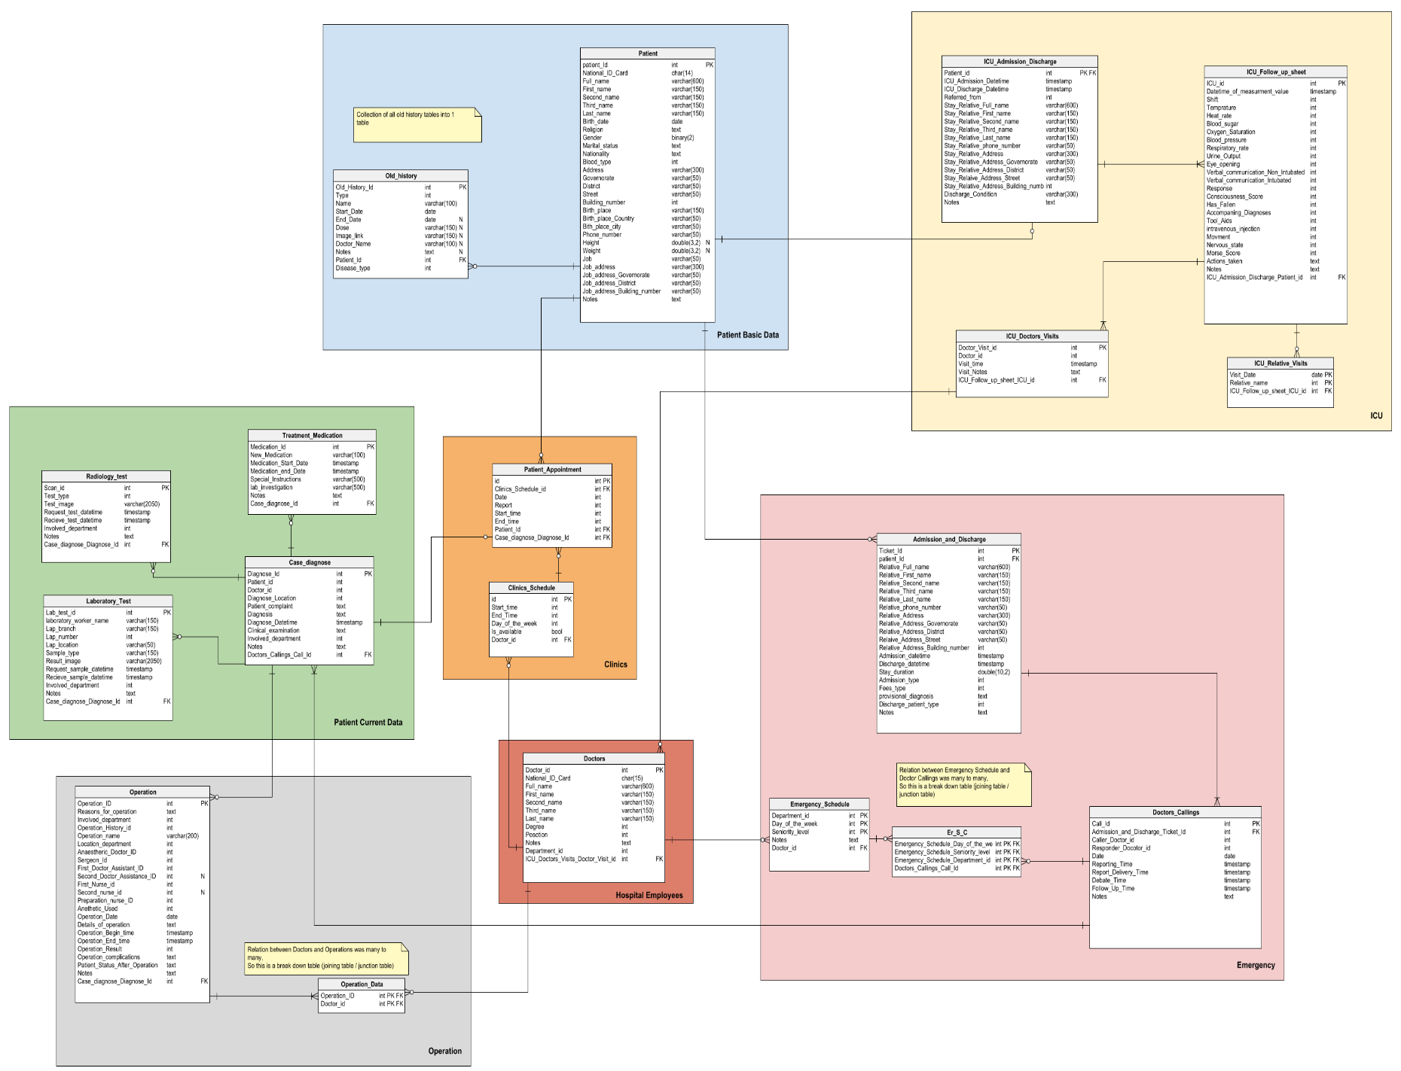

Figure 36 Schema

### ERD

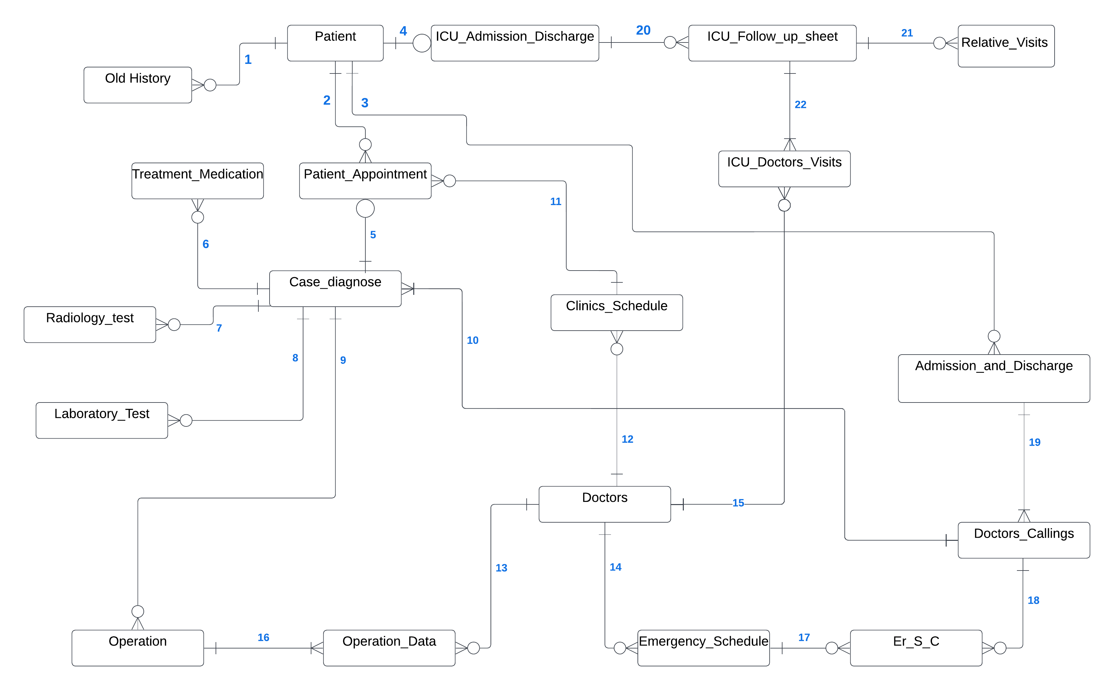

Figure 37 ERD

### Business Rules

**1**

* Patient may have one or more Old history records.
* One Old history record must be related to only one patient

**2**

* One Patient may have 1 or more patient Appointment.
* One patient Appointment must have 1 patient.

**3**

* One Patient may have one or more Admission tickets (where every ticket indicates a one-time visit to the hospital Emergency Section).
* One Admission Ticket must have only one patient.

**4**

* patient may have one or zero ICU_Admission_Discharge to ICU.
* ICU_Admission_Discharge must be done by one patient .

**5**

* One Patient Appointment must have one case diagnose.
* One case diagnose may be from a patient appointment (or from any other emergency departments)

**6**

* One Case Diagnose may have one or more Treatment/Medication.
* One Treatment/Medication must be connected to one Case Diagnose.

**7 & 8**

* One Case Diagnose may have one or more Laboratory tests / Radiology tests
* One Laboratory tests / Radiology tests must be connected to only one Case Diagnose.

**9**

* One Case Diagnose may have one or more operations.
* One Operation is connected to only one Case Diagnose.

**10**

* One Doctor Calling Record Must have 1 or more Case Diagnose.
* One Case Diagnose may be connected to a Doctor Calling Record.

**11**

* One Clinical Schedule record may have one or more Patient Appointment.
* One Patient Appointment Must be connected to only one Clinical Schedule record with one doctor.

**12**

* One Doctor may Have one or more Clinical Schedule record.
* One Clinical Schedule record must have 1 doctor only.
* One Operation must have many doctors(Anaetheric ,Sergion , Assistants..), and A doctors can work in many operations
* Since this a many to many relation , It is broken down to a (joining / junction) table called Operation_data Where : (**13** & **16**)

**13**

* One Operation_data must be connected to one doctor.
* One Doctor may be connected to one or more operation _data records.

**14**

* One Doctor may have one or more Emergency schedule record.(Differ in Day_of_the_week)
* One Emergency schedule record must have only 1 doctor.

**15**

* doctor may do one or more visit in ICU .
* ICU visit must have one doctor visit

**16**

* One Operaion must be connected to many operation_data records.
* One operation_data record must be connected to one operation.
* One Emergency schedule record may be connected to one or more Doctor calling.
* One Doctor calling Record May be connected to one or more Emergency schedule record.

**Since** the Relation is many to many , A junction table is created (ER_S_C) Where : (**17** & **18**)

**17**

* One Emergency schedule record may be connected to one or more ER_S_C.
* One ER_S_C Record Must be connected to only one Emergency schedule record.

**18**

* One Doctor Calling record may be connected to one or more ER_S_C.
* One ER_S_C Record Must be connected to only one Doctor Calling.

**19**

* One Admission Ticket must have 1 or more Doctor Calling record.
* One Doctor calling record must be connected to only one ticket.

**20**

* ICU_Admission_Discharge record can have one or more follow-up-sheets.
* A Follow-up-sheet must be done by only one ICU-admission-discharge .

**21**

* Follow-up sheet may have one or more relative visit.
* Relative visit will be added in one follow-up sheet

**22**

* Follow-up sheet must have one or more doctor visit.
* Doctor visit will be added in one follow-up sheet.

### Entities

#### Patient

|  |  |  |
| --- | --- | --- |
| **Column name** | **Type** | **Properties** |
| patient_Id | int | PK |
| National_ID_Card | char(14) |  |
| Full_name | varchar(600) |  |
| First_name | varchar(150) |  |
| Second_name | varchar(150) |  |
| Third_name | varchar(150) |  |
| Last_name | varchar(150) |  |
| Birth_date | date |  |
| Religion | text | Ref |
| Gender | binary(2) | Ref |
| Marital_status | text | Ref |
| Nationality | text | Ref |
| Blood_type | int | Ref |
| Address | varchar(300) |  |
| Governorate | varchar(50) |  |
| District | varchar(50) |  |
| Street | varchar(50) |  |
| Building_number | int |  |
| Birth_place | varchar(150) |  |
| Birth_place_Country | varchar(50) |  |
| Bith_place_city | varchar(50) |  |
| Phone_number | varchar(50) |  |
| Height | double(3,2) | null |
| Weight | double(3,2) | null |
| Job | varchar(50) |  |
| Job_address | varchar(300) |  |
| Job_address_Governorate | varchar(50) |  |
| Job_address_District | varchar(50) |  |
| Job_address_Building_number | varchar(50) |  |
| Notes | text |  |

Table 1 Patient



Table 2 patient related data

#### Admission_and_Discharge

|  |  |  |
| --- | --- | --- |
| **Column name** | **Type** | **Properties** |
| Ticket_Id | int | PK |
| patient_Id | int |  |
| Relative_Full_name | varchar(600) |  |
| Relative_First_name | varchar(150) |  |
| Relative_Second_name | varchar(150) |  |
| Relative_Third_name | varchar(150) |  |
| Relative_Last_name | varchar(150) |  |
| Relative_phone_number | varchar(50) |  |
| Relative_Address | varchar(300) |  |
| Relative_Address_Governorate | varchar(50) |  |
| Relative_Address_District | varchar(50) |  |
| Relaive_Address_Street | varchar(50) |  |
| Relative_Address_Building_number | int |  |
| Admission_datetime | timestamp |  |
| Discharge_datetime | timestamp |  |
| Stay_duration | double(10,2) |  |
| Admission_type | int | Ref |
| Fees_type | int | Ref |
| provisional_diagnosis | text |  |
| Discharge_patient_type | int | Ref |
| Notes | text |  |

Table 3 Admission_and_Discharge



Table 4 Admission and Discharge related data

#### Case_diagnose

**Description:**Case summary on the patient's condition written by Doctors.

|  |  |  |
| --- | --- | --- |
| **Column name** | **Type** | **Properties** |
| Diagnose_Id | int | PK |
| Patient_id | int |  |
| Doctor_id | int |  |
| Diagnose_Location | int | Ref |
| Patient_complaint | text |  |
| Diagnosis | text |  |
| Diagnose_Datetime | timestamp |  |
| Clinical_examination | text |  |
| Involved_department | int |  |
| Notes | text |  |
| Doctors_Callings_Call_Id | int |  |

Table 5 Case_diagnose



Table 6 Case diagnoses related data

#### Laboratory_Test

|  |  |  |
| --- | --- | --- |
| **Column name** | **Type** | **Properties** |
| Lab_test_id | int | PK |
| laboratory_worker_name | varchar(150) |  |
| Lap_branch | varchar(150) |  |
| Lap_number | int |  |
| Lap_location | varchar(50) |  |
| Sample_type | varchar(150) |  |
| Result_image | varchar(2050) |  |
| Request_sample_datetime | timestamp |  |
| Recieve_sample_datetime | timestamp |  |
| Involved_department | int |  |
| Notes | text |  |
| Case_diagnose_Diagnose_Id | int |  |

Table 7 Laboratory_Test

#### Radiology_test

|  |  |  |
| --- | --- | --- |
| **Column name** | **Type** | **Properties** |
| Scan_id | int | PK |
| Test_type | int |  |
| Test_image | varchar(2050) |  |
| Request_test_datetime | timestamp |  |
| Recieve_test_datetime | timestamp |  |
| Involved_department | int |  |
| Notes | text |  |
| Case_diagnose_Diagnose_Id | int |  |

Table 8 Radiology_test

#### Operation

|  |  |  |
| --- | --- | --- |
| **Column name** | **Type** | **Properties** |
| Operation_ID | int | PK |
| Reasons_for_operation | text |  |
| Involved_department | int |  |
| Operation_History_id | int |  |
| Operation_name | varchar(200) |  |
| Location_department | int |  |
| Anaestheric_Doctor_ID | int |  |
| Sergeon_Id | int |  |
| First_Doctor_Assistant_ID | int |  |
| Second_Doctor_Assistance_ID | int | null |
| First_Nurse_id | int |  |
| Second_nurse_id | int | null |
| Preparation_nurse_ID | int |  |
| Anethetic_Used | int |  |
| Operation_Date | date |  |
| Details_of_operation | text |  |
| Operation_Begin_time | timestamp |  |
| Operation_End_time | timestamp |  |
| Operation_Result | int |  |
| Operation_complications | text |  |
| Patient_Status_After_Operation | text |  |
| Notes | text |  |
| Case_diagnose_Diagnose_Id | int |  |

Table 9 Operation

#### ICU_Admission_Discharge

|  |  |  |
| --- | --- | --- |
| **Column name** | **Type** | **Properties** |
| Patient_id | int | PK FK |
| ICU_Admission_Datetime | timestamp |  |
| ICU_Discharge_Datetime | timestamp |  |
| Referred_from | int | Ref |
| Stay_Relative_Full_name | varchar(600) |  |
| Stay_Relative_First_name | varchar(150) |  |
| Stay_Relative_Second_name | varchar(150) |  |
| Stay_Relative_Third_name | varchar(150) |  |
| Stay_Relative_Last_name | varchar(150) |  |
| Stay_Relative_phone_number | varchar(50) |  |
| Stay_Relative_Address | varchar(300) |  |
| Stay_Relative_Address_Governorate | varchar(50) |  |
| Stay_Relative_Address_District | varchar(50) |  |
| Stay_Relaive_Address_Street | varchar(50) |  |
| Stay_Relative_Address_Building_number | int |  |
| Discharge_Condition | varchar(300) |  |
| Notes | text |  |

Table 10 ICU_Admission_Discharge



Table 11 ICU Admission related data

#### ICU_Follow_up_sheet

|  |  |  |
| --- | --- | --- |
| **Column name** | **Type** | **Properties** |
| ICU_id | int | PK |
| Datetime_of_measurment_value | timestamp |  |
| Shift | int | Ref |
| Temprature | int |  |
| Heat_rate | int |  |
| Blood_sugar | int |  |
| Oxygen_Saturation | int |  |
| Blood_pressure | int |  |
| Respiratory_rate | int |  |
| Urine_Output | int |  |
| Eye_opening | int | Ref |
| Verbal_communication_Non_Intubated | int | Ref |
| Verbal_communication_Intubated | int | Ref |
| Response | int |  |
| Consciousness_Score | int |  |
| Has_Fallen | int | Ref |
| Accompaning_Diagnoses | int | Ref |
| Tool_Aids | int | Ref |
| intravenous_injection | int | Ref |
| Movment | int | Ref |
| Nervous_state | int | Ref |
| Morse_Score | int |  |
| Actions_taken | text |  |
| Notes | text |  |
| ICU_Admission_Discharge_Patient_id | int | FK |

Table 12 ICU_Follow_up_sheet



Table 13 ICU Follow-up related data

#### Treatment_Medication

|  |  |  |
| --- | --- | --- |
| **Column name** | **Type** | **Properties** |
| Medication_Id | int | PK |
| New_Medication | varchar(100) |  |
| Medication_Start_Date | timestamp |  |
| Medication_end_Date | timestamp |  |
| Special_Instructions | varchar(500) |  |
| lab_investigation | varchar(500) |  |
| Notes | text |  |
| Case_diagnose_Id | int |  |

Table 14 Treatment_Medication

#### ICU_Doctors_Visits

|  |  |  |
| --- | --- | --- |
| **Column name** | **Type** | **Properties** |
| Doctor_Visit_id | int | PK |
| Doctor_id | int |  |
| Visit_time | timestamp |  |
| Visit_Notes | text |  |
| ICU_Follow_up_sheet_ICU_id | int |  |
| Doctors_id | int | FK |

Table 15 ICU_Doctors_Visits

#### ICU_Relative_Visits

|  |  |  |
| --- | --- | --- |
| **Column name** | **Type** | **Properties** |
| Patient_id | int |  |
| Visit_Date | date | PK |
| Relative_name | int | PK |
| ICU_Follow_up_sheet_ICU_id | int |  |

Table 16 Relative_Visits

#### Old_history

|  |  |  |
| --- | --- | --- |
| **Column name** | **Type** | **Properties** |
| Old_History_Id | int | PK |
| Type | int | Ref |
| Name | varchar(100) |  |
| Start_Date | date |  |
| End_Date | date | null |
| Dose | varchar(150) | null |
| Image_link | varchar(150) | null |
| Doctor_Name | varchar(100) | null |
| Notes | text | null |
| Patient_Id | int | FK |
| Disease_type | int | Ref |

Table 17 Old_history



Table 18 Old history related data

#### Patient_Appointment

|  |  |  |
| --- | --- | --- |
| **Column name** | **Type** | **Properties** |
| id | int | PK |
| Clinics_Schedule_id | int |  |
| Date | int |  |
| Report | int |  |
| Start_time | int |  |
| End_time | int |  |
| Patient_Id | int | FK |
| Case_diagnose_Diagnose_Id | int | FK |

Table 19 Patient_Appointment

#### Clinics_Schedule

|  |  |  |
| --- | --- | --- |
| **Column name** | **Type** | **Properties** |
| id | int | PK |
| Start_time | int |  |
| End_Time | int |  |
| Day_of_the_week | int | Ref |
| Is_available | bool |  |
| Doctor_id | int | FK |

Table 20 Clinics_Schedule

#### Doctors

|  |  |  |
| --- | --- | --- |
| **Column name** | **Type** | **Properties** |
| Doctor_id | int | PK |
| National_ID_Card | char(15) |  |
| Full_name | varchar(600) |  |
| First_name | varchar(150) |  |
| Second_name | varchar(150) |  |
| Third_name | varchar(150) |  |
| Last_name | varchar(150) |  |
| Degree | int | Ref |
| Posotion | int | Ref |
| Notes | text |  |
| Department_id | int | Ref |
| ICU_Doctor_Visits_Doctor_Visit_Id | int | FK |

Table 21 Doctors



Table 22 Doctors related data

#### Emergency_Schedule

|  |  |  |
| --- | --- | --- |
| **Column name** | **Type** | **Properties** |
| Department_id | int | PK |
| Day_of_the_week | int | PK |
| Seniority_level | int | PK |
| Notes | text |  |
| Doctor_id | int | FK |

Table 23 Emergency_Schedule

#### Doctors_Callings

**Description:**This table represents the Doctors calling for a patient in the ED. The ED doctor calls specific needed departments for each patient after his initial examination.

|  |  |  |
| --- | --- | --- |
| **Column name** | **Type** | **Properties** |
| Call_Id | int | PK |
| Admission_and_Discharge_Ticket_Id | int | FK |
| Caller_Doctor_id | int |  |
| Responder_Docotor_id | int |  |
| Date | date |  |
| Reporting_Time | timestamp |  |
| Report_Delivery_Time | timestamp |  |
| Debate_Time | timestamp |  |
| Follow_Up_Time | timestamp |  |
| Notes | text |  |

Table 24 Doctors_Callings

#### Er_S_C

|  |  |  |
| --- | --- | --- |
| **Column name** | **Type** | **Properties** |
| Emergency_Schedule_Day_of_the_week | int | PK FK |
| Emergency_Schedule_Seniority_level | int | PK FK |
| Emergency_Schedule_Department_id | int | PK FK |
| Doctors_Callings_Call_Id | int | PK FK |

Table 25 Er_S_C

#### Operation_Data

|  |  |  |
| --- | --- | --- |
| **Column name** | **Type** | **Properties** |
| Operation_ID | int | PK |
| Doctor_id | int | PK |

Table 26 Operation_Data



## U**se Case Diagrams**

use-case diagrams model the behavior of a system and help to capture the requirements of the system.

Use-case diagrams describe the high-level functions and scope of a system. These diagrams also identify the interactions between the system and its actors. [9]

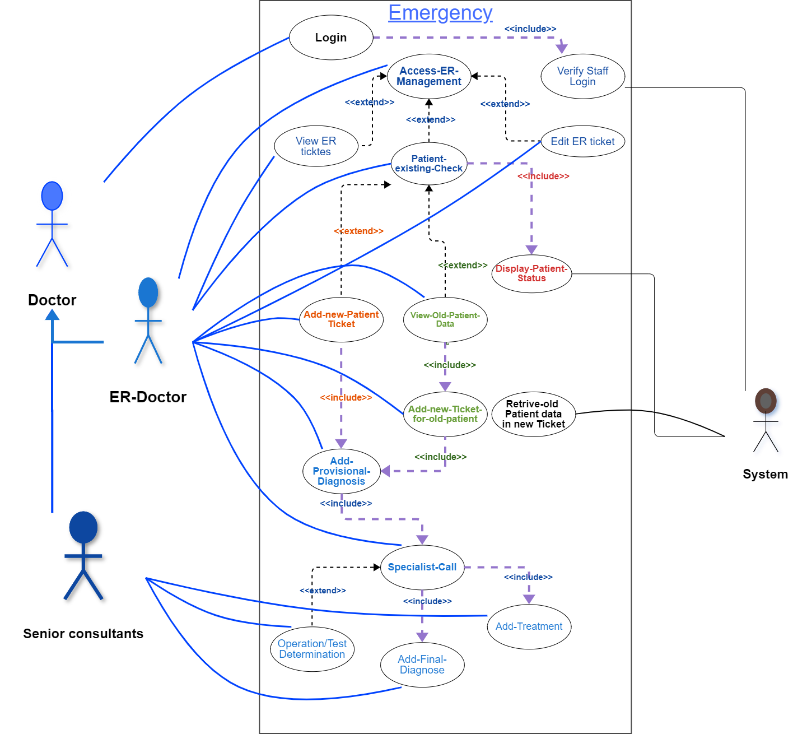

Figure 38 Usecase 1

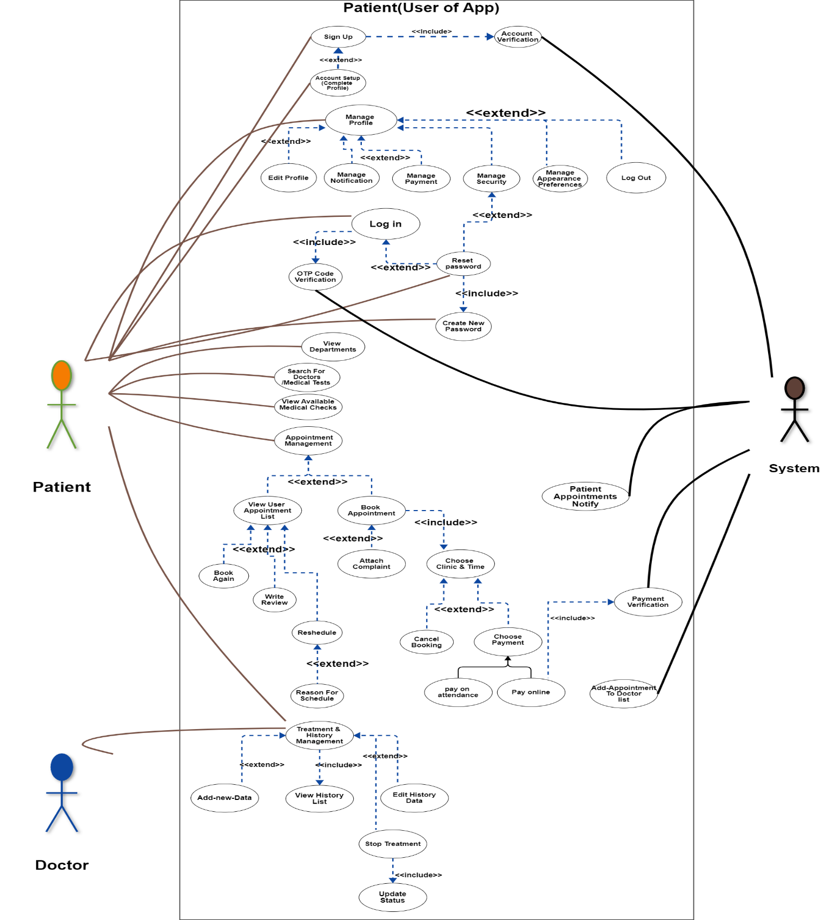

Figure 39 UseCase 2

## Sequence Diagram

The sequence diagram is used primarily to show the interactions between objects in the sequential order that those interactions occur. Much like the class diagram, developers typically think sequence diagrams were meant exclusively for them. However, an organization's business staff can find sequence diagrams useful to communicate how the business currently works by showing how various business objects interact. Besides documenting an organization's current affairs, a business-level sequence diagram can be used as a requirements document to communicate requirements for a future system implementation. During the requirements phase of a project, analysts can take use cases to the next level by providing a more formal level of refinement. When that occurs, use cases are often refined into one or more sequence diagrams. [10]

#### Diagram Description automatically generatedUser Login

Figure 40 User Login Sequence Diagram

As shown in this Figure the user [user] can log in to the system by entering his name and his password then the system will accept if it matches the id with the password in the database, reject otherwise.

#### User Logout

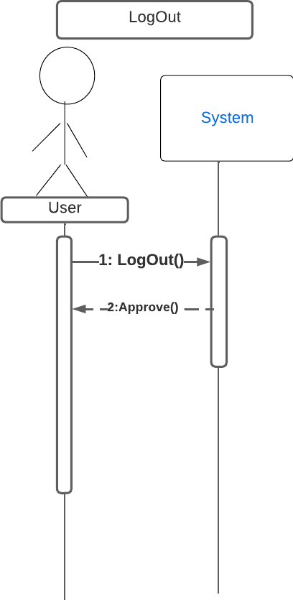

Figure 41 User Logout Sequence Diagram

As shown in this Figure the user [ patient, doctor, system-admin ] will log out from the system and the system will inform him if his log out has been done successfully.

#### User Data Access

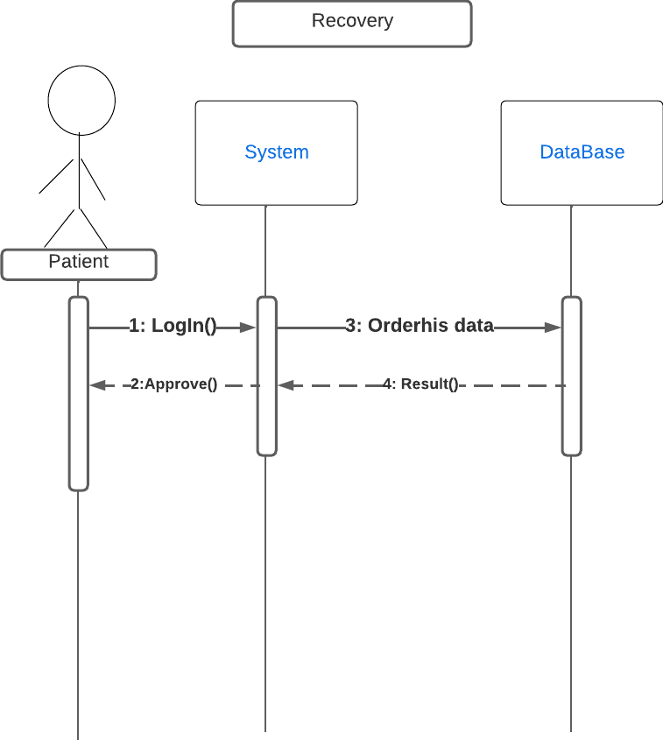

Figure 42 User Data Access

As shown in this Figure the user [ patient ] when patient want to see or access his history data in the hospital he can login in the system and get it from his profile .

#### Diagnose

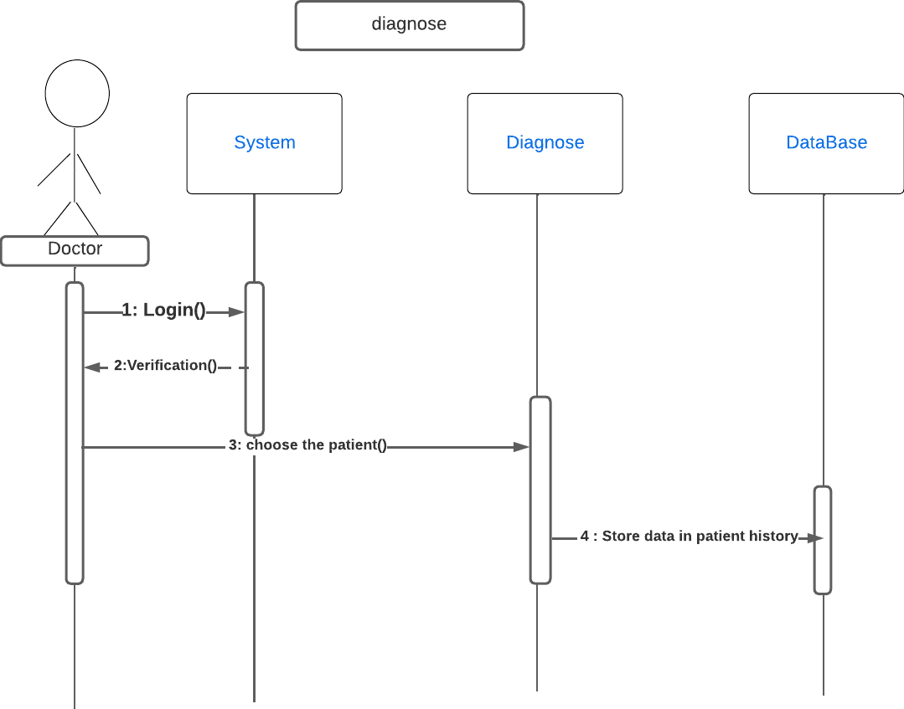

Figure 43 Diagnose Sequence Diagram

When a patient enters the hospital in any of its departments, whether the clinics or the reception clinic, the doctor diagnoses him and stores that in the database, which adds any history of the patient’s diagnoses.

#### Treatment

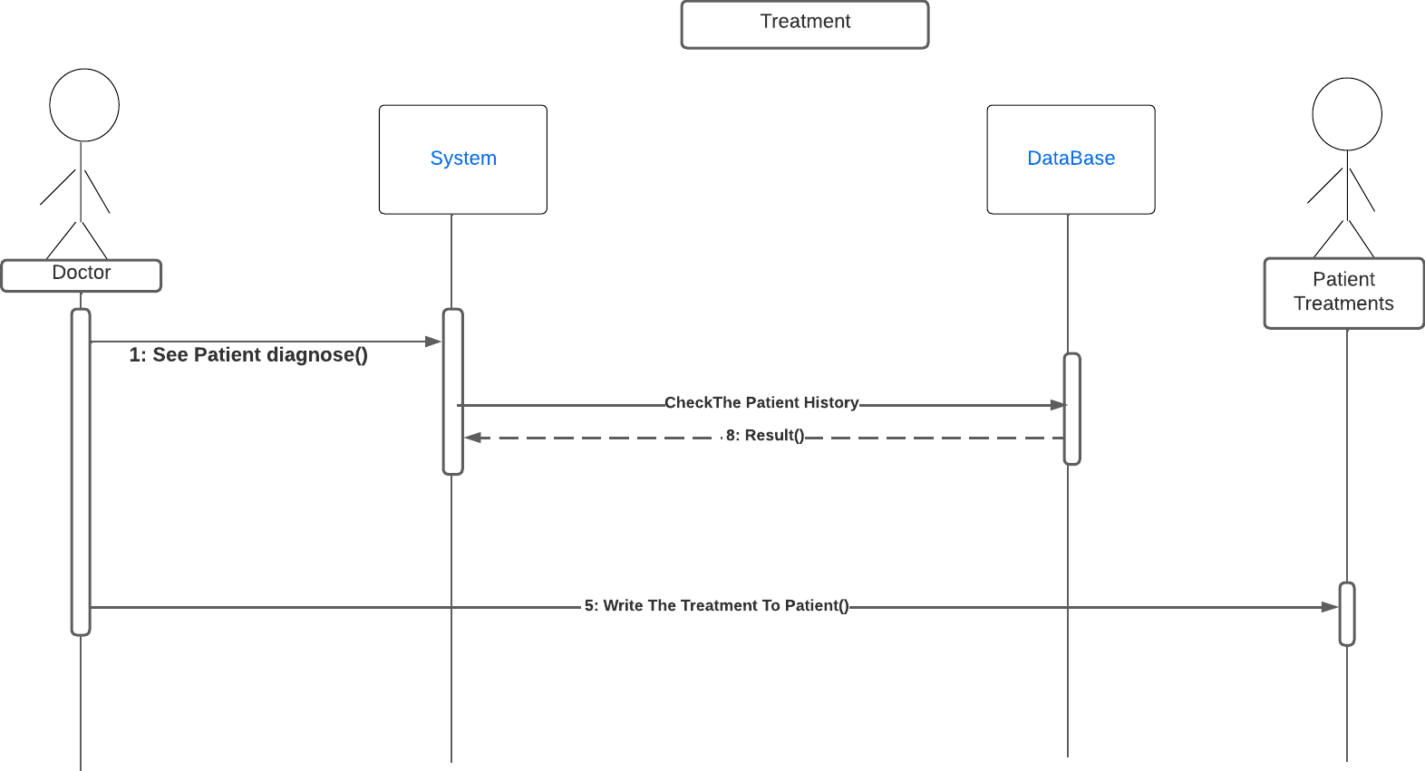Figure 44 Treatment Sequence Diagram

As shown in this Figure the user [ patient ] Here we see that when the patient comes to the doctor to take a treatment for him or a treatment plan, the doctor reviews the patient's diagnoses from the database, and then gives the patient his treatment plan

#### Patient entering Intensive Care Unit

Figure 45 ICU Sequence Diagram

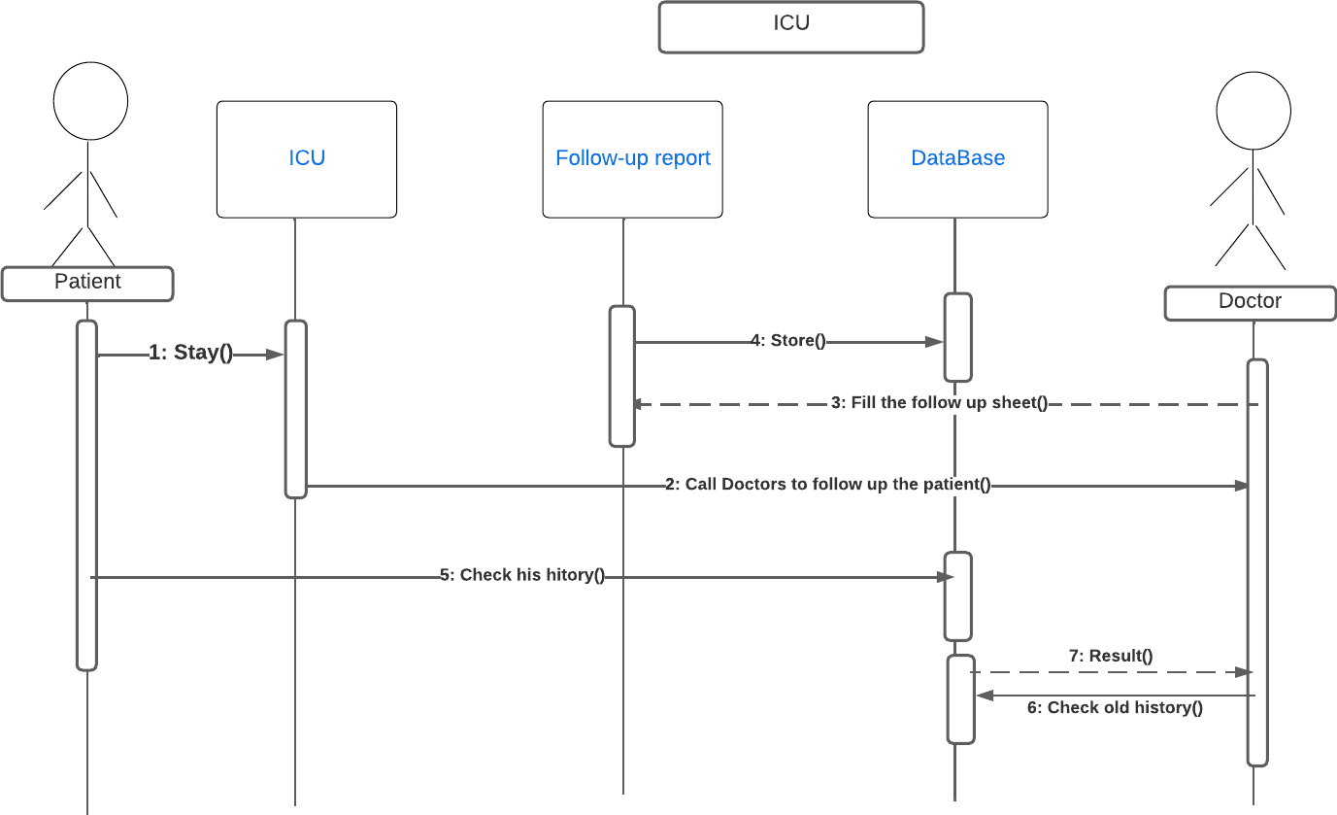

As shown in this Figure the user [ patient ] when it tended him to enter the ICU in the hospital the doctor will access his follow-up sheet and it will be stored in the database

#### Patient Entering the Emegency

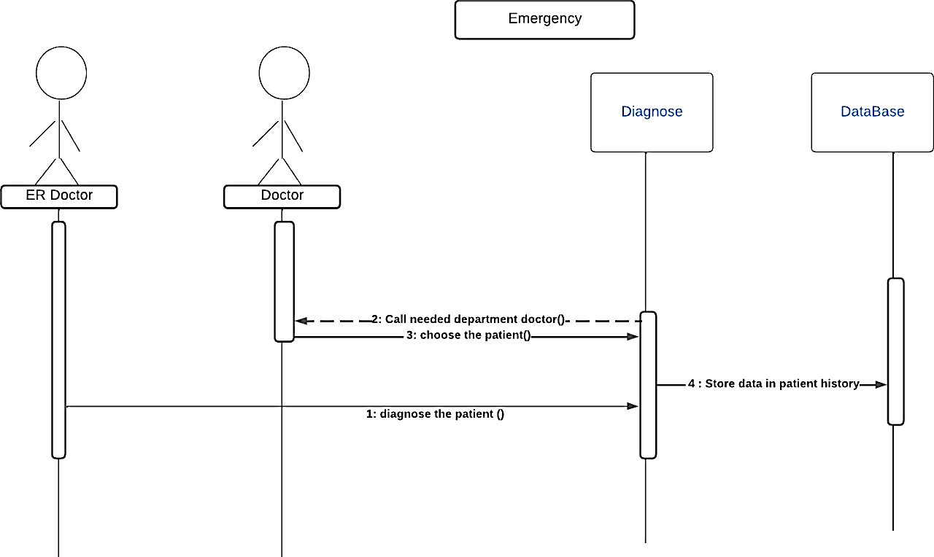

Figure 46 Patient Entering Emergency

In this form, it is shown that when the receiving doctor finds that the patient needs necessary care, he informs the doctors responsible for such cases so that they diagnose and follow them up.

## Data Flow Diagrams

The Data Flow Diagram (DFD) provides a graphical representation of the flow of data through a system. It shows logically what information is exchanged by our system processes and external interfaces or data stores, but it does not explicitly show when or in what sequence the information is exchanged. [11]

#### Context Diagram

Figure 47 Context Diagram

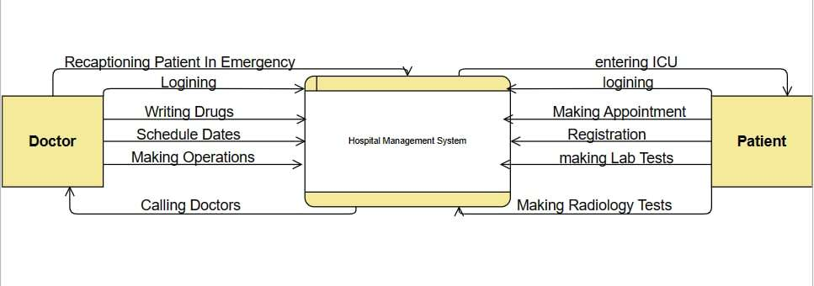

This diagram is a general level from Data Flow Diagram and it contains the external entities which link with our system using processes between them.

#### Level 1

Figure 48 Patient DataFlow Diagram

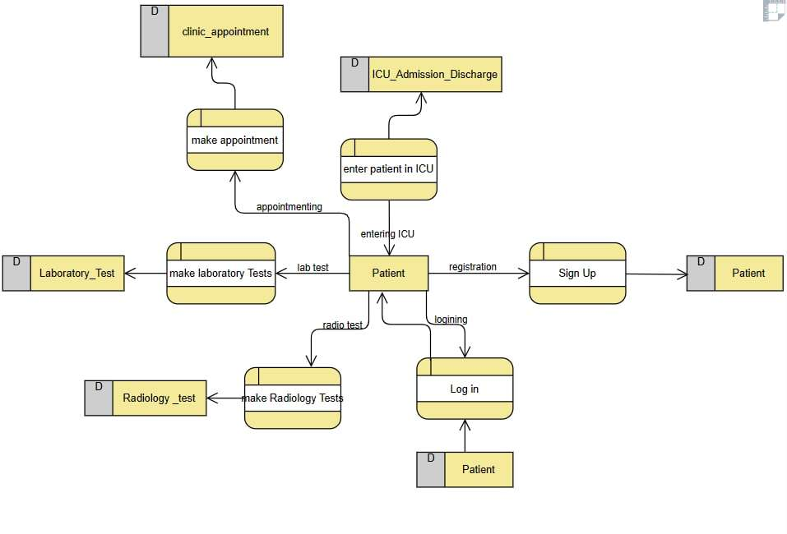

First Data Flow Diagram explain the Processes by which External Entity (Patient) can interact with the system and how the system can interact with the patient.

Figure 49 Doctor DataFlow Diagram

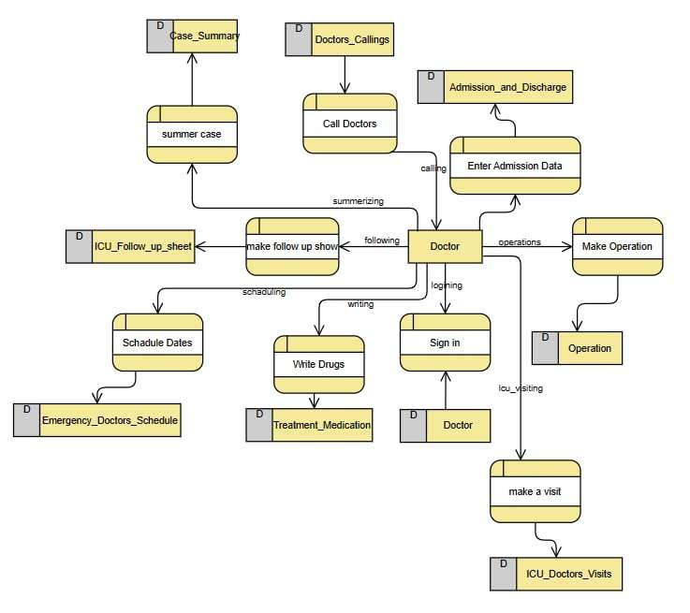

Second Data Flow Diagram explain the processes by which the Doctor can interact with the system and how the system can interact with External Entity (The Doctor in This Diagram).

## Activity Diagram

Activity diagrams are graphical representations of workflows of stepwise activities and actions with support for choice, iteration and concurrency. In the Unified Modeling Language, activity diagrams are intended to model both computational and organizational processes (i.e., workflows), as well as the data flows intersecting with the related activities. Although activity diagrams primarily show the overall flow of control, they can also include elements showing the flow of data between activities through one or more data stores. [12]

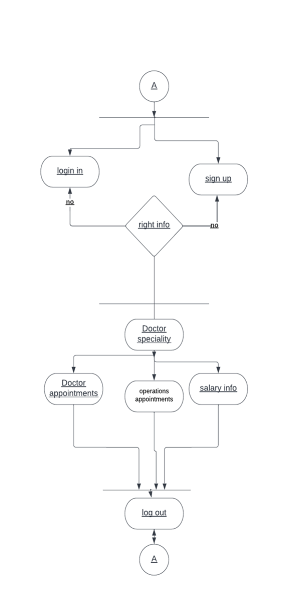

Figure 50 Doctors Activity diagram

Firstly, in the activity diagram of the doctor the diagram move from start point to login and sign up activity if the information is wrong the data replayed into the login and sign up activity again. Secondly, the application passes through 1 main activity doctor specialty branches from it 3 activities doctor appointment and operation appointment and salary info application passes on log out activity and ends.

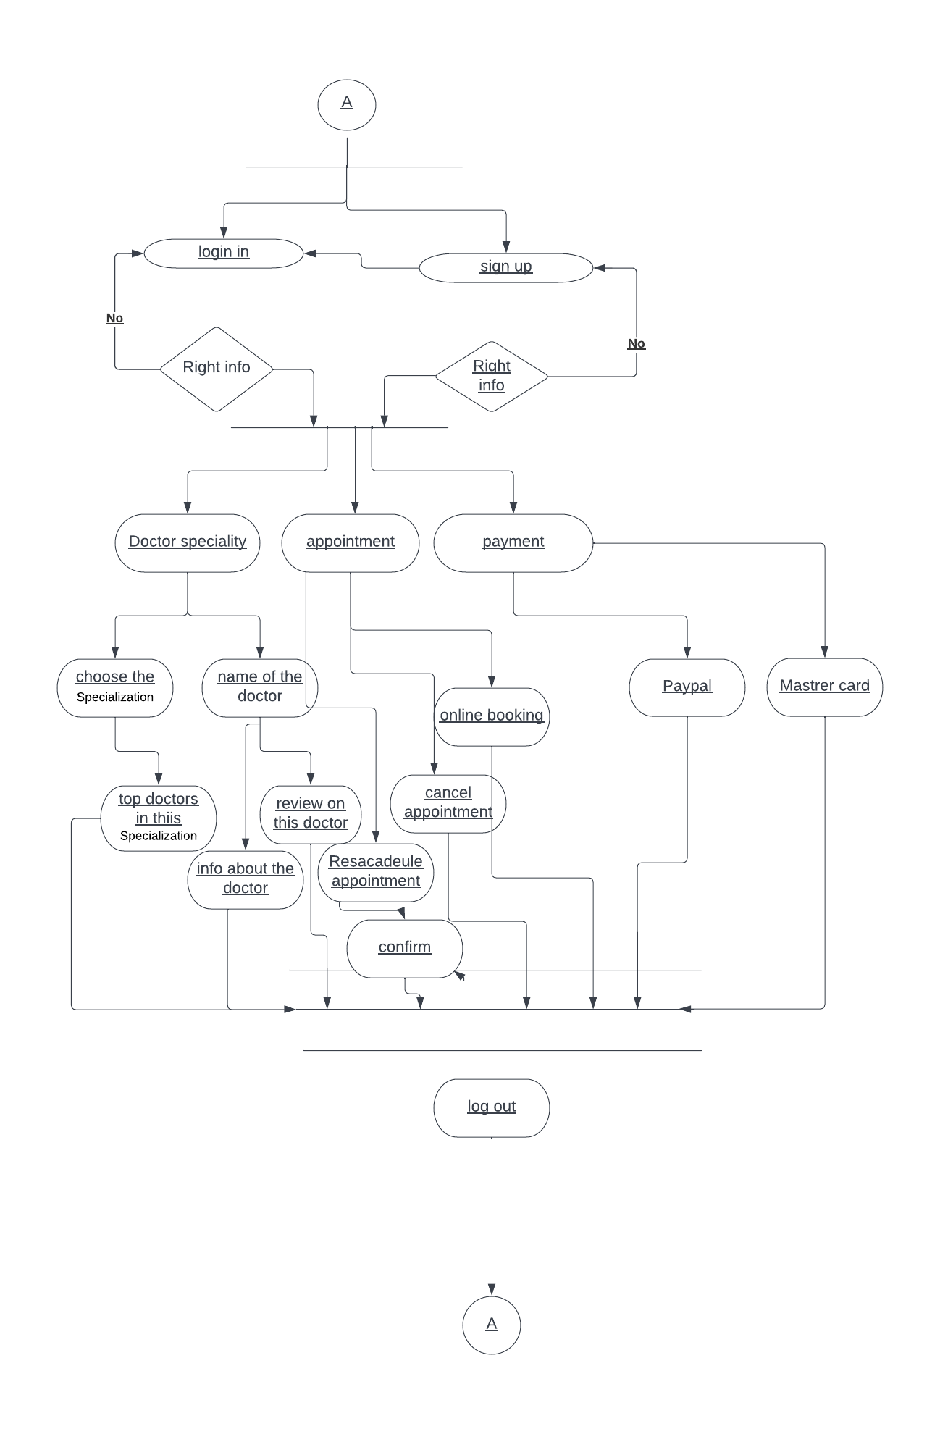

Figure 51 Patient Activity Diagram

Firstly, in the activity diagram of the patient the diagram moves from start point to login and sign-up activity if the information is wrong the data replayed into the login and sign-up activity again. Secondly, the application passes through 3 main activities doctor specialty and appointment and payment and from every activity of these activities branches from it many activities .At last the application passes on log out activity and ends.

# Chapter 4 : Implementation Methodology

The implementation methodology for our systems aims to develop a comprehensive mobile and web-based application that allows patients to book appointments, access their medical history, and communicate with their doctors. The application will also provide doctors with features to manage their schedules and patient meetings. The implementation methodology will use Flutter, a cross-platform framework for mobile app development, to create an intuitive and user-friendly interface for patients and doctors. Additionally, a web-based front-end will be developed to provide access to the system from desktops and laptops. The project will also include a robust back-end to handle data processing and storage. The implementation methodology will follow a structured approach, involving front-end development, back-end development, integration, testing, and deployment, to ensure that the final product meets the project requirements and provides a seamless experience for patients and doctors.

The implementation methodology will follow an iterative and incremental approach, with each iteration building upon the previous one. This approach allows for flexibility and agility, as changes and updates can be made to the project as it progresses.

The front-end development will focus on creating a visually appealing and user-friendly interface for mobile and web-based applications. The user interface will be designed to be intuitive and easy to use for patients and doctors, with features such as appointment scheduling, medical History, and communication tools.

The back-end development will involve creating a scalable and secure server-side API to handle data processing and storage. The API will be designed to handle requests from the mobile and web-based front-end and will include features such as user authentication, data encryption, and database management.

Overall, the implementation methodology for the Hospital management systems project will be focused on creating a user-friendly and secure application that meets the needs of patients and doctors and provides a seamless experience for both parties.

as will be shown below:

## Mobile Application

The mobile application for our project is designed to provide patients with a convenient and user-friendly way to book appointments, access their medical history, and communicate with their doctors. The application will be built using Flutter, a cross-platform framework for mobile app development, and will feature a modern and simple user interface.

### Development Framework (Flutter)

Flutter is a mobile app development framework that allows developers to create high-quality and performant mobile apps for both Android and iOS platforms. Flutter is known for its fast development cycle, hot reload feature, and cross-platform compatibility, making it a popular choice for mobile app development.

We chose to use Flutter for our hospital system project because of its advantages in terms of speed, flexibility, and ease of development. Flutter's fast development cycle and hot reload feature allow developers to make changes to the code and see the changes in real-time without having to restart the app. This saves us a lot of time and effort during the development process, allowing us to focus more on the core features of the app.

In addition, Flutter's cross-platform compatibility allows us to build the app for both Android and iOS platforms using a single codebase, which reduces our development time and effort. This also ensures that the app has a consistent look and feel across different platforms, providing a seamless user experience.

Moreover, Flutter has a rich set of widgets and tools that make it easy to create beautiful and engaging user interfaces. This is important for our hospital system project because we need to provide patients with an intuitive and user-friendly interface that allows them to book appointments and access their health history easily.

Overall, we chose to use Flutter for our hospital system project because of its speed, flexibility, cross-platform compatibility, and rich set of tools and widgets. Flutter provides us with the tools we need to create a high-quality and performant mobile app that meets the needs of our users.

### State Management

State management is an important aspect of the hospital management systems project mobile application implementation methodology. Refers to how application data is stored, updated, and displayed in the user interface. The implementation methodology will use both BLoC/Cubit and GetX state management methods, which provide scalable and efficient ways to manage state in Flutter applications. These approaches will allow for seamless user experiences, efficient data sharing, and easy application testing and maintenance, which we will explain in detail, first:

1. **BLoC (Business Logic Component)** is a design pattern used in Flutter for managing the state of an application. BLoC separates the business logic from the presentation layer and provides a clear separation of concerns. It is a very popular design pattern in the Flutter community, and it is widely used in building complex and large-scale applications.

BLoC is important in your hospital system project because it helps you manage the state of your application in a predictable and efficient manner. By separating the business logic from the presentation layer, you can easily update and maintain your code, which is essential for any large-scale project.

One of the main benefits of using BLoC is that it helps you keep your code modular and reusable. You can easily isolate your business logic into separate components and reuse them across your application. This not only saves you time but also makes your code more organized and maintainable.

In addition, BLoC also helps you manage your application's state efficiently. By using streams and stream controllers, you can easily track and manage changes to your application's state. This allows you to update the UI only when necessary, reducing unnecessary re-renders and improving performance.

For example, in your hospital system project, you can use BLoC to manage the state of patient appointments and health history. You can create a separate AppointmentBloc and HistoryBloc that manage the state of these components, and then use them across your application. This allows you to easily update and maintain these components, and also improves the performance of your application.

In summary, BLoC is an important design pattern in Flutter for managing the state of an application. By separating the business logic from the presentation layer, BLoC helps you keep your code modular, reusable, and maintainable. It also allows you to manage your application's state efficiently, improving performance and reducing unnecessary re-renders.

1. **GetX** is a popular lightweight and powerful state management library for Flutter that offers several features and advantages over other state management solutions.

Here are some of the key advantages and features of the GetX library:

Simple and Intuitive API: GetX provides an easy-to-understand API, making it quick and easy to set up state management for your Flutter application.

Reactive State Management: GetX allows for reactive state management, which means that your UI will automatically update when data changes.

Dependency Injection: GetX offers a powerful dependency injection system, which makes it easy to manage dependencies and avoid tightly-coupled code.

Routing and Navigation: GetX offers a simple and powerful routing and navigation system that makes it easy to manage navigation within your app.

Performance: GetX is highly optimized for performance, providing fast and efficient state management that won't slow down your app.

Minimal Boilerplate: GetX requires minimal boilerplate code, which means that you can focus on building your app instead of writing repetitive code.

Easy Testing: GetX makes it easy to write unit tests for your app, allowing you to test your code and ensure that it works as expected.

Overall, GetX is a powerful and flexible state management solution that offers several key advantages over other state management libraries. Whether you're building a small app or a large-scale project, GetX can help you simplify your code and improve your app's performance.

For our hospital systems project, we decided to use both BLoC and GetX for state management. We chose BLoC because it provides a clear separation between the UI and the business logic of the application, using streams to manage the flow of data. This is particularly useful for managing complex data structures and business logic. On the other hand, we chose GetX because it provides a simpler and more straightforward API for state management, making it easier to manage dependencies and decouple components in the application. GetX also includes a built-in dependency injection system, which simplified the process of managing dependencies in our project.

Using both BLoC and GetX in our hospital systems project provided a powerful combination of state management solutions. We used BLoC for managing the complex data flows and business logic involved in booking appointments and managing health history, while using GetX for simpler state management tasks such as displaying UI elements or handling user input.

### Design Pattern

The Model-View-Controller (MVC) pattern is a design pattern used in software engineering to separate the application's data, user interface, and control logic into three distinct components. Here's how it can be applied to your hospital systems mobile app:

**Model:**

The Model represents the data and business logic of the application, including user information, appointment details, medical records, and diagnoses.

It communicates with the controller to update the view and handle user input.

**View:**

The View is the user interface component of the application, including the screens, buttons, and other interactive elements.

It displays the data from the Model and provides an interface for user interaction.

It communicates with the controller to send user input and update the Model as necessary.

**Controller**:

The Controller acts as the intermediary between the View and Model components, handling user input and updating the Model accordingly.

It retrieves data from the Model and updates the View to reflect changes in the data.

It receives user input from the View and updates the Model accordingly.

### Features

**Easy Access to Information:**

A Flutter-based app can provide easy access to information about the hospital, such as location, contact details, services offered, and doctors' profiles. This can help patients and doctors make informed decisions about their healthcare needs, and doctors can also view their schedules and patient information through the app.

**User-Friendly Interface:**

Flutter offers a user-friendly interface that can make it easier for patients and doctors to navigate the app, find information, and access healthcare services. This can improve the overall user experience and increase patient and doctor satisfaction.

**Accessibility:**

Flutter's responsive design and accessibility features can make it easier for patients and doctors with disabilities to use the app and access healthcare services.

**Push Notifications:**

Using push notifications, a Flutter app can alert patients and doctors about upcoming appointments, test results, and health-related reminders. This can improve patient and doctor engagement and help them stay on top of their healthcare needs.

**Patient Portals:**

A Flutter-based app can provide patients and doctors with access to medical records, test results, and prescriptions. This can help patients track their health status, communicate better with their doctors, and take a more proactive approach to their healthcare. Doctors can also write diagnoses and other medical information that appear for the patient through the app.

**Authentication:**

Register and login: Allows patients to create an account and log in securely using their email address or social media accounts.

Forgot password: Allows patients to reset their password in case they forget it.

**Online Appointments:**

The Online Appointments feature in the Hospital Systems app allows patients to schedule, edit, add, or cancel appointments with doctors online. This feature eliminates the need for patients to visit the hospital or clinic physically, saving time and making the appointment process more convenient for them.

**Booking:**

The app allows patients to view available doctors, select a preferred date and time slot, and book an appointment with a doctor of their choice based on availability and medical needs.

Add Appointment: The app enables patients to add new appointments with doctors of their choice, providing flexibility and convenience in scheduling appointments.

Cancel Appointment: The app allows patients to cancel a previously scheduled appointment, providing them with the option to reschedule at a later time.

Update Appointment: The app allows patients to reschedule appointments or change the doctor they've booked an appointment with, providing them with flexibility in managing their healthcare appointments.

**Favorite doctors:**

Add favorite doctors: Allows patients to add doctors they prefer to their list of favorite doctors, making it easier to find them in the future.

View favorites doctors: Allows patients to view their list of favorite doctors and book appointments with them directly.

**Search and Filtration:**

Search for doctors: Allows patients to search for doctors by name, specialty, or location.

Filter search results: Allows patients to filter search results based on criteria such as availability, rating, and experience.

**Online Diagnoses Management:**

With this feature, patients can upload, download, and view their diagnosis files online. The app enables patients to securely store their medical documents, including lab results, X-rays, and other health-related files. They can also share these files with their doctors or other healthcare providers for review and recommendations.

**Image to PDF Conversion:**

This feature allows patients to scan any image and convert it into a PDF format. This makes it easier for patients to view and share their medical documents with their doctors or other healthcare providers. The app's conversion feature is fast and reliable, providing high-quality PDF files.

**Diagnoses File Management for Doctors:**

This feature enables doctors to access and review their patients' diagnosis files online. Doctors can add their recommendations or treatment plans to these files, and patients can view the updates in real-time. Doctors can also securely download the files for sharing with other healthcare providers or for personal records.

**Health Articles:**

Our hospital system app includes a feature that provides patients with access to a global API for health and medical articles. Patients can browse and read articles related to various health topics, such as disease prevention, treatment options, and healthy lifestyle tips. The articles are curated by medical professionals and updated regularly to ensure that patients receive accurate and up-to-date information. This feature can help patients stay informed about their health and make more informed decisions about their healthcare needs.

**Dark Mode:**

Allows users to switch between a light and dark mode interface in the app.

Users can access this feature in the settings section of the app.

The dark mode feature allows users to switch to a dark background theme that can be easier on the eyes and help reduce eye strain, especially in low-light environments. It can also help save battery life on devices with OLED or AMOLED screens. The option to switch between light and dark mode can be accessed through the settings section of the app, giving users the flexibility to choose the mode that works best for them.

### App Snippets

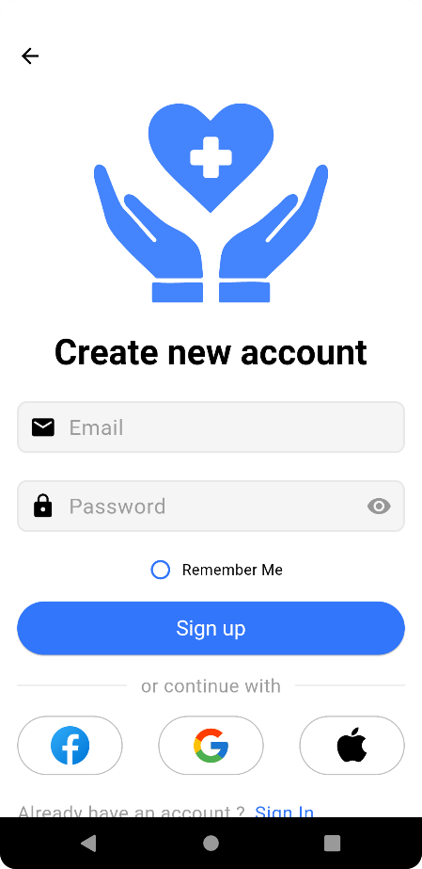

Figure 52 Sign Up Screen

Figure 53 On Boarding Screen

Figure 54 Splash Screen

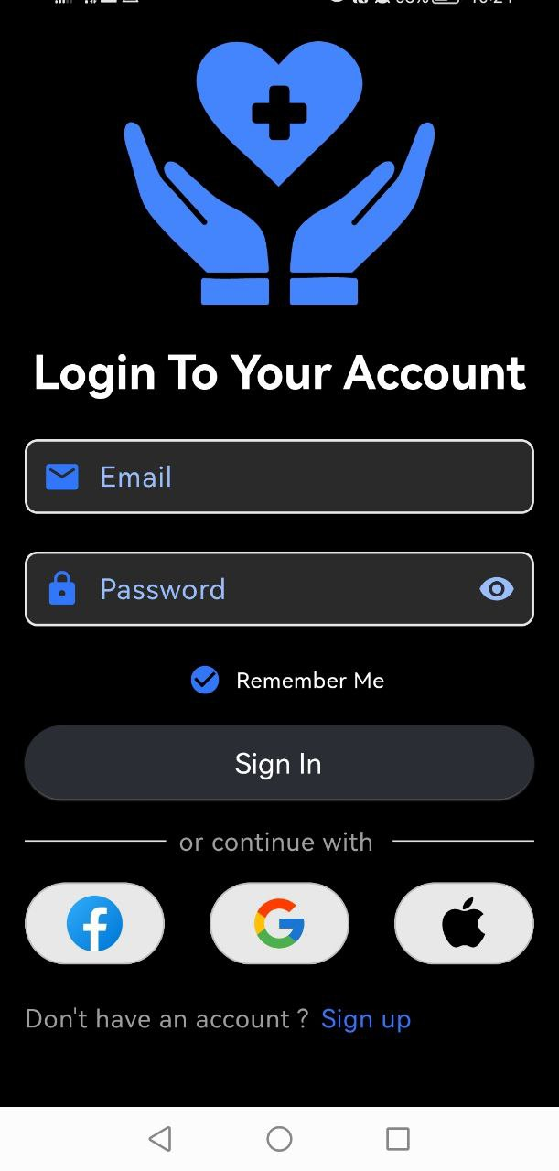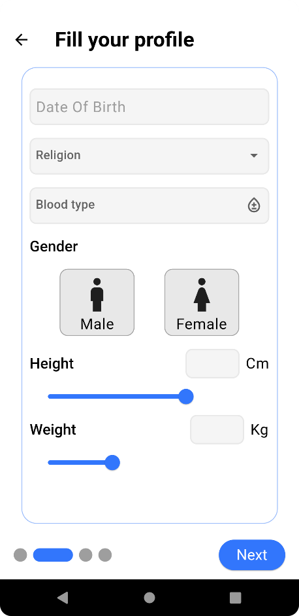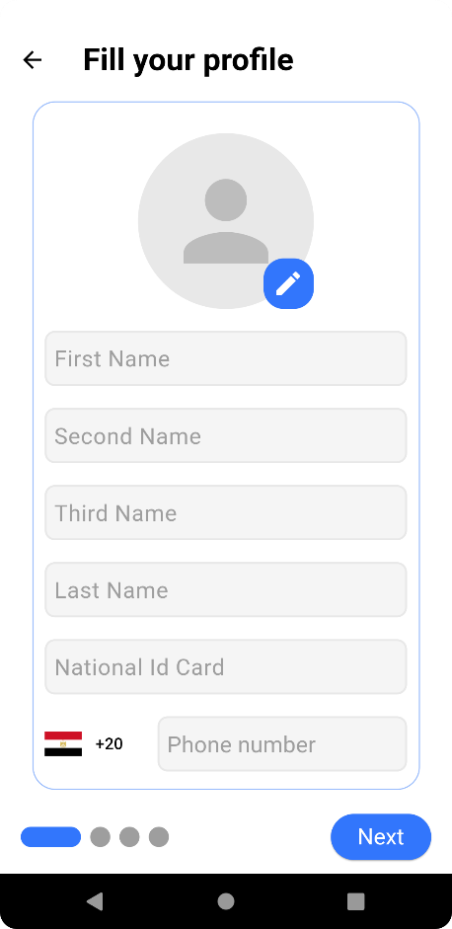

Figure 55 Profile Data 2

Figure 56 Profile Data 1

Figure 57 Sign In Screen

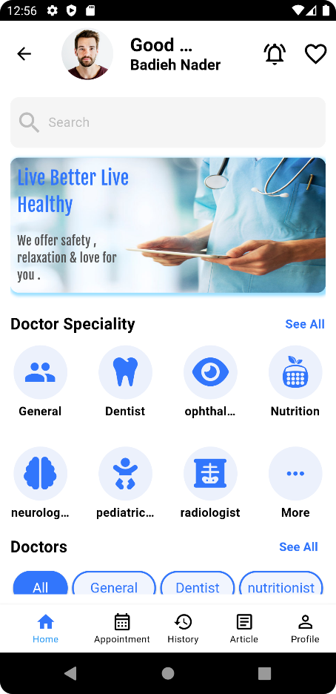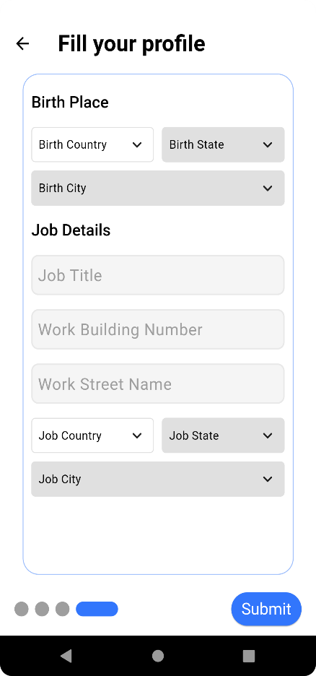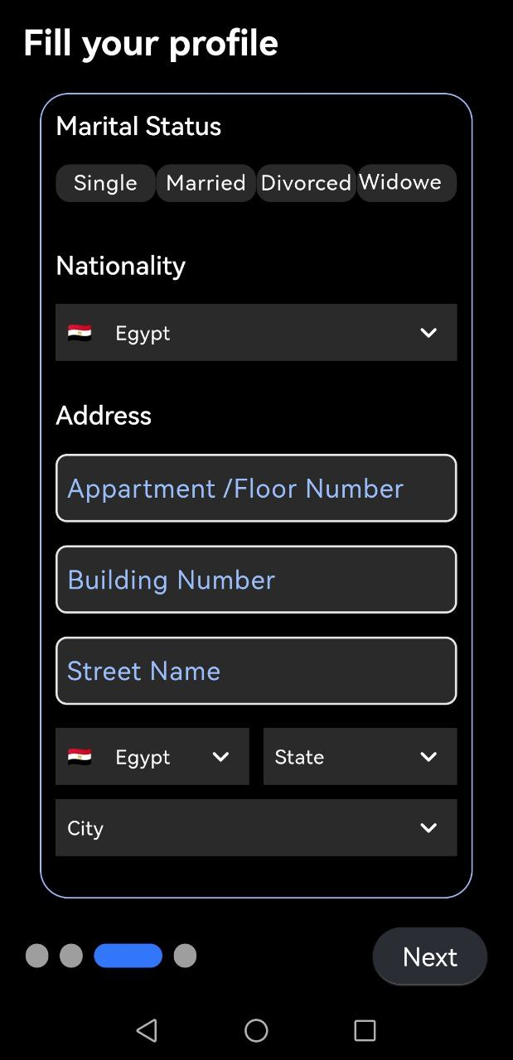

Figure 58 Profile Data 3

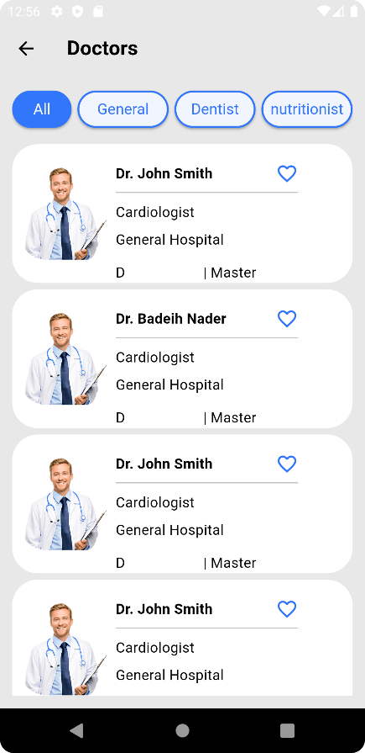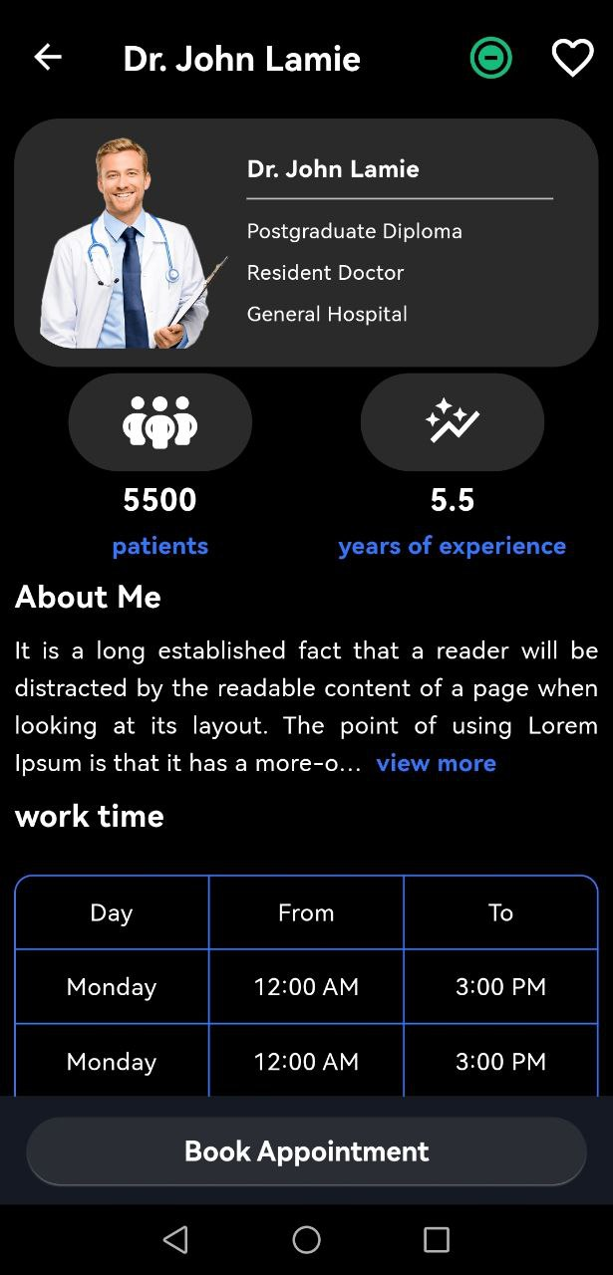

Figure 59 Home Screen

Figure 60 Profile Data 4

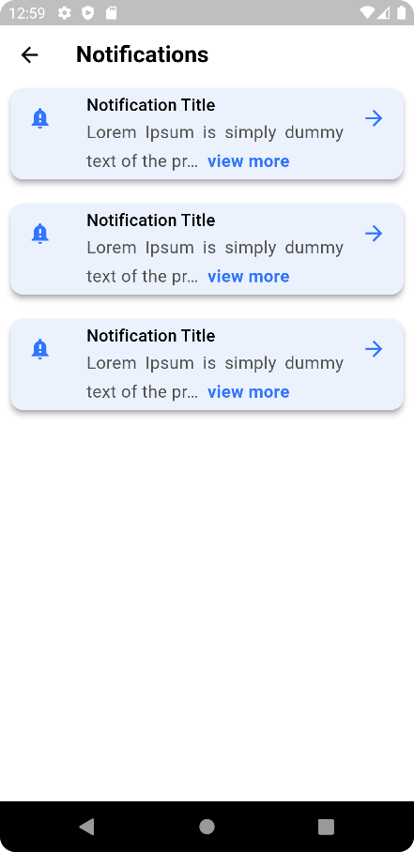

Figure 61 Notification Screen

Figure 62 Doctor Details

Figure 63 Doctors Screen

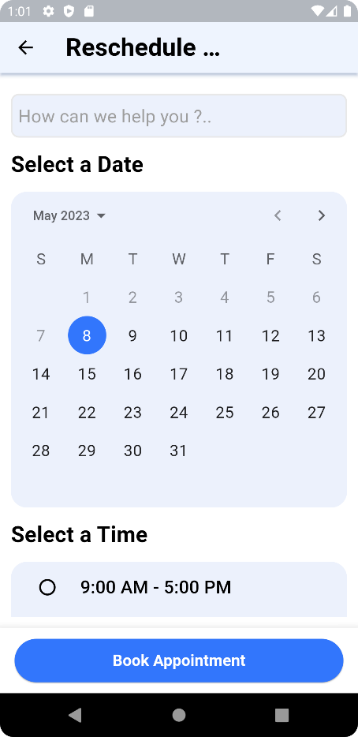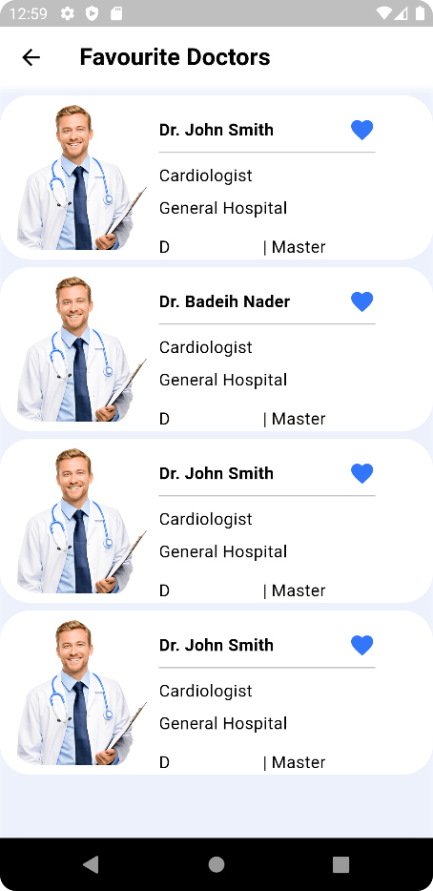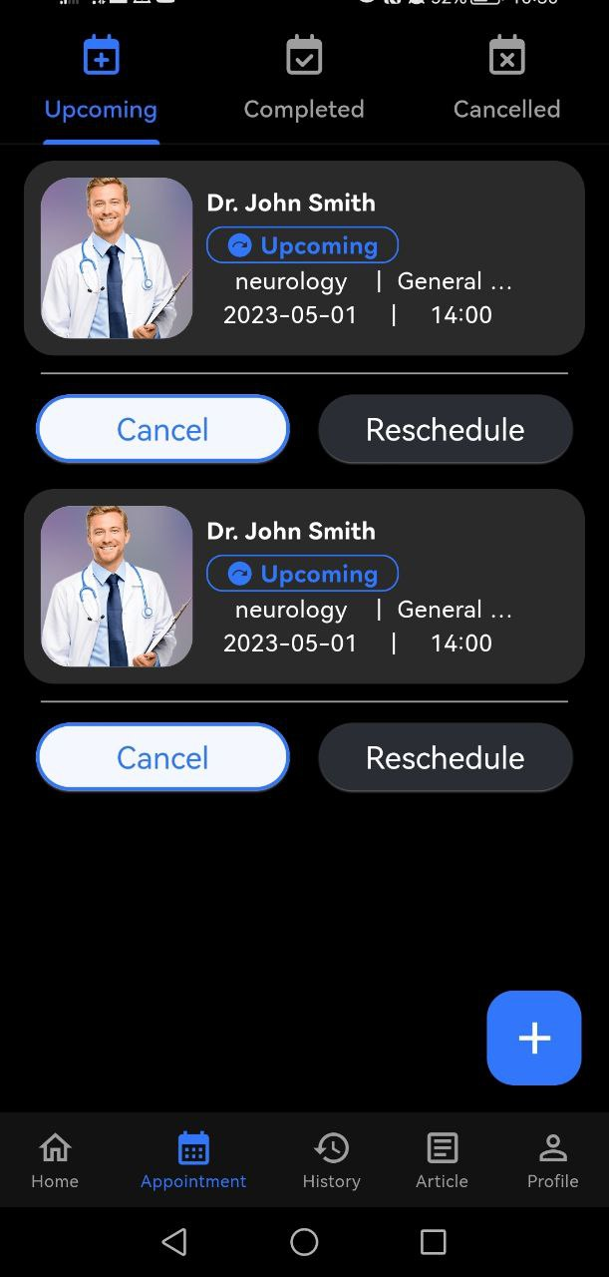

Figure 64 Favourite Doctors Screen

Figure 65 Upcoming Appointments Screen

Figure 66 Reschedule Appointment Screen

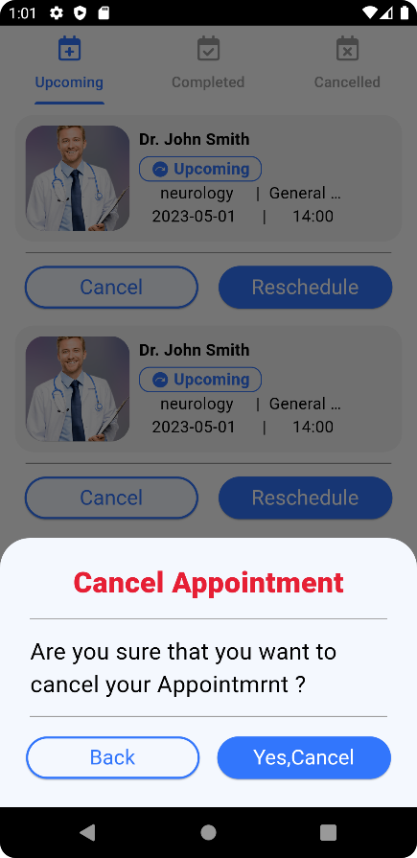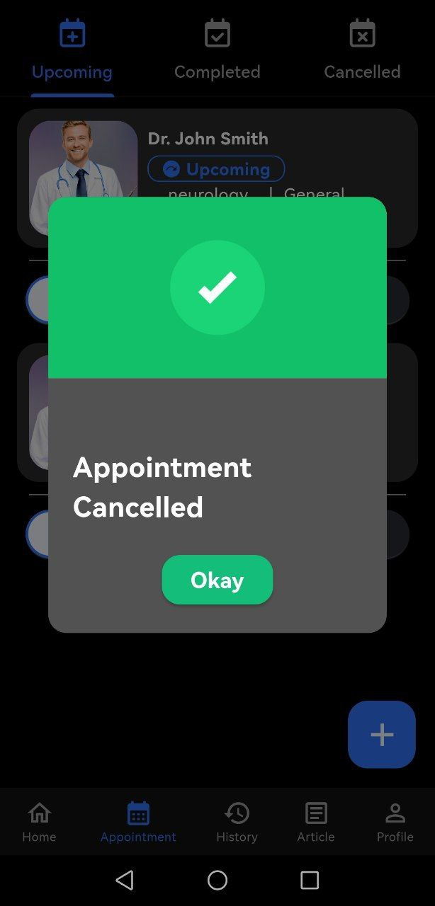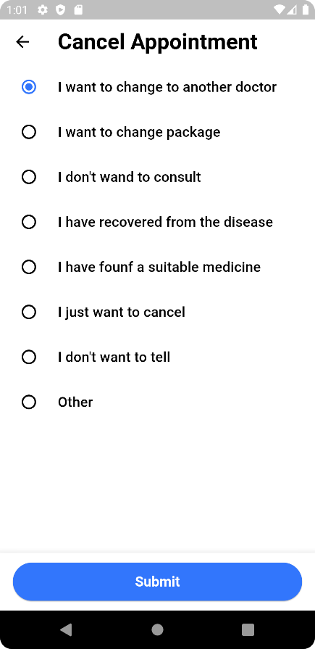

Figure 67 Cancel Appointment Screen

Figure 68 Confirmation Message

Figure 69 Cancellation Reason Screen

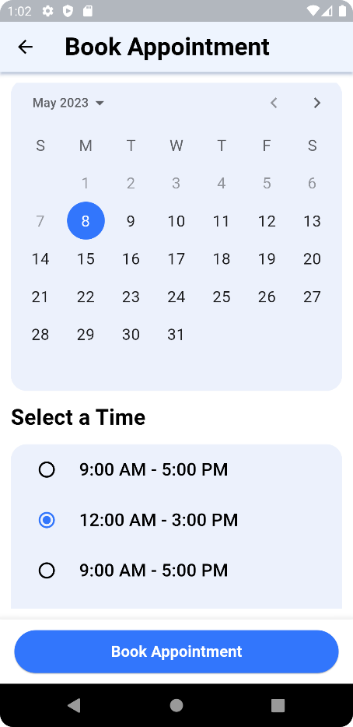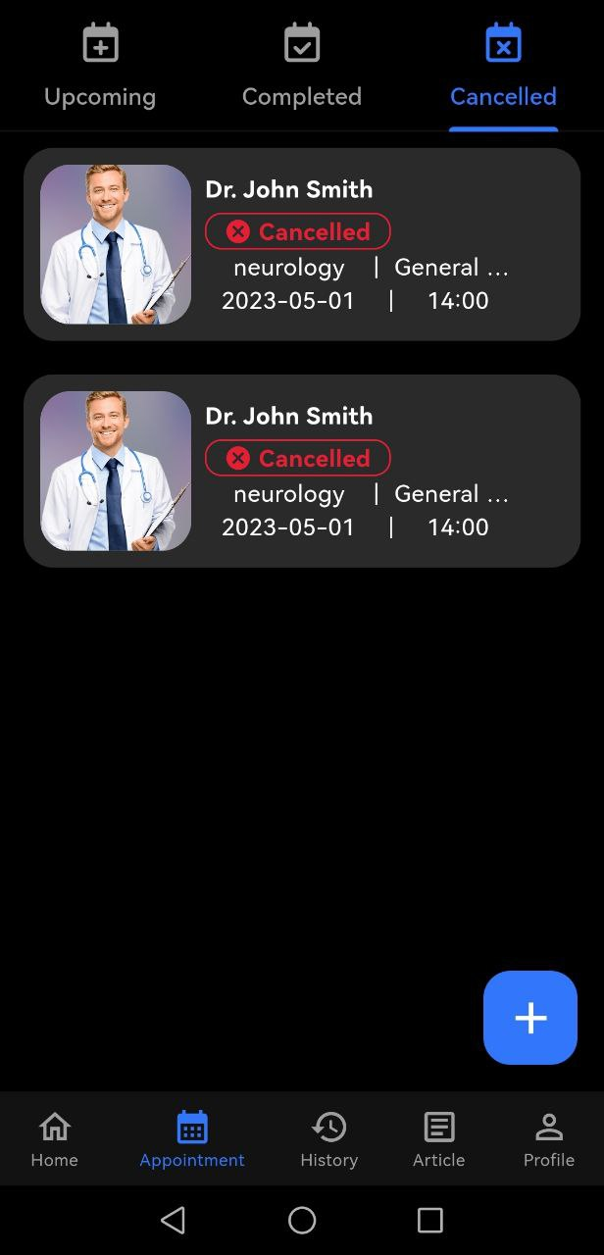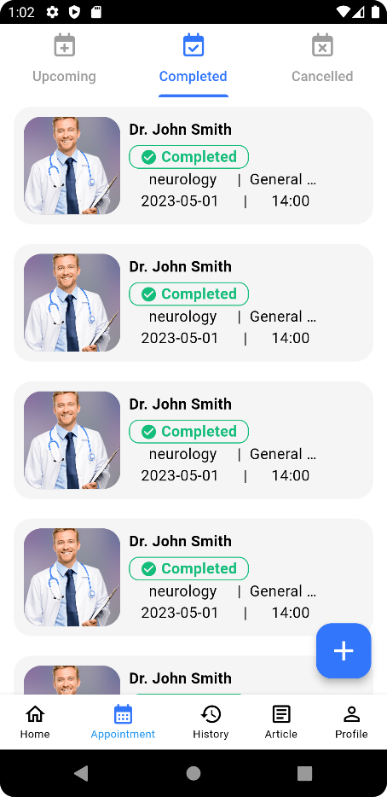

Figure 70 Completed Appointments Screen

Figure 71 Cancelled Appointments Screen

Figure 72 Book Appointment Screen

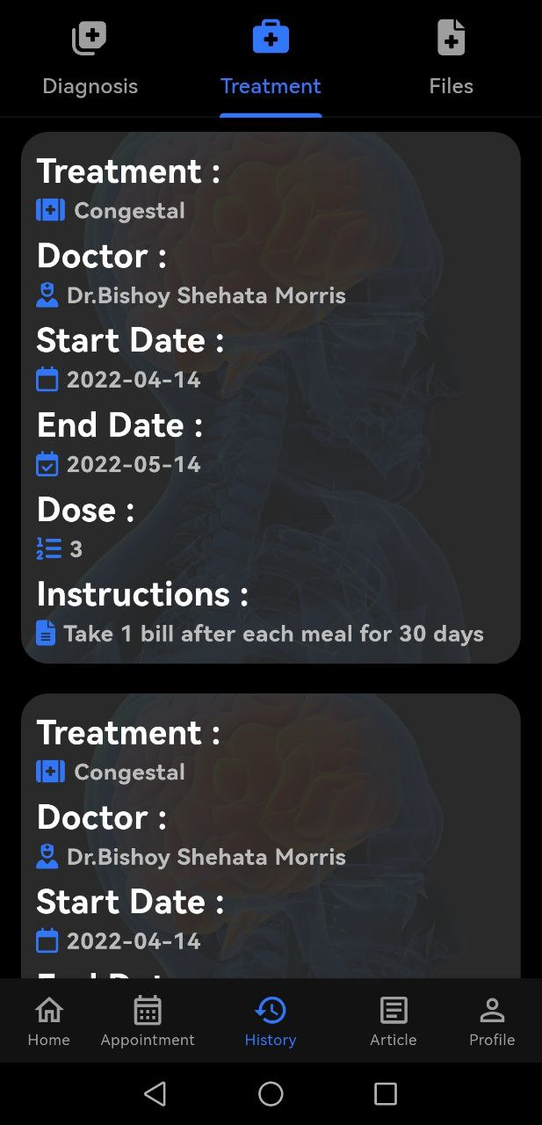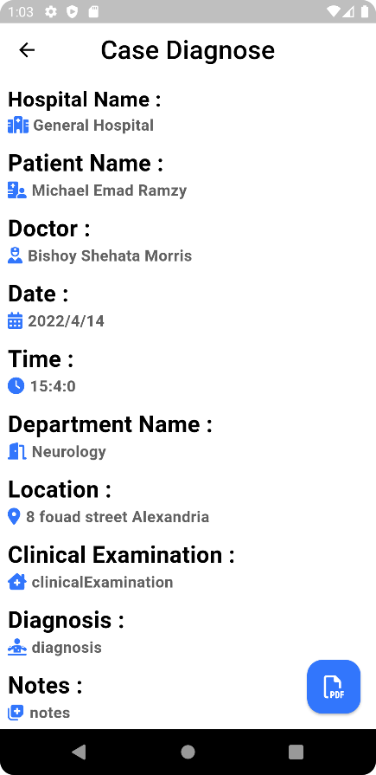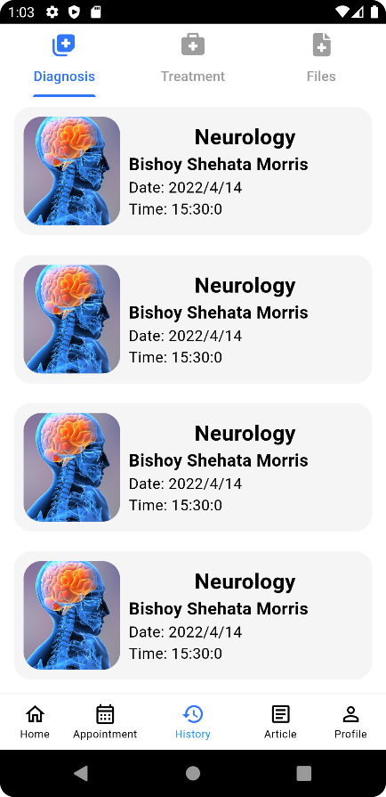

Figure 73 Treatments Screen

Figure 74 Case Diagnose Screen

Figure 75 Diagnoses Screen

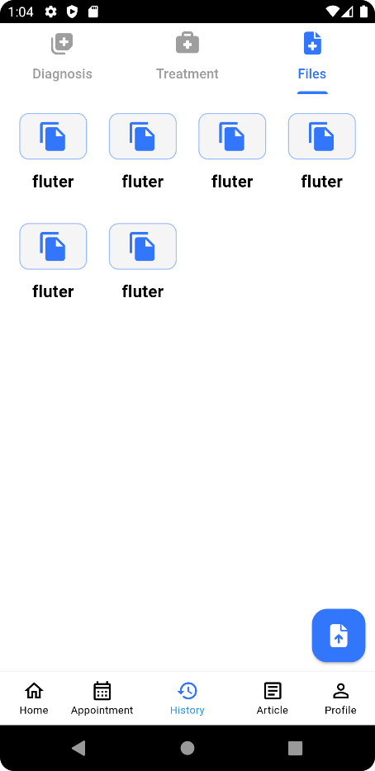

Figure 76 Article Screen

Figure 77 Articles Screen

Figure 78 Files Screen

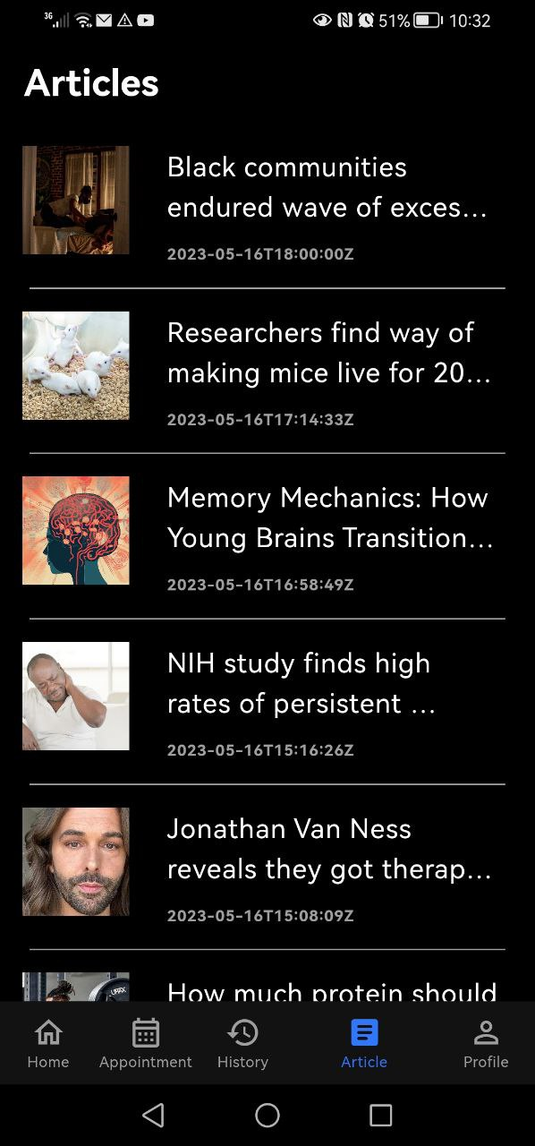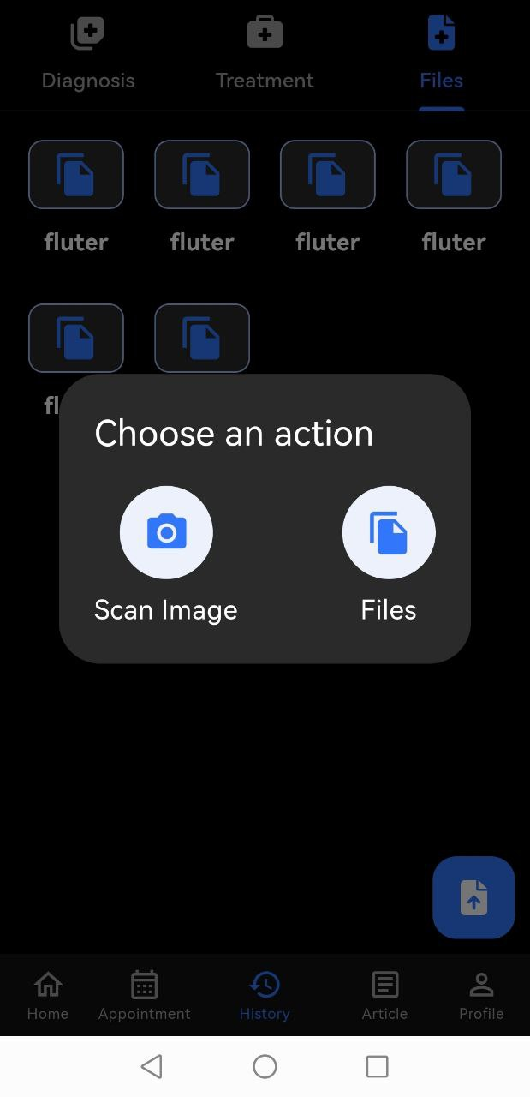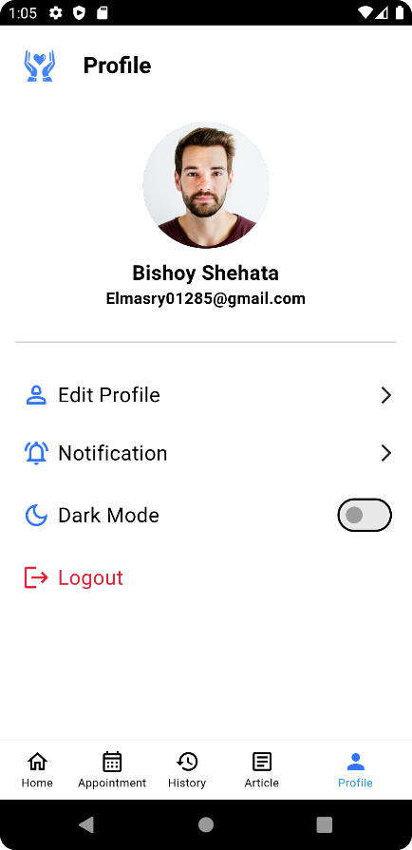

Figure 79 Pdf File Preview

Figure 80 Files Actions

Figure 81 Setting Screen

## Front-end

In today's digital age, web development has become an essential part of many industries, including healthcare. Our graduation project focuses on implementing a hospital system that allows patients to book appointments and access their health records online. To accomplish this, we utilized a variety of web development technologies, including HTML, CSS, JavaScript, and React JS.

Each of these technologies played a critical role in the success of our project. HTML provided the structure and content of our web pages, while CSS allowed us to style and format those pages for a more engaging user experience. JavaScript enabled us to add dynamic functionality to our pages, such as form validation and user input handling. Finally, React JS provided a powerful framework for building complex, interactive user interfaces.

While each of these technologies has its advantages and disadvantages, we believe that the combination of HTML, CSS, JavaScript, and React JS provided the optimal solution for our hospital system project. HTML is a widely recognized standard for web page structure, while CSS allows for consistent and attractive styling across all pages. JavaScript provides powerful client-side functionality and interactivity, and React JS allows for the creation of complex and dynamic user interfaces.

In the following sections of our graduation book, we will provide a more detailed overview of each of these technologies and how they were used in our project. We will also discuss the challenges we faced and how we overcame them, as well as our plans for future improvements to the hospital system. Overall, we believe that our use of these web development technologies has resulted in a user-friendly and efficient hospital system that can benefit both patients and healthcare providers.

### Technologies

#### HTML:

HTML, or HyperText Markup Language, is a standard markup language used for creating web pages. It provides the structure and content of web pages, including headings, paragraphs, lists, links, and images. By using HTML, we were able to create web pages that were easy to read and navigate, and that provided the necessary information for patients to book appointments and access their health records.

#### CSS:

CSS, or Cascading Style Sheets, is a style sheet language used for describing the visual presentation of web pages. It allows developers to control the layout, colors, fonts, and other visual aspects of web pages, making them more attractive and engaging for users. By using CSS, we were able to create a consistent and professional-looking design across all pages of our hospital system.

#### JavaScript:

JavaScript is a programming language used for creating interactive and dynamic web pages. It allows developers to add client-side functionality, such as form validation, user input handling, and data manipulation. By using JavaScript, we were able to create a more engaging and interactive user experience for patients, and to provide them with real-time feedback and alerts.

#### React JS:

React.js is a popular JavaScript library used for building user interfaces. It was created by Facebook and is widely used in web development.

React allows developers to build complex UIs using a declarative programming model. This means that developers can describe how a UI should look and behave and react takes care of the underlying code to make it happen.

One of the key features of React is its use of components. Components are like building blocks that can be combined to create more complex UIs. This makes it easy to reuse code and maintain a consistent look and feel across an application.

React also makes it easy to manage the state of an application. With React, developers can create dynamic UIs that respond to user input in real-time.

Overall, react is a powerful tool for building modern, dynamic web applications. Its flexibility and ease-of-use make it a popular choice for developers around the world.

This Technology we learn it by its documentation: https://legacy.reactjs.org/

In conclusion, the combination of HTML, CSS, JavaScript, and React JS provided a powerful and flexible solution for our hospital system project. Each technology played a critical role in creating a user-friendly and efficient system that can improve the patient experience and streamline healthcare operations. By mastering these technologies, we have gained valuable skills that can be applied to future web development projects in a wide range of industries.

#### Material Ui:

Material UI is a popular React component library that provides developers with a set of pre-designed UI components. The library is based on Google's Material Design guidelines, which emphasize a clean, modern, and consistent design language.

Material UI components are highly customizable, allowing developers to easily adjust the look and feel of their applications to match their brand or design aesthetic. They also come with a wide range of features, such as accessibility support, responsive design, and built-in animations.

One of the key benefits of Material UI is its ease of use. Developers can quickly build complex UIs by combining and customizing pre-designed components. This can save a significant amount of time and effort compared to building UIs from scratch.

Material UI also offers a range of tools and resources to help developers get started, including a comprehensive documentation library, code examples, and a vibrant community of users.

Overall, Material UI is a powerful tool for building responsive, modern, and visually appealing user interfaces. Its ease of use, customization options, and support for accessibility and responsive design make it a popular choice for developers around the world.

This Tool, we learn it by its documentation: <https://mui.com/material-ui>

#### React Router:

React Router is a popular library used for managing navigation and routing in React applications. It allows developers to create dynamic, single-page applications by mapping URLs to different components and allowing users to navigate between them without having to reload the page.

React Router provides a simple and flexible API, making it easy for developers to create and manage routes in their applications. It also includes a range of features, such as nested routes, route parameters, and programmatic navigation.

One of the key benefits of React Router is that it allows developers to create applications with multiple views, without having to write complex code to manage state and navigation. This can save a significant amount of time and effort compared to building apps from scratch.

React Router also offers a range of tools and resources to help developers get started, including a comprehensive documentation library, code examples, and a vibrant community of users.

This Tool, we learn it by its documentation: <https://reactrouter.com/>

### Libraries and tools

#### React Js Component:

We Use React Function Component in React to Build Reusable & Responsive Pages.

Such As Part of AppBar we built it by function component to Re use it in All pages in Project's website.

#### React Hooks:

Hooks provide a way to extract stateful logic from a component, making it easier to reuse code and manage complex application logic. With hooks, developers can use state, context, and other React features in functional components, which are simpler and easier to write than class components. We use hooks in this project in some logics especially useState. useState allows to store data which fetched from database to use it and show in the site. Also, we use useEffect hook to deal with React lifecycle. And to Organizing the processes of dealing with the data and the time of displaying, recalling, and changing it.

#### React Router:

It provides routing capabilities to single-page apps built in React, and it is the most popular solution for routing in React applications. Here been used in link among all pages and prevent refreshing on the server So that the data is not wasted. Also, we use createBrowserRouter () & RouterProvider () to create the root router and map all pages depending on the root.

#### Reusable Component:

In This Section We use material UI library to build the main parts are on each page Such as NavBar with Links and Logo, Doctor's data Wrapper we build it as A reusable Card with some Properties. The main component from material UI which we used (<AppBar />,<Card />, <Tabs />, Material Icon, <Avatar />)

### Website Snippets

#### Patient

Figure 82 Home Page

on this website, the home page is the main page which the user(patient) can login or signup , then book an appointment ,choose doctors , see his history (diagnose or treatment) , read articles or see his profile and edit it if needed

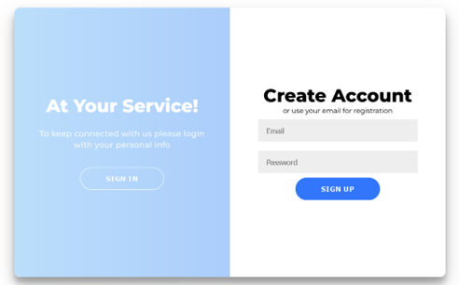

Figure 83 Sign Up

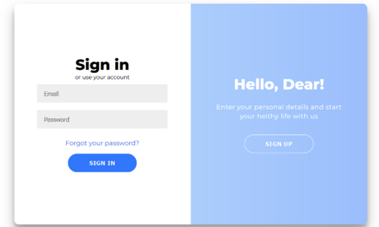

Figure 84 Sign In

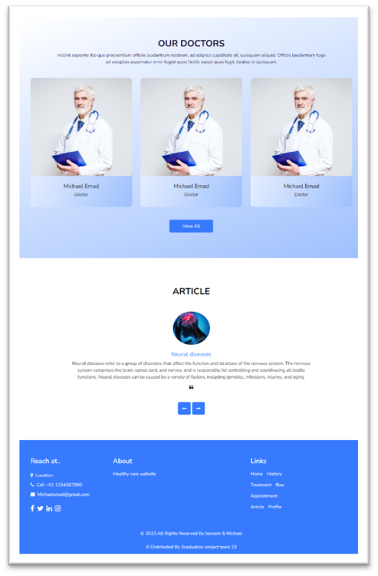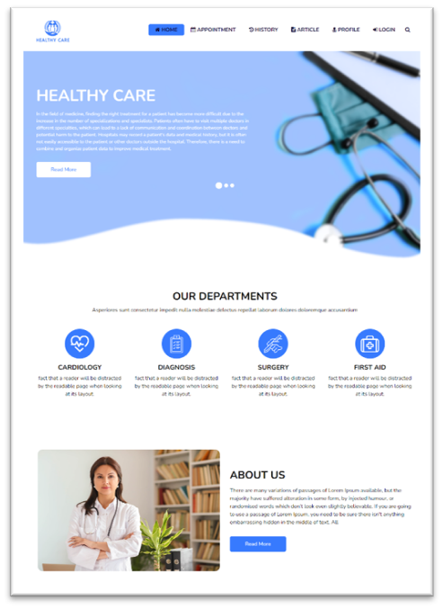

Figure 85 Full Home Page 2

Figure 86 Full Home Page 1

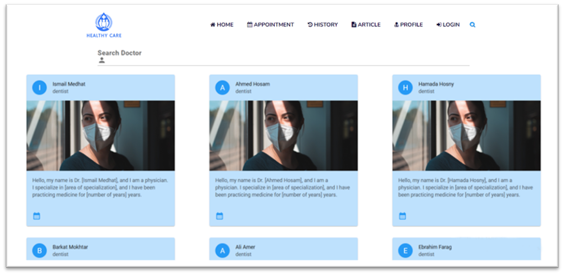

Figure 87 Doctor Search

Here the patient can find the doctors , or search for a specific doctor to book an appointment .

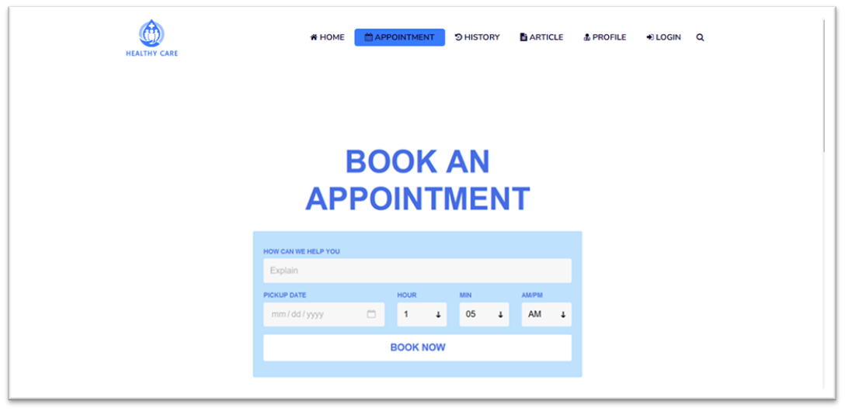

Figure 88 Booking Appointment

The patient here can book an appointment and see doctor available dates so can book .

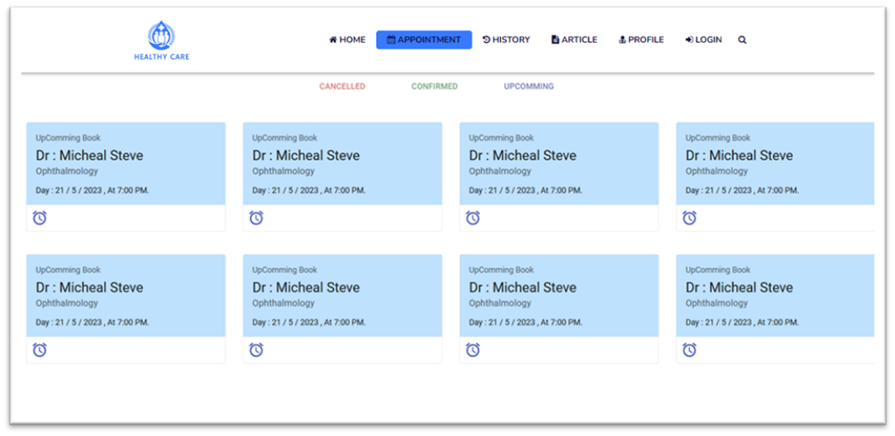

Figure 89 Upcoming Appointments

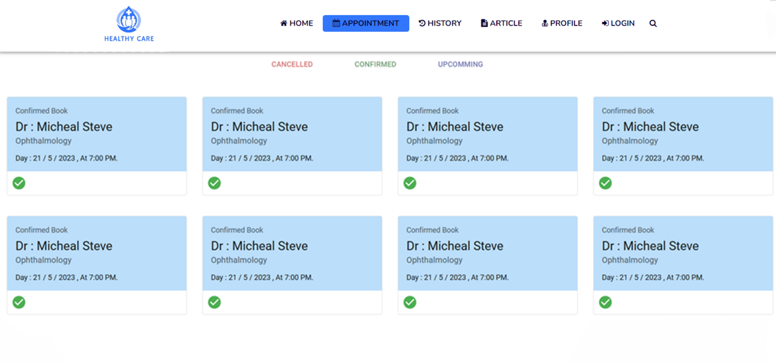

Figure 90 Confirmed Appointments

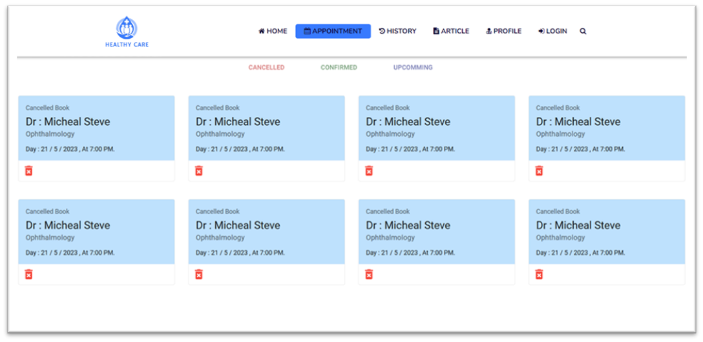

Figure 91 Cancelled Appointments

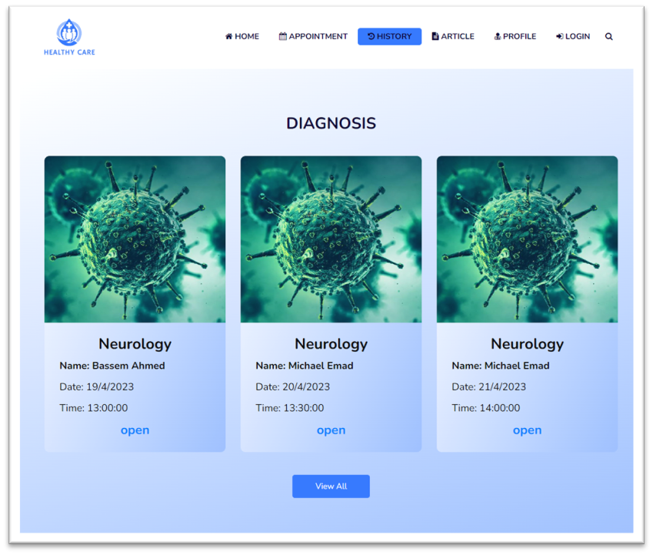

Figure 92 History (Diagnoses) Page

Here the patient can see all his diagnosis history noting by the diagnose name his name (patient name) date and time of the appointment , and by click on open in any diagnose it goes directly to Diagnose Details Page(figure 5.6) , also by clicking on view all goes to Files Page.

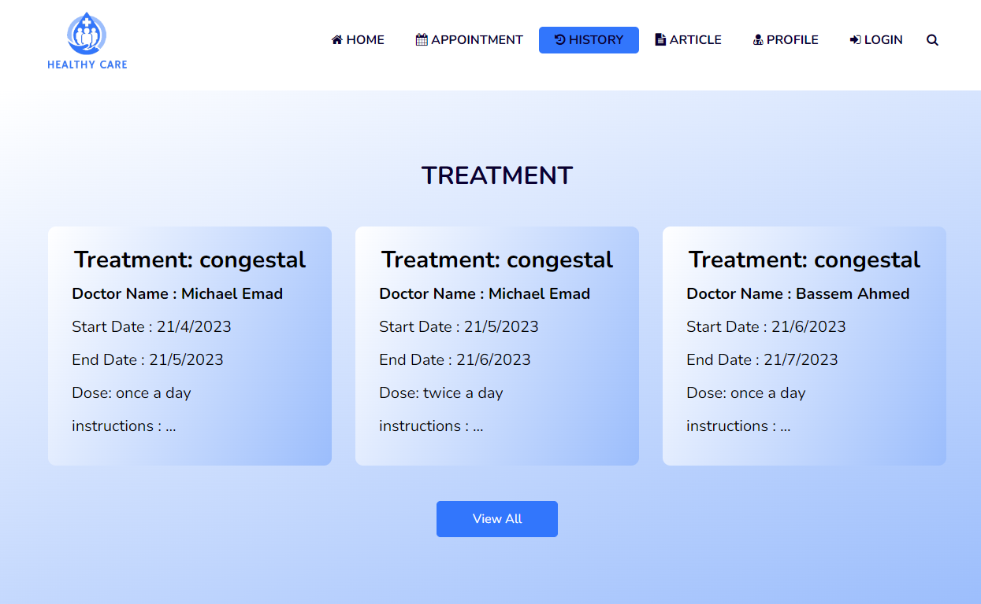

Figure 93 History (Treatment) Page

Here the patient can see all his Treatments History , and each treatment name doctor giving this treatment , starting date , end date , dose and if there is instructions, also by clicking on view all goes to Files Page .

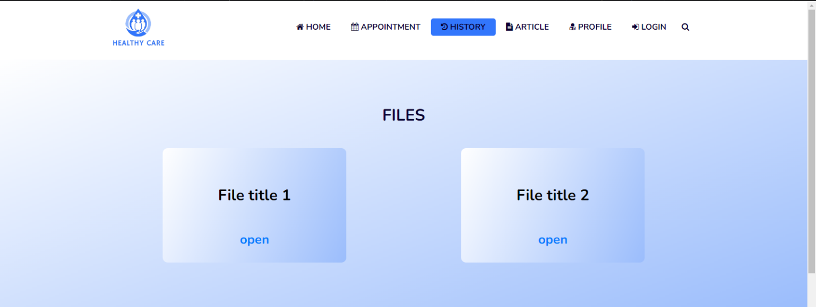

Figure 94 Files Page

In File Page the patient can access his old History files (diagnoses and treatments ) .

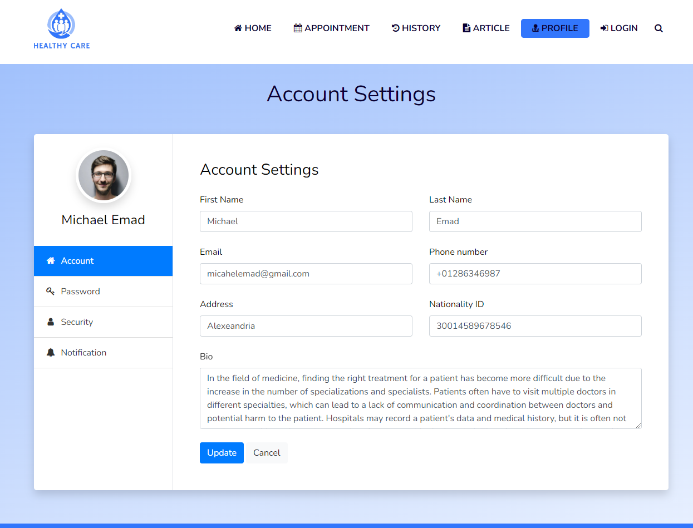

Figure 95 Profile Page

User profile page which can check , edit or update his own information .

#### Doctor

In doctor section the dashboard is the easiest and fastest way for doctor to see and check his appointments .

Figure 96 Doctor Dashboard (Appointment Page)

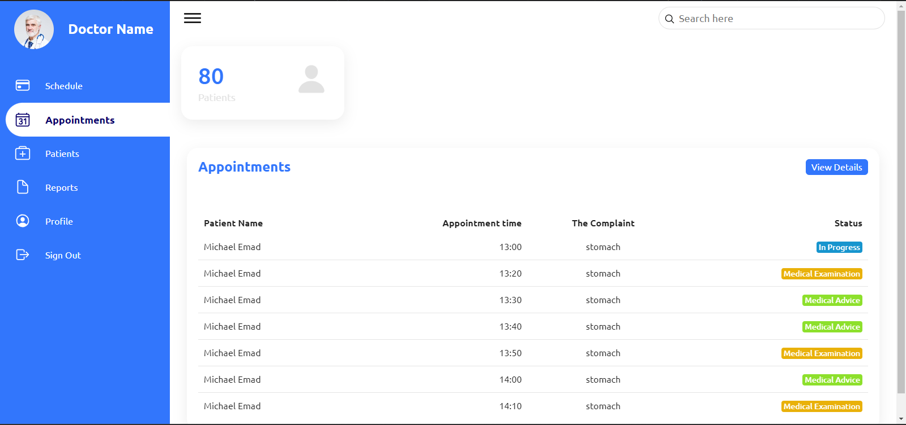

Here in appointment page doctor can check the number of his patients , and progressed and upcoming appointments .

## Back-end

The backend implementation methodology for the Hospital management systems project involves using MySQL, Node.js, and Express.js to create a robust and scalable server-side API. The implementation methodology will follow a structured approach, involving design, development, integration, testing, and deployment. The API will include features such as user authentication, and database management, and will be designed to handle requests from the mobile and web-based front-end. The implementation methodology will prioritize security, reliability, and scalability, to ensure a seamless experience for patients and doctors using the Hospital management systems application. The use of MySQL will provide efficient and scalable database management, while Node.js and Express.js will provide a high-performance and scalable server-side solution, as we will talk about below.

### The programming language and framework

Node.js is a popular server-side JavaScript runtime environment that allows us to build scalable and high-performance applications. It provides a non-blocking I/O model that allows multiple requests to be processed simultaneously, making it an ideal technology for building real-time web applications for hospitals.

In our hospital system project, we utilized Node.js for the backend side of the application, which allowed us to handle multiple requests from patients and doctors in real-time. We were able to create a scalable and efficient system that can handle a high volume of traffic without slowing down or crashing.

Express.js is a popular Node.js web application framework that simplifies the process of building web applications by providing a set of flexible and powerful features. It allows developers to easily create routes, handle HTTP requests and responses, and integrate with various templating engines and databases.

In our hospital system project, we utilized Express.js to build the RESTful API endpoints for the application, which allowed us to easily handle incoming requests and send responses to the client. We were able to create a set of APIs that can be easily consumed by the frontend and other services, making the hospital application highly interoperable.

Furthermore, using Node.js and Express.js allowed us to take advantage of a vast ecosystem of open-source modules and libraries specifically designed for building healthcare applications, which helped to streamline the development process and reduce the time and effort required to build complex features for our hospital system.

### The Database Management System

MySQL is the world’s most popular open source database. According to DB-Engines, MySQL ranks as the second-most-popular database, behind Oracle Database. MySQL powers many of the most accessed applications, including Facebook, Twitter, Netflix, Uber, Airbnb, Shopify, and Booking.com.

Since MySQL is open source, it includes numerous features developed in close cooperation with users over more than 25 years. So it’s very likely that your favorite application or programming language is supported by MySQL Database.

Open source means it’s possible for anyone to use and modify the software. Anybody can download MySQL software from the internet and use it without paying for it. We can also change its source code to suit our needs. MySQL software uses the GNU General Public License (GPL) to define what we may not do with the software in different situations.

#### MySQL benefits

MySQL is fast, reliable, scalable, and easy to use. It was originally developed to handle large databases quickly and has been used in highly demanding production environments for many years.

Although MySQL is under constant development, it offers a rich and useful set of functions. MySQL’s connectivity, speed, and security make it highly suited for accessing databases on the internet.

MySQL’s key benefits include

**Ease of use:** Developers can install MySQL in minutes, and the database is easy to manage.

**Reliability:** MySQL is one of the most mature and widely used databases. It has been tested in a wide variety of scenarios for more than 25 years, including by many of the world’s largest companies. Organizations depend on MySQL to run business-critical applications because of its reliability.

**Scalability:** MySQL scales to meet the demands of the most accessed applications. MySQL’s native replication architecture enables organizations such as Facebook to scale applications to support billions of users.

**High availability:** MySQL delivers a complete set of native, fully integrated replication technologies for high availability and disaster recovery. For business-critical applications, and to meet service-level agreement commitments, customers can achieve

**Security:** Data security entails protection and compliance with industry and government regulations, including the European Union General Data Protection Regulation, the Payment Card Industry Data Security Standard, the Health Insurance Portability and Accountability Act, and the Defense Information Systems Agency’s Security Technical Implementation Guides. MySQL Enterprise Edition provides advanced security features, including authentication/authorization, transparent data encryption, auditing, data masking, and a database firewall.

**Flexibility:** The MySQL Document Store gives users maximum flexibility in developing traditional SQL and NoSQL schema-free database applications. Developers can mix and match relational data and JSON documents in the same database and application.

### The libraries and tools

#### Authentication:

* **bcryptjs:** a library used for hashing passwords.
* **passport:** a middleware used for authentication.

#### Security:

* **helmet:** a library that provides various security middleware functions for setting HTTP headers and other security-related measures.
* **xss-clean:** a middleware function that removes malicious script tags from user input.

#### Data validation:

**joi:** a schema validation library for JavaScript objects.

**morgan:** an HTTP request logging middleware.

#### Database management:

**mysql2:** a MySQL client library.

**sequelize:** an ORM (Object-Relational Mapping) library for Node.js that provides an easy-to-use interface for managing database tables, associations, and queries.

#### Other:

**http-status:** a library that provides an easy-to-use set of HTTP status codes.

**moment:** a library for handling dates and times.

**nodemon:** a tool used for automatically restarting the Node.js application when changes are detected in the code.

**path**: a Node.js module for working with file and directory paths.

**jsonwebtoken:** a library used for generating and verifying JSON Web Tokens (JWTs).

### Scalability and maintainability

As software engineers, we understand that scalability refers to our system's ability to handle increased workload without sacrificing performance. We also know that maintaining scalability is crucial as our application grows and more users start using it. On the other hand, we believe that maintainability is essential as well - it refers to the ease with which our application can be modified and maintained over time. Having a maintainable application is crucial to reducing the cost and effort of future development.

We believe that Node.js is an excellent choice for building scalable and maintainable applications because of its asynchronous, non-blocking I/O model. This allows our application to handle multiple requests concurrently, which can significantly improve its performance under heavy load.

In addition to Node.js, we believe that the libraries and tools we've mentioned can also contribute to the scalability and maintainability of our application. For example:

Sequelize ORM can make it easier to manage database schema changes and maintain database performance as the size of our database grows.

Passport and JWT can help us implement secure and scalable authentication and authorization mechanisms in our application.

Joi and Validator can help us implement data validation and enforce data integrity, which can prevent errors and data inconsistencies that could lead to scalability and maintainability issues.

Node.js's built-in cluster module can help us scale our application horizontally by creating multiple child processes, each of which can handle a portion of the incoming requests.

Overall, we believe that the combination of Node.js and the libraries and tools we've mentioned can contribute to building a scalable and maintainable application that can handle increased workload and maintain its performance and integrity over time.

### Challenges faced and solutions found

During the development of this project, we encountered several challenges that required prompt action to ensure the timely delivery of a quality application. One of the significant challenges We faced was related to the database. As the database grew and complexity, it became challenging to manage schema changes and maintain performance. To overcome this challenge, we implemented the Sequelize ORM, which made it easier to manage database schema changes and maintain database performance.

Another challenge we faced was related to debugging and fixing errors that occurred during the development process. This challenge was particularly prevalent when integrating various libraries and tools into the application. To address this challenge, we used various logging and error tracking tools, such as Morgan. This tool helped us to identify and isolate errors, troubleshoot issues, and optimize the application's performance over time.

Communication was also a significant challenge during the development process, especially since the team was working remotely. To ensure effective communication, we used Discord as our primary communication tool. We also scheduled regular virtual meetings to discuss progress and clarify project requirements

Effective project management was also a challenge we faced. To overcome this challenge, we used various tools, such as Trello and GitHub

Effective project management was also a challenge we faced. To overcome this challenge, we used various tools, such as Trello and GitHub Projects, to track project progress, assign tasks, and manage deadlines. Our supervisor, Prof. Dr. Gamal M. Behery, provided valuable guidance and support throughout the project, which helped us overcome many of the challenges we faced.

### Implementation Structure

#### Project Structure

|  |  |
| --- | --- |
| **config\** | **# Environment variables and configuration related things** |
| **controllers\** | # Route controllers (controller layer) |
| **middleware\** | # Custom express middleware’s |
| **models\** | # Mongoose models (data layer) |
| **routes\** | # Routes |
| **services\** | # Business logic (service layer) |
| **validations\** | # Request data validation schemas |
| **index.js** | # express app |

#### API Endpoints

##### Auth routes:

|  |  |  |
| --- | --- | --- |
| method | Endpoint | description |
| POST | V1/auth/login | login User |
| POST | /v1/auth/refresh-tokens | refresh auth tokens |
| POST | /v1/auth/forgot-password | send reset password email |
| POST | /v1/auth/reset-password | reset password |
| POST | v1/auth/send-verification-email | send verification email |
| POST | /v1/auth/verify-email | verify email |

##### User routes:

|  |  |  |
| --- | --- | --- |
| method | Endpoint | description |
| post | V1/users | create a user |
| GET | v1/users | get all users |
| GET | v1/users/:user ID | get user |
| PATCH | v1/users/:user ID | update user |
| DELETE | v1/users/:user ID | delete user |
| get | V1/users/:user ID | Get Doctor Details |
| post | V1/users/:user ID | Make Patient Appointment |
| post | V1/users/:user ID | Get Cancelled Appointments |

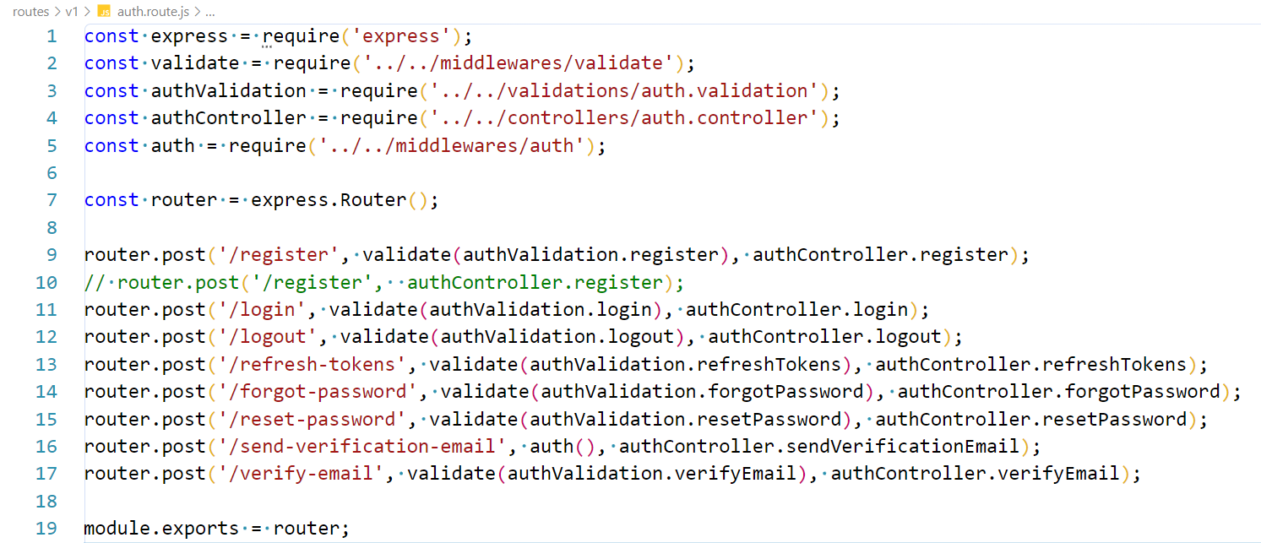

Figure 97 Auth Routes

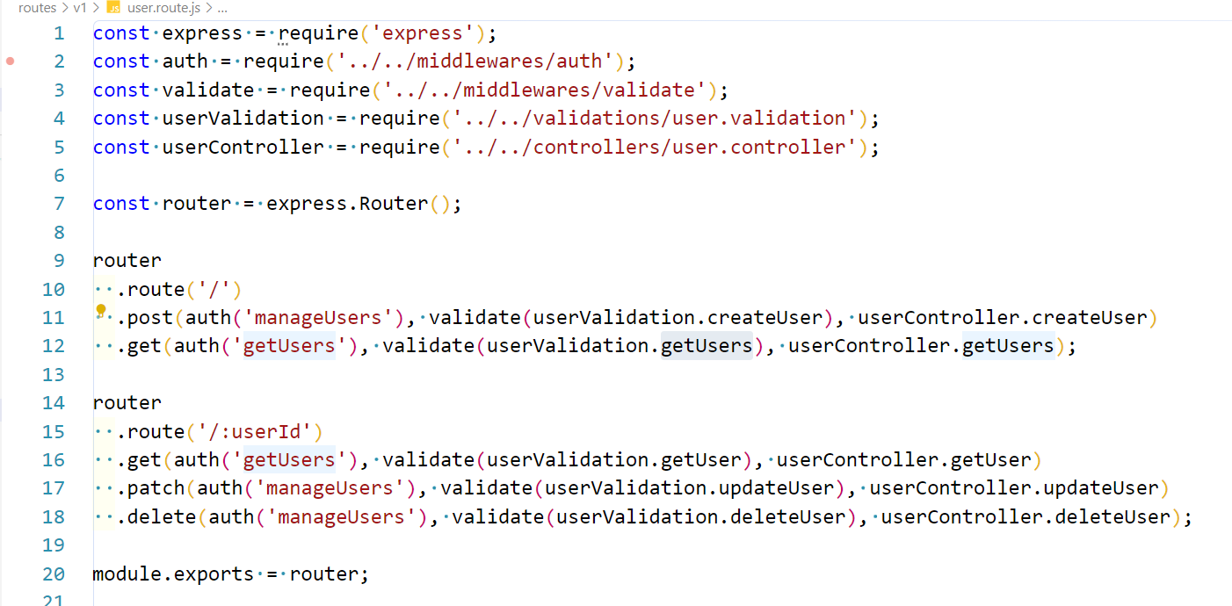

Figure 98 User routes

Auth and user routes which specify the validation and controller for each route.

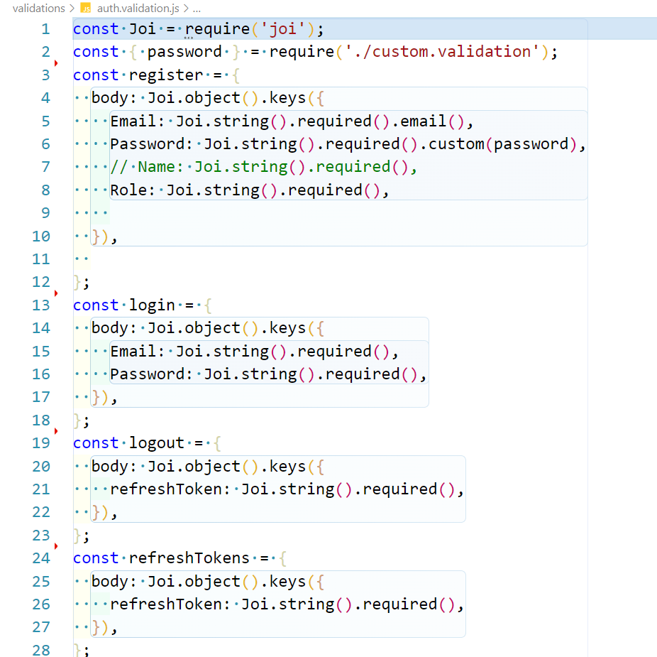

Figure 99 Auth Validate

specify the fields required when calling API

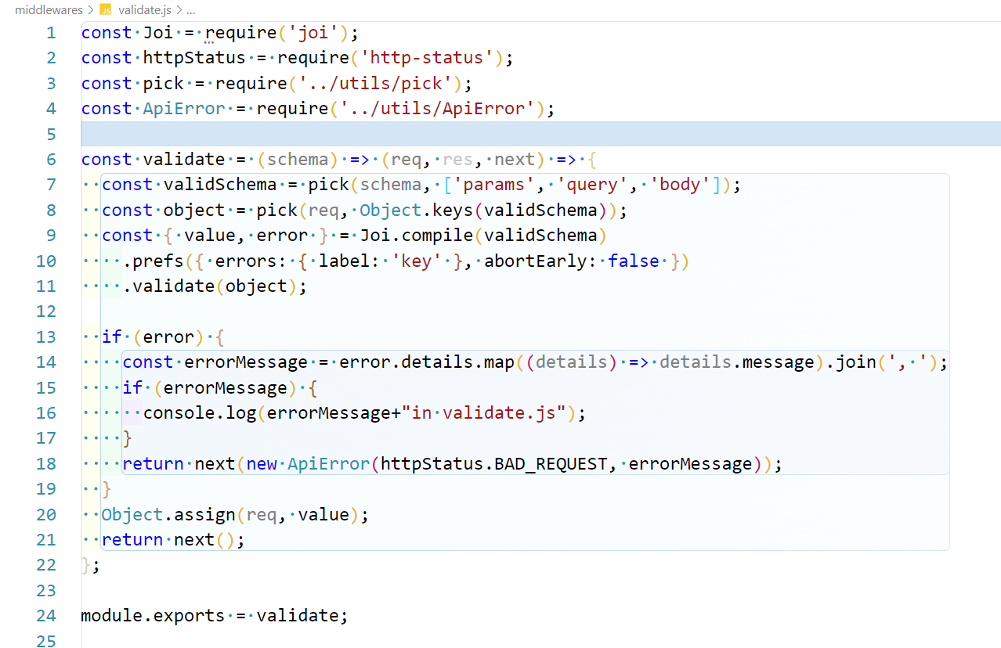

Figure 100 Validate Middleware

validate the schema which is called by

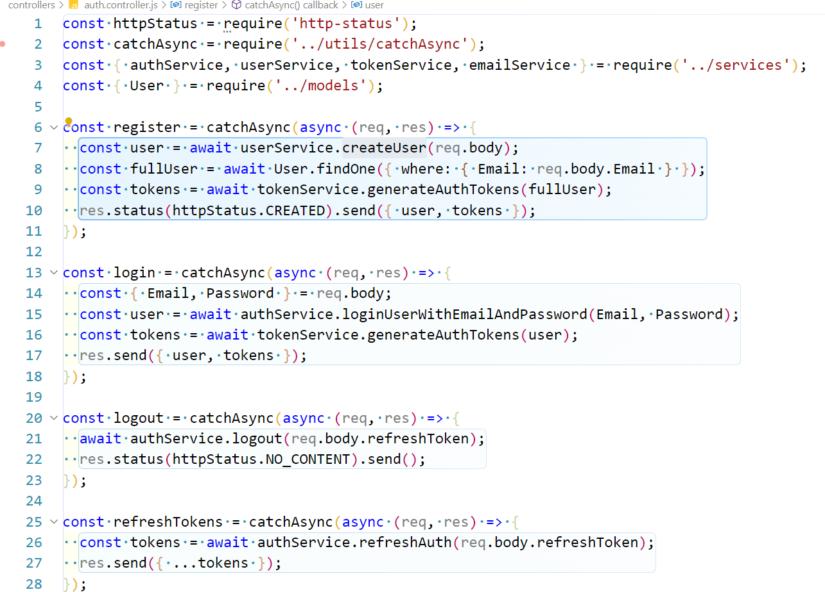

Figure 101 Auth Controller

handles request to call required service such as register, login, logout, refresh Tokens, forgot Password, reset Password, send Verification Email, verify Email.

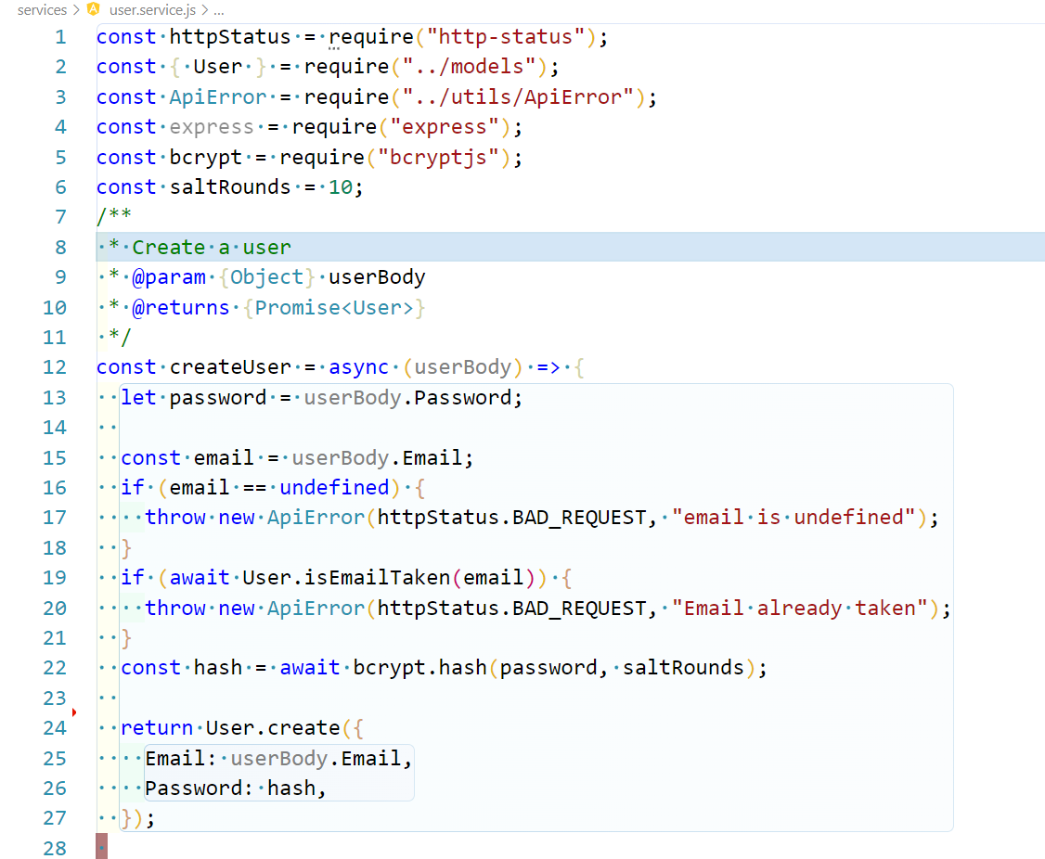

Figure 102 User Service

The service that performs CRUD operations on User model such as create User, query Users, Get User by Id, Get User by Email, Update User by Id.

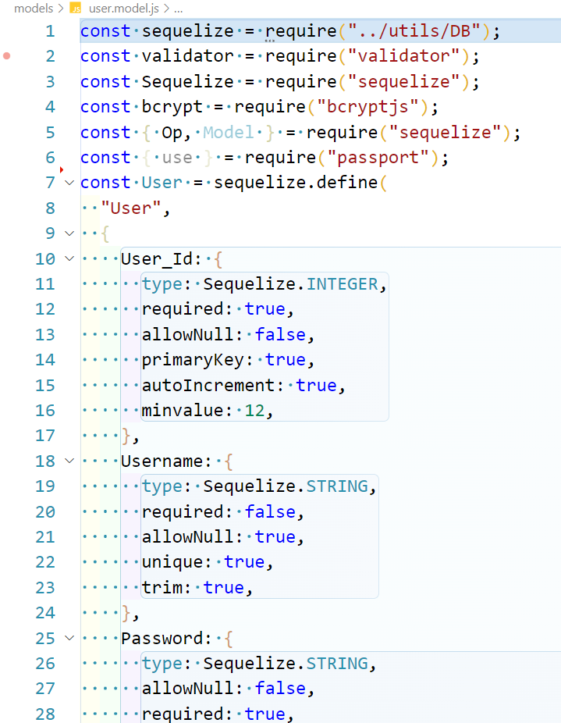

Figure 103 User Model 1

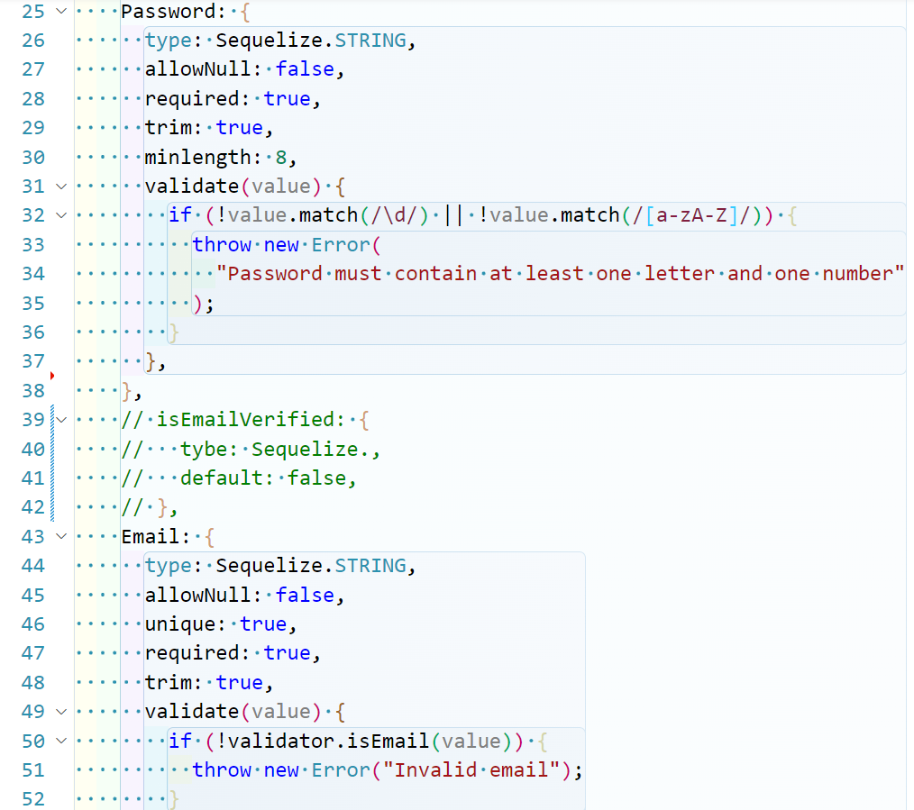

Figure 104 User Model 2

it defines the attributes of user by Sequelize ORM

and the model related functions

# References

|  |  |
| --- | --- |
| [1] | "Description of the database normalization basics," 5 May 2022.  Available: https://learn.microsoft.com/en-us/office/troubleshoot/access/database-normalization-description. |
| [2] | Ramez Elmasri, Fundemtals of Database Systems Seventh Edition, 7th ed. (pp.59-63,159) |
| [3] | Sungdeok Cha and Richard N. Taylor, HandBook of software Engineering, 2019.Springer Cham.(pp.52) |
| [4] | Charles Lane and Nico Krüger, "How to write software requirements specification," 16 December 2021. Available: https://www.perforce.com/blog/alm/how-write-software-requirements-specification-srs-document. |
| [5] | I. Group, "Your guide to writtinga a software requirments specification," 21 October 2021.  Available: https://medium.datadriveninvestor.com/your-guide-to-writing-a-software-requirements-specification-srs-document-6d01bc4cd96e. |
| [6] | I. Sommerville, Software Engineering, 10th ed., Pearson Education © 2016. |
| [7] | "Digital Eye Strain is Common Among all Users," . Available: https://userway.org/blog/digital-eye-strain/. |
| [8] | M. Smallcombe, 3 septemper 2021.  Available: https://www.integrate.io/blog/database-schema-examples/. |
| [9] | "Relational sofware architect," IBM,  Available: https://www.ibm.com/docs/en/rational-soft-arch/9.6.1?topic=diagrams-use-case. |
| [10] | D. Bell, "Explore the UML sequence diagram," 15 February 2004. Available: https://developer.ibm.com/articles/the-sequence-diagram/. |
| [11] | T. Loton, "DataFlow Diagram with Examples," 2011. Available: https://www.modernanalyst.com/Resources/Articles/tabid/115/ID/2015/Data-Flow-Diagram-with-Examples-Tips.aspx. |
| [12] | "Activity Diagram," . Available: https://en.wikipedia.org/wiki/Activity_diagram#cite_note-3. |
| [13] | "Data Flow Diagram," .Available: https://youtu.be/kZspaeZ3o7Y. |
| [14] | "Context Diagram," 24 December 2020. Available: https://youtu.be/zcY94sCL4yg. |
| [15] | B. Lutkevich, "Database," september 2021.Available: https://www.techtarget.com/searchda [13]tamanagement/definition/database. |

[16] helmet package: <https://helmetjs.github.io/>

[17] xss-clean: <https://www.npmjs.com/package/xss-clean>

[18] bcryptjs: <https://www.npmjs.com/package/bcryptjs>

[19] passport: <http://www.passportjs.org/>

[20] joi: https://joi.dev/

[21] morgan: https://www.npmjs.com/package/morgan

[22] mysql2: https://www.npmjs.com/package/mysql2

[23] sequelize: https://sequelize.org/

[24] express: https://expressjs.com/

[25] http-status: https://www.npmjs.com/package/http-status

[26] nodemon: https://nodemon.io/

[27] path: https://nodejs.org/api/path.html

[28] jsonwebtoken: <https://jwt.io/>

[29] "Clean Architecture: A Craftsman's Guide to Software Structure and Design" by Robert C. Martin (Prentice Hall, 2017)

[30] "Designing Data-Intensive Applications: The Big Ideas Behind Reliable, Scalable, and Maintainable Systems" by Martin Kleppmann (O'Reilly Media, 2017)

[31] "Software Engineering: A Practitioner's Approach" by Roger S. Pressman and Bruce R. Maxim (McGraw Hill Education, 2015)

[32] "Building Microservices: Designing Fine-Grained Systems" by Sam Newman (O'Reilly Media, 2015)

[33] "Scalability Rules: 50 Principles for Scaling Web Sites" by Martin L. Abbott and Michael T. Fisher (Addison-Wesley Professional, 2016)

[34] Flutter docs : <https://flutter.dev/docs>

[35] dart dev : <https://dart.dev/guides>

[36] Widget catalog : <https://flutter.dev/docs/development/ui/widgets>

[37] flutter block : <https://pub.dev/packages/flutter_bloc>

[38] http : <https://pub.dev/packages/http>

[39] csc_picker package : <https://pub.dev/packages/csc_picker>

[40] intl_phone_number_input package : <https://pub.dev/packages/intl_phone_number_input>

[41] font_awesome_flutter package : <https://pub.dev/packages/font_awesome_flutter>

[42] syncfusion_flutter_pdfviewer package : <https://pub.dev/packages/syncfusion_flutter_pdfviewer#getting-started](https://pub.dev/packages/syncfusion_flutter_pdfviewer#getting-started)>

[43] Download & Open ANY File | PDF, Image, Video, Music : [https://www.youtube.com/watch?v=6tfBflFUO7s](https://www.youtube.com/watch?v=6tfBflFUO7s)](https://www.youtube.com/watch?v=6tfBflFUO7s%5d(https://www.youtube.com/watch?v=6tfBflFUO7s))

[44] React router : <https://reactrouter.com/en/main>

[45] ReactJS : <https://legacy.reactjs.org/>

[46] Install Material UI : <https://mui.com/material-ui/getting-started/installation/>

[47] TanStack Query : <https://tanstack.com/query/v3/>